Document Title
Document Subtitle
PM Name
31 July 2026

- The purpose of the document is provide the Program Manager an outline for a tech eval plan prior to beginning New Development Contracts, LRIP and FRP Lot Buys, Large ECPs, etc.
- This template provides the PM with areas and information that should be considered when forming a team and what’s needed to reach program objectives.
- Tailor this document as needed to develop a tech eval plan to perform a successful evaluation of the Contractor proposal.
- Do not change the headings of this document; doing so could disable proper export.
Note: This file has been “set-up” using specific Headings so the contents can be exported into PowerPoint. There is an instruction file at the end of this document describing “Instructions to Export to PowerPoint.”

Contents
1. Program Overview 3
2. Structure of the RFP 3
3. Technical Evaluation Approach 3
4. WBS Structure 4
5. Identify Team Structure and Functions 5
6. Technical Evaluation and Negotiation Schedules 5
7. Links and Attachments 6

Program Overview

Describe program purpose and technical requirements

Reference Systems Engineering Plan for added information for program technical requirements

Contract Type

Contract Value or “Not-to-Exceed” (NTE) for Undefinitized Contract Action (UCA) contracts

Period of Performance

Prime and Major Subcontractor experience information

Qualifying Proposal Concerns

Proposal is deemed “unqualified” upon submission if…

Contractor and/or subcontractors did not bid to SOW, SRD, etc. on contract

Debit/Credit is not proposed IAW FAR requirements

Un-executable/unrealistic terms and conditions

Over-all program schedule

Include all major reviews

Structure of the RFP

Technical, Contract, Cost Volumes, Incentive Fee Plan

Definitization schedule

Definitization schedule constraints

DCAA Audit

Initial Pricing Review

Final Pricing Review

List of milestone reviews and proposed dates

Technical Evaluation Approach

Define management structure

PM, PCO, Pricing, DCMA/DCAA, Functionals

Fact finding and negotiation locations

At WPAFB, off-site, at Contractor’s facility

Methods of fielding and answering questions

Written, submitted thru Government Contracts (PK)

Determine ability to call counterparts at contractors

Face-to-face formal meetings

Main areas of risk for the proposal(s)

Method for arriving at Min/Obj/Max positions

Use of other methods, as needed and necessary

Data models, averaging, normalize actuals

Identify planned Government/Contractor meetings

WBS Structure

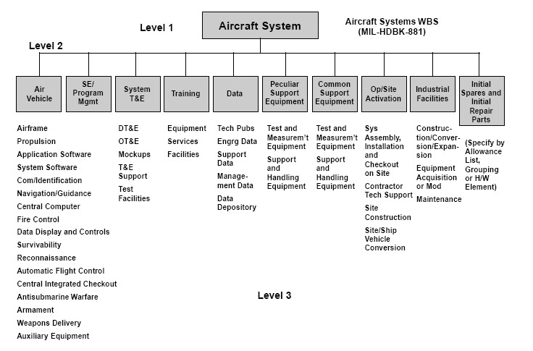

Identify Team Structure and Functions

Define management structure

Org chart identifying Team Members and functions at the WBS Level

Identify roles and responsibilities

Ensure all functional areas are covered - Engineering, Financial, Logistics, Test, Configuration Mgmt., etc.

Identify gaps in team functional competencies and how these areas will be handled

Review training requirements, needs and dates prior to RFP arrival

Ensure each team member reviews and understands the RFP and its requirements

Scope of effort

SOW, IMP, IMS, CDRLs

Identify any risk and disconnect areas to key on during negotiations

Technical Evaluation and Negotiation Schedules

Establish a team schedule for reviews and negotiations

Proposal review start-end dates

PMO tech eval team kick-off

Meetings with contractor

Interval reviews

Key milestones

Planned completion review dates for team members

Establish a Communication Plan

Team provides leadership information for progress, key issues etc. during the tech eval proves.

Method of progress to external stake holders

Method for handling minority views

Links and Attachments

Locations of program documents

Instructions to Export to PowerPoint

