

Process Guide

A106

**Air Force Life Cycle Management Center (AFLCMC)**

**Process for**

**Schedule Management Fundamentals**

Process Owner: AFLCMC/AZA

Date: 8 November 2019

Version: 5.0

|  |  |  |
| --- | --- | --- |
| **Record of Changes** | | |
| Version | Effective Date | Summary |
| 1.0 | 11 Sep 12 | Basic document |
| 2.0 | 17 Feb 16 | Update to References |
| 3.0 | 14 Mar 16 | Combined S04 Develop Program Schedule Standard Process with this Process Guide. This modification is because S04 was changed to a Process Guide and to decrease redundancy in both documents, they were combined into a single Process Guide. |
| 4.0 | 4 Sep 18 | Update to References |
| 5.0 | 8 Nov 19 | Update to Schedule Management Tools table and Training table |

**Table of Contents**

1. Process Definition 1

2. Purpose and Scope 1

2.1 References 1

3. Develop Program Schedule 2

3.1 Develop Program Schedule Responsibilities 4

3.1.1 Program Manager 4

3.1.2 Functional Managers 4

3.1.3 Subject Matter Experts 4

3.1.4 Scheduling Resource 4

3.2 Develop Schedule Plan 4

3.2.1 Determine/Acquire a Scheduling Tool 5

3.2.2 Set Scheduling Expectations 5

3.2.3 Rolling Wave Planning 7

3.3 Build Program Schedule 9

3.3.1 Deliverable Descriptions 9

3.3.2 Task Definition 9

3.3.3 Task Descriptions 9

3.3.4 Task Sequencing 9

3.3.5 Touchpoints 10

3.3.6 Estimating Task Duration 11

3.3.7 Resource Assignments 11

3.3.8 Set Milestones 12

3.3.9 Constraint Dates 12

4. Schedule Management 13

4.1 Set Expectations 14

4.2 Control Configuration 16

4.3 Perform Assessments 17

4.3.1 SME Content Assessment 17

4.3.2 Schedule Health Assessment (SHA) 18

4.3.3 Schedule Risk Assessment (SRA) 18

4.4 Make Decisions 18

4.5 Report Schedule Status 19

5. Schedule Management Tools 20

6. Training 20

7. Process Audit 21

DEFINITION OF TERMS 22

# Process Definition

Schedule management is one of the basic requirements of program management planning and strategic analysis. The process to develop a program schedule includes the activities to plan schedule development, select a scheduling method and tool, develop the program schedule based on specific program data and requirements, baseline the schedule, and then monitor, analyze, manage and report on schedule performance.

A Schedule is a list of activities and events organized by time. In program management practice, the schedule is a powerful planning, control, and communications tool that, when properly executed, supports time and cost estimates, opens communications among personnel involved in program activities, and establishes commitment to program activities. Scheduling begins with selecting a scheduling method and tool, and incorporating specific program data within the tool to develop a schedule. An example of a scheduling method is the Critical Path Method (CPM). An example of a scheduling tool is Microsoft Project.

# Purpose and Scope

The purpose of scheduling is to provide a “roadmap” that represents how and when the program will deliver the products defined in the program scope and by the program team. A program team develops a schedule to provide insight into progress towards program completion by allowing comparison of actual accomplishments relative to the baseline. This baseline becomes the basis of the Acquisition Program Baseline (APB) defined by the program scope, and against which actual progress is determined. A well-built, logically-linked, resource-loaded schedule will provide the critical path of activities required to accomplish required work as actual progress is measured. The scope of schedule management includes planning, managing program office resources, and performing assessments in order to make informed decisions and report status. This guide describes the process for developing and managing a government schedule, as well as, the contractor Integrated Master Schedule (IMS). Both may be maintained independently, but ideally they are combined by the program office into a single, integrated program schedule. Regardless, they should be managed together (by the program manager) to obtain a true program-level view. This process guide, although aimed at acquisition programs, contains universal scheduling fundamentals appropriate for other government activities.

## References

The following regulations, instructions, and guides provide the governing principles for developing and managing a program schedule:

* DoDI 5000.02. This regulation sets forth mandatory procedures for Major Defense Acquisition Programs and Major Automated Information System acquisition programs.
* MIL-STD-881D. This standard addresses mandatory procedures for those programs subject to DoDI 5000.02. It offers uniformity in definition and consistency of approach for developing the top levels of the Work Breakdown Structure (WBS). It does not, however, identify Level 3 elements for the Program Management or Systems Engineering WBS elements. This allows the program manager flexibility to identify efforts that are important to the specific program.
* DoD IMP & IMS Preparation and Use Guide. Provides guidance for the preparation and implementation of a program’s IMP and IMS.
* Data Item Description (DID) DI-MGMT-81861, Integrated Program Management Report (IPMR). Contains format and content preparation instructions for the IMS.
* National Defense Industrial Association (NDIA) Planning and Scheduling Excellence Guide. Provides the team, including new and experienced master planner/schedulers, with practical approaches for building, using, and maintaining an IMS.

# Develop Program Schedule

Scheduling is not a 15 minute exercise, but a continually repeated process that requires up-front and periodic planning to capture the full scope of the government activities required to implement and manage the program. The process flowchart below represents the process to develop a program schedule.



This table below provides additional detail for the activity boxes in the above flowchart.

|  |  |  |  |  |  |
| --- | --- | --- | --- | --- | --- |
| **Lvl** | **WBS** | **Activity** | **Description** | **OPR** | **Time** |
| **1** | **1.0** | **Develop Program Schedule** | The process is performed by PMs and their teams when the PEO, or other authority, directs a program to have a PMO schedule. | PM | **5-6 mo** |
| **2** | **1.1** | **Develop Schedule Plan (IMP)** | PM must consider the mix of SMEs and where to get them, which scheduling tool is most appropriate, and the battle rhythm for statusing and reporting. | PM | **60d** |
| 3 | 1.1.1 | Set Expectations | Determine and communicate: Resource-loading or not, working calendar, status interval, reporting interval, & justifications for duration estimates, hard constraints, non-FS relationships, Lead/Lag. | PM | 5d |
| 3 | 1.1.2 | Plan Resources | Scheduling is a collaborative effort and requires input from many functional areas. It is up to the PM to ensure SMEs are identified, including a scheduling resource ("scheduler"). | PM | 20d |
| 3 | 1.1.3 | Determine & Acquire Tool | In most cases, MS Project will be sufficient. For programs with an EVM component or high levels of integration (i.e., multiple, integrated schedules), matching the Ktr tool may be warranted. | PM | 60d |
| **2** | **1.2** | **Build Program Schedule (IMS)** | PM develops and maintains the IMP and IMS. Both IMP and IMS integrate program activities to include disposal and schedules into a single sight picture. This includes IMSs from all contractors, as well as government activities to include test plans and depot activation. | PM,SMEs, Scheduler | **40d** |
| 3 | 1.2.1 | Build | Describe Deliverables, Define Tasks, Sequence Tasks/Identify Touchpoints, Estimate Task Durations, Assign Resources, Set Milestones/Constraints. | PM, SMEs, Scheduler | 20d |
| 3 | 1.2.2 | Analyze | SME technical assessment, Horizontal/Vertical Traceability, Float, Critical & Driving Path analysis, Baseline analysis, Schedule Health Assessment. | SMEs Scheduler | 10d |
| 3 | 1.2.3 | Set Baseline | Snapshot in time of the time-phased plan to accomplish the work. | PM Scheduler | 5d |
| **2** | **1.3** | **Manage Program** | PM must use the information from the schedule and other sources to make programmatic adjustments. | PM | **20d/ mo** |
| 3 | 1.3.1 | Status | Enter actual values as program progresses. Collect status and update schedule with “actual” start/finish dates. | PM, SMEs,  Scheduler | 5d |
| 3 | 1.3.2 | Analyze Schedule | SME technical assessment, Horizontal/Vertical Traceability, Float, CP/Driving Path analysis, Baseline analysis, SHA, Schedule Risk Assessment, Resource Leveling | PM | 10d |
| 3 | 1.3.3 | Report Schedule Status | Report schedule status, as required, via MAR, SMART, CCAR/eCCAR. For Services Acquisitions $100M and above, utilize the Predictive Scheduling Tool (PST). | PM | 5d |
| 3 | 1.3.4 | Programmatic Adjustments | On-track (Baseline)? Do EVM data & schedule data support each other? What has changed on CP? Does it matter? If so, what do we do? | PM, SMEs, Scheduler | 5d |

## Develop Program Schedule Responsibilities

Schedule development is a collaborative effort. Involvement includes, but is not limited to, program managers (PM), functional managers, subject matter experts (SME), and scheduling resources. The following provides the basic responsibilities for the schedule development team. Other users, performers, suppliers, and/or decision makers of the process may provide information regarding development, status, and management of the schedule throughout the program’s life cycle.

### Program Manager

The PM is responsible for ensuring a pool of resources (e.g., Multi-Functional Team [MFT]) is available to define, describe, and evaluate schedule tasks. This pool should include functional SMEs from engineering (EN), finance (FM), contracting (PK), logistics (LG), acquisition (AQ), and others as required by the program scope. Directorate-level SMEs may be available on-loan for use by multiple programs. The PM is responsible for ensuring that program resources are scheduled. The PM is responsible for choosing and acquiring licenses for a scheduling tool (e.g., MS Project).

### Functional Managers

The Functional Managers are responsible for ensuring that the resources provided to the PM have the appropriate skills required to perform program tasks.

### Subject Matter Experts

SMEs are responsible for identifying/reviewing the tasks needed to perform the work; and identifying the skill level of the resources required to perform the work. In addition, SMEs are responsible for providing status updates (i.e., Actual Start/Finish dates), as well as, revision estimates for durations and resource skill-levels.

### Scheduling Resource

The scheduling resource (scheduler) is responsible for replicating SME and PM information in the scheduling tool. The scheduler is responsible for ensuring that generally accepted scheduling best practices are applied when building and maintaining the program schedule.

## Develop Schedule Plan

When a program begins to consume government resources (man-hours, material, etc.), it is time to plan those activities in a schedule. Prior to preparing the government schedule and prior to providing the contractor with scheduling direction, the schedule approach should be defined. This approach should include requirements for schedule margin, schedule granularity, methods of duration estimation, schedule baseline control process, schedule tripwires, and preferred schedule metrics.

**WBS.** Although MIL-STD-881D does not identify Level 3 elements for the Program Management WBS event, it does not mean those elements do not exist on the government side. Even if there are no government tasks associated with a program’s deliverables, there are most certainly government activities associated with budget requirements (cost), milestone reviews (schedule), technical justification (performance), and the documentation to support them. These activities require resources that must be coordinated and managed, and should be developed into a government WBS. DODI 5000.02 and AFI 63-101 should be used to determine the level 3 activities applicable to the program to be included in the government schedule.

**IMP.** The WBS should be decomposed into the program IMP. “The IMP is an event-based plan consisting of a hierarchy of program events, with each event being supported by specific accomplishments, and each accomplishment associated with specific criteria to be satisfied for its completion.” The IMP also provides a narrative explaining the overall management of the program. The IMP should also include the requirements for schedule margin, schedule granularity, methods of duration estimation, schedule baseline control process, schedule tripwires, and preferred schedule metrics.

**Schedule.** The IMP should be decomposed into the government schedule by adding the specific tasks required to support satisfaction of the criteria identified in the IMP, and identifying the durations of those tasks and the relationships among them. By following the process below, the program office should be able to develop a manageable, executable government schedule.

**Cost Estimate.** The government schedule drives many of the activities and milestones that determine the Fiscal Year Phasing of the Government cost estimate, which in turn becomes the Government’s budget. The cost analyst needs to be involved with schedule development to assure that the schedule is executable and to assure that the Government’s estimate and budget aligns with the schedule’s milestones.

### Determine/Acquire a Scheduling Tool

A scheduling tool is not part of the AF Standard Desktop suite of applications, therefore it may be necessary for the PM to choose and acquire enough licenses of a scheduling tool (e.g., MS Project) to support the program (1 license is often sufficient). In most cases, MS Project will be sufficient, but may still require purchase by the Program Office. For programs with an earned value management (EVM) component or high levels of integration or risk (e.g., multiple, integrated schedules), matching the contractor’s tool may be warranted, and will require purchase. For small, simple, short-term (<6 months), or low-risk programs, a scheduling tool may not be necessary at all and standard presentation and/or spreadsheet tools may be sufficient.

Another factor to consider when choosing a scheduling tool is whether the desired tool is on the AF commercial off-the-shelf (COTS)/Government off-the-shelf (GOTS) Evaluated Products List (EPL). There are three scheduling tools that are typically on the EPL: MS Project, Deltek OPP, and Oracle Primavera (P6). Before purchasing a scheduling tool, verify that the specific version of the desired tool is listed on the EPL. If the tool is no longer listed on the EPL, or another tool is identified, it will be the PM’s responsibility to sponsor the tool through the EPL process.

### Set Scheduling Expectations

Scheduling is a collaborative effort requiring participation of the PM, a number of SMEs from different areas of specialization, and a scheduling resource (scheduler). In order to effectively utilize a schedule to manage a program, it is important that each member of the Program Office team know their responsibilities with regard to the schedule, and is committed to providing best-effort inputs. It is important for the PM to express these scheduling expectations early and often.

* Communicate the Battle Rhythm. The entire Program Office should be aware of how often the schedule must be reported (e.g., MAR, PMR, etc.).
* Set the status/update interval. It is important to status/update the schedule on a regular basis. Best-practice is to update the schedule at least twice as often as it has to be reported. Bi-weekly and monthly are two common intervals.
* SME participation is required. It is important that SMEs are aware of their commitment to the schedule. SMEs are responsible for identifying/reviewing the tasks needed to perform the work. They are responsible for identifying the skill level of the resources required to perform the work, and for providing status updates (i.e., Actual Start/Finish dates), as well as, revision estimates for durations, resource skill-levels, etc.
* A Scheduler is required (if a scheduling tool is used). An individual familiar with the chosen scheduling tool and learned in scheduling best practices will be an invaluable asset. Scheduling resources are few-and-far-between. It may be necessary to hire, develop, become, or share a scheduler. In addition to building and maintaining the schedule, the scheduler (with assistance from the SMEs) should perform baseline analysis, critical path analysis, and driving path analysis.
* Schedule Analysis is required (if a scheduling tool is used). Schedule analysis should be performed on a monthly basis. At a minimum, the Defense Contract Management Agency (DCMA) 14-point Schedule Health Assessment (SHA) should be performed. There is an EPL-approved macro from DCMA. There are also commercially-available products that perform the 14-point assessment on MS Project and other scheduling tools. Consider price and EPL considerations before purchasing a commercial assessment tool. In addition to the SHA, baseline analysis, critical path analysis and driving path analysis should be performed on a regular basis, as well as monthly technical assessments by the various SME.
* Resource Loading should be considered (if a scheduling tool is used). Resource loading can run the gamut from simply assigning points of contact (POCs), to full-up resource loading with a resource pool, resource calendars, labor rates, etc. Determining the level of resource loading will itself be constrained by the resource(s) available to maintain a resource-loaded schedule. The POC-method requires little maintenance; building a resource pool using skill code designations requires moderate maintenance; and full-up resource loading can be a full-time position, especially on a large program.
* Working Calendar(s). A calendar must be defined within the scheduling tool that accurately represents the general working days available to the program. Holidays and across-the-board days off should not be considered working days.
* Justifications. Durations, hard constraints, non-FS relationships, and Lead/Lag are all acceptable scheduling techniques, provided each is adequately justified. Justifications for these items should be documented in the Acquisition Plan or other Program Office documentation.

### Rolling Wave Planning

Rolling wave planning is a technique in which detail planning is done in increments so that work is only planned out as far as practical. Six months is an acceptable increment, but should be based on the program. If the increment is too long, there are too many unknowns to have confidence in the schedule. If the increment is too short, the planning activity never ends.

Keep in mind that a task in one wave may become a summary task in a future wave. Make sure the logic (predecessors, successors, constraints, etc.) and resources are transferred from the original task to its detail tasks (i.e., no logic or resources on summary tasks). If the schedule has been baselined, the new detail tasks must fit in the same timeframe as the original task (i.e., the sum of the new task durations must equal the original task duration).

There are two types of rolling wave planning: traditional and block.

#### Traditional Rolling Wave Planning

Work is planned out as far as possible for each work package or control account. The planning process is continual, with detail plans being established ahead of start dates.



#### “Block” Rolling Wave Planning

Work is planned out as far as practical in total. Planning is performed in “waves”, where all work is detailed to a given point (usually a critical decision point in the program). This planning process is also continual, with detail plans being established ahead of start dates.



**Rolling Wave Example:**



**3 months later…**



## Build Program Schedule

In order to build a comprehensive schedule, the schedule development team must describe deliverables, define tasks, sequence tasks and identify touchpoints, estimate durations, assign resources, and set constraints. This section provides guidance for developing a Government schedule.

### Deliverable Descriptions

The scheduler is responsible for transposing the items from the IMP to the Government schedule. Descriptions should be nouns. For example, if the deliverable is a risk management plan, one might describe it as “Risk Management Plan.” Once complete, the list of deliverables in the scheduling tool must map to the IMP on a one-for-one basis.

### Task Definition

SMEs (from EN, FM, PK, LG, AQ, etc.) are responsible for defining all tasks required to produce the deliverables listed in the IMP. The scheduling resource (aka scheduler) is responsible for documenting the task definitions, as well as, naming the tasks. [NOTE: The schedule is not a “to-do” list. For example, defining tasks to make phone calls is not appropriate for inclusion in a program schedule list of tasks.]

### Task Descriptions

The scheduler is responsible for naming the tasks. Tasks must be uniquely described, including a verb and at least one object, with clarifying adjectives. For example, if the task being described is the effort to produce the first draft of a document, one might describe it as “Write First Draft-Risk Management Plan.”

### Task Sequencing

SMEs (from EN, FM, PK, LG, AQ, etc.) are responsible for defining the sequence in which the tasks will be performed. The scheduler is responsible for documenting the sequence in the scheduling tool. Task sequencing provides the logic that drives the schedule, and allows the scheduling tool to perform its calculations. For example, if Task A is required to be complete prior to the start of Task B, then the scheduler will key a finish-to-start relationship between A and B into the scheduling tool. Every discreet (not summary) task must have at least one predecessor and one successor, with the exception of: the program’s start milestone will have successors only; the finish milestone will have predecessors only.

Task sequencing is one of the key factors in building a useful schedule. With the exceptions of the first task (i.e., start milestone) and last task (i.e., finish milestone), every discrete task (NOT summary tasks) should have at least one predecessor and one successor. For tasks using other than a Finish-to-Start (FS) relationship, additional predecessors and/or successors are required to “complete” the logic. The following provides the types of task-to-task relationships.

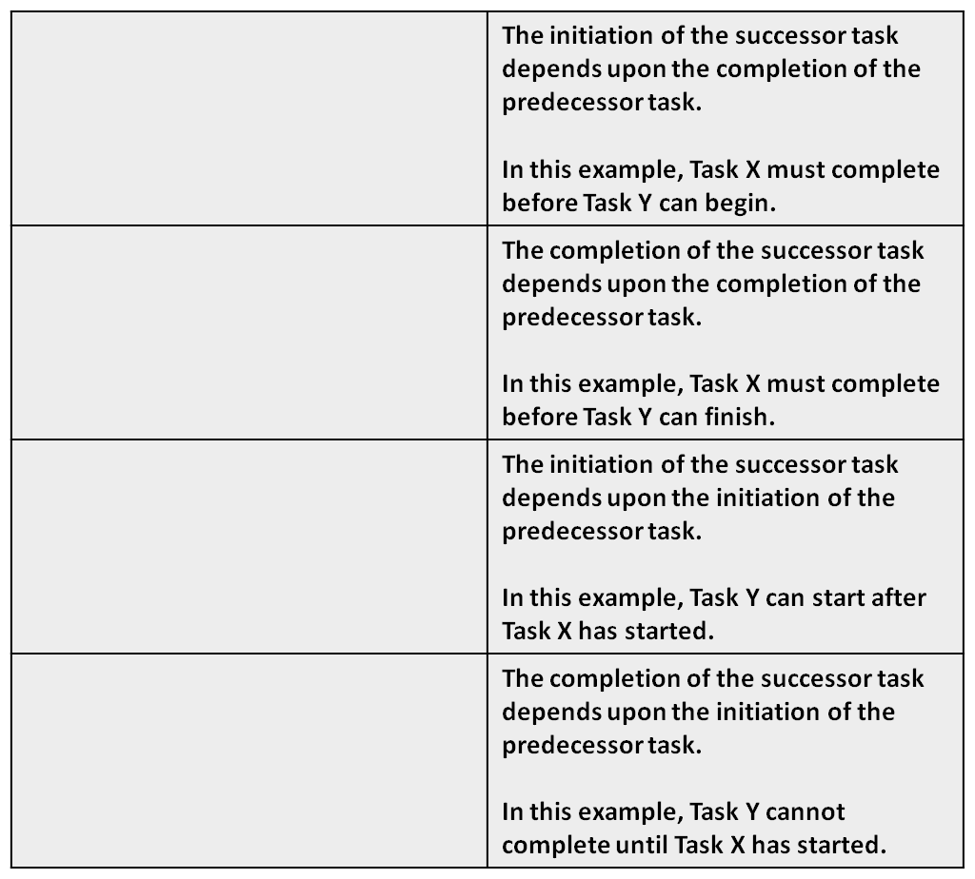

Task X

Task Y

**(FF)**

**Finish to Finish**

Task X

Task Y

**(FS)**

**Finish to Start**

Task X

Task Y

**(SS)**

**Start to Start**

Task X

Task Y

**(SF)**

**Start to Finish**

Note:

* In a finish-to-finish (FF) relationship, the second task must have an additional predecessor, or else nothing drives the start of the second task.
* In a start-to-start (SS) relationship, the first task must have an additional successor, or else the first task never has to finish.
* In a start-to-finish (SF) relationship, the first task must have an additional successor (or else the first task never has to finish), and the second task must have an additional predecessor (or else nothing drives the start of the second task).

### Touchpoints

Touchpoints represent giver-receiver handoffs between schedules. If scheduling tools and the electronic environment are compatible, electronic touchpoints can be used to identify the giver-receiver handoffs, and are assigned as predecessors/successors. If electronic touchpoints cannot be used, manual touchpoints can be created. A manual touchpoint will take the form of an inserted “receiver” task or milestone in each affected schedule that represents the handoff (or “giver” task(s)) from another schedule.

A manual touchpoint as a task will represent the work being accomplished in one schedule (a single or multiple tasks) as a single task whose duration equals the duration of the task(s) it represents in the “giver” schedule. By assigning predecessors/successors to the touchpoint task in the “receiver” schedule, you can determine the impact to the “receiver” schedule based on the status of the task(s) in the “giver” schedule. By monitoring the start/finish date, duration, and logic in the “giver” schedule, you can determine the impact to the “receiver” schedule and make adjustments to the “receiver” schedule to reflect the current plan from month to month.

A manual touchpoint as a milestone will represent the delivery of an item from the “giver” schedule. By assigning predecessors/successors to the touchpoint milestone in the “receiver” schedule, you can determine the impact to the “receiver” schedule based on the status of the task(s) in the “giver” schedule. By monitoring the start/finish date, and logic in the “giver” schedule, you can determine the impact to the “receiver” schedule and make adjustments (e.g. predecessors/successors, duration) to the “receiver” schedule to reflect the current plan from month to month.

### Estimating Task Duration

SMEs (from EN, FM, PK, LG, AQ, etc.) are responsible for estimating the duration of tasks. The scheduler is responsible for documenting the estimates in the scheduling tool. Tasks should be scoped so that the duration will be less than two times the update cycle (i.e., status interval). Ideally, duration values should not be more than three times the update cycle. Specifically, for tasks other than milestone (i.e., zero-duration) tasks, duration values should range from five to 44 days (1 week to ~2 months). Under certain circumstances, such as critical decision activities, tasks can have a duration value of less than five days, but never less than one day. Duration value units should be days, not hours. [NOTE: “To-do” list types of tasks are usually too small in duration to be included in a program task list.]

### Resource Assignments

The scheduler is responsible for creating a representative resource pool, and assigning resources to tasks based on SME recommendations. Resource names can come from sources such as MS Outlook, a list of labor categories, or can be manually keyed in the schedule file. Capacity is the amount of a unit of resource that is available to be consumed by the program. These quantities will be determined when the pool of labor resources is allocated to the Program Office. Should a resource have a work calendar with exceptions (ex., the resource does not work on Friday of each week), then a calendar indicating the exception is loaded at this time.

Assigning resources entails selecting a name from the resource list in the scheduling tool and adding it to the task record. The level of effort required of a resource to perform the task is entered when the resource is assigned to the task, and is expressed in a percentage of a unit. For example, if a resource is required to perform a task on a full-time basis, then the required level of effort is 100%.

Resource leveling entails “smoothing” a resource’s allocation contour. A resource’s allocation can vary from time-period to time-period. For instance, a resource could be under-allocated during a given time period and over-allocated during another. This variation, or contour, needs to be adjusted in such a way that the allocation matches the resource’s availability. Scheduling software enables this leveling. Using software to level resource allocations could require adjusting task precedence, task duration, and/or the required level of effort. During the leveling process, the software will schedule the work in accordance with the resource’s calendar. Leveling should be performed prior to setting the original baseline, as well as during the life of the program as task completion occurs.

Concurrent with resource leveling, resource usage should be optimized. This means streamlining resource deployment given constraints such as skill level, task objective, and time. Optimization should be performed prior to setting the original baseline, as well as, during the life of the program as task completion occurs.

If true resource loading is determined to be non-value-added by the PM/Program Executive Officer (PEO), the PM should consider assigning responsible POCs at the task level using an open/unused free-text field (e.g., “Text10”) within the scheduling tool. While earned value and resource leveling cannot be accomplished using this method, it allows the PM to assign and track work informally.

### Set Milestones

A milestone is a zero-duration task. The scheduler is responsible for keying at least two milestones into the scheduling tool. One is the program’s start event; the other is the program’s finish event. Additional milestones, such as Preliminary Design Review (PDR), Critical Design Review (CDR), etc., should also be added to the program schedule.

### Constraint Dates

A constraint is a limitation or restraint placed on a task or milestone that affects the start and finish dates of the task or milestone. The PM is responsible for specifying constraints. The scheduler is responsible for keying the constraint dates in the scheduling tool. Constraint dates must be used judiciously, as they corrupt the logic defined by sequencing, durations, and relationship types. Constraints must NOT be used to replace schedule logic.

**The preferred way to “hold a date” in a schedule is by using a soft constraint (SNET/FNET).** This allows you to hold a date until the logic (i.e., its predecessor(s)) “pushes against” that date, in which case the constrained task will slip one-for-one with its predecessor task(s). Hard constraints should NOT be used to hold a date. The primary purpose for a hard constraint (MSO/MFO, SNLT/FNLT) is to perform what-if analyses on an existing schedule to determine the impact on the program if a specific task must start or finish earlier than predicted by the early start/finish calculated by the scheduling tool. The following provides the types of constraints available.

| **Constraint Name** | **Description** |
| --- | --- |
| As Late As Possible (ALAP) | Schedules the task as late as possible with the task ending before the project ends and without delaying subsequent tasks. This is the default constraint for tasks when you schedule from the project finish date. Do not enter a task start or finish date with this constraint. |
| As Soon As Possible (ASAP) | Schedules the task to begin as early as possible. This is the default constraint for tasks when you schedule from the project start date. Do not enter a start or finish date with this constraint. |
| Start No Earlier Than (SNET) | Schedules the task to start on or after a specified date. Use this constraint to ensure that a task does not start before a specified date. |
| Finish No Earlier Than (FNET) | Schedules the task to finish on or after a specified date. Use this constraint to ensure that a task does not finish before a certain date. |
| Start No Later Than (SNLT) | Schedules the task to start on or before a specified date. Use this constraint to ensure that a task does not start after a specified date. |
| Finish No Later Than (FNLT) | Schedules the task to finish on or before a specified date. Use this constraint to ensure that a task does not finish after a certain date. |
| Must Finish On (MFO) | Schedules the task to finish on a specified date. Sets the early, scheduled, and late finish dates to the date that you type and anchors the task in the schedule. |
| Must Start On (MSO) | Schedules the task to start on a specified date. Sets the early, scheduled, and late start dates to the date that you type and anchors the task in the schedule. |

# Schedule Management

The AFLCMC Schedule Management process focuses on the minimum elements for managing the schedules that capture the activities required to implement and manage a program. This should include the government schedule and the contractor IMS. The contractor IMS should contain their own activities, as well as, task linkage or giver/receiver coding (i.e., touch points) to subcontractor schedules, at a minimum. Taken together, these schedules indicate all of the activities the program must accomplish to deliver its objective. Figures 1 and 2 provide a sample Government schedule and contractor IMS with task linkage.

**Figure 1. Government Schedule with Touch Points to Contractor IMS**

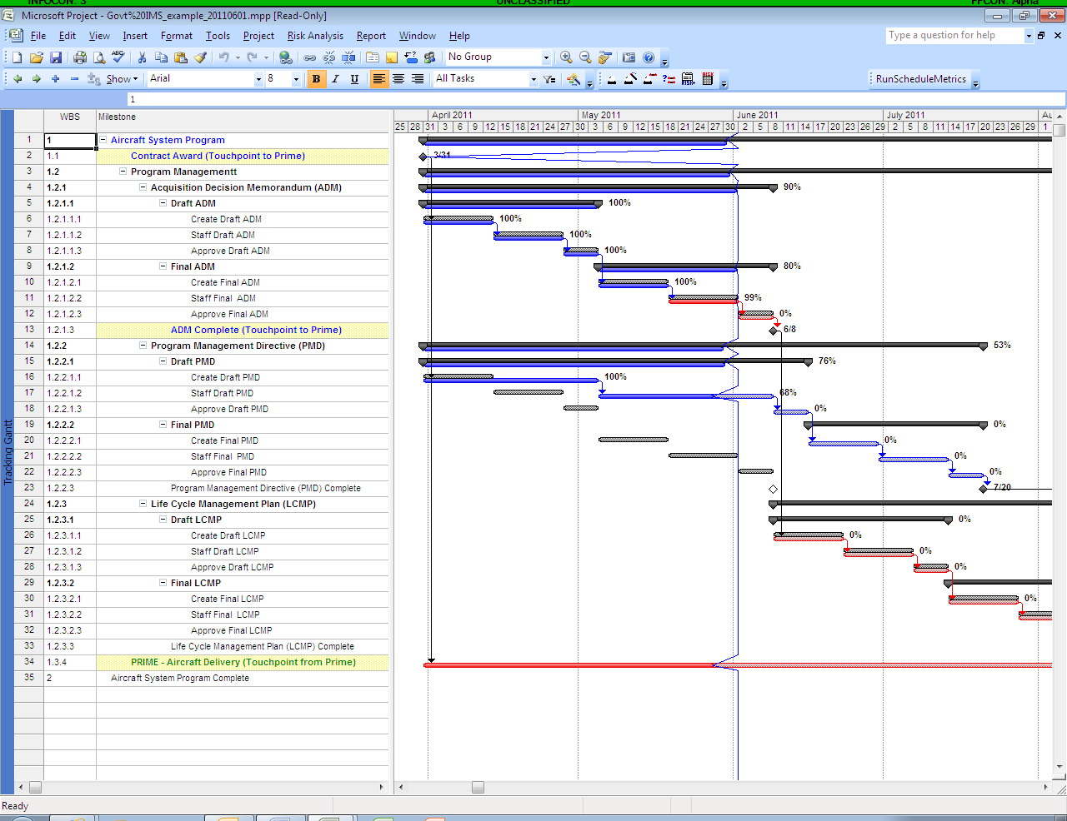

**Figure 2. Contractor IMS with Touch Points to Government Schedule**

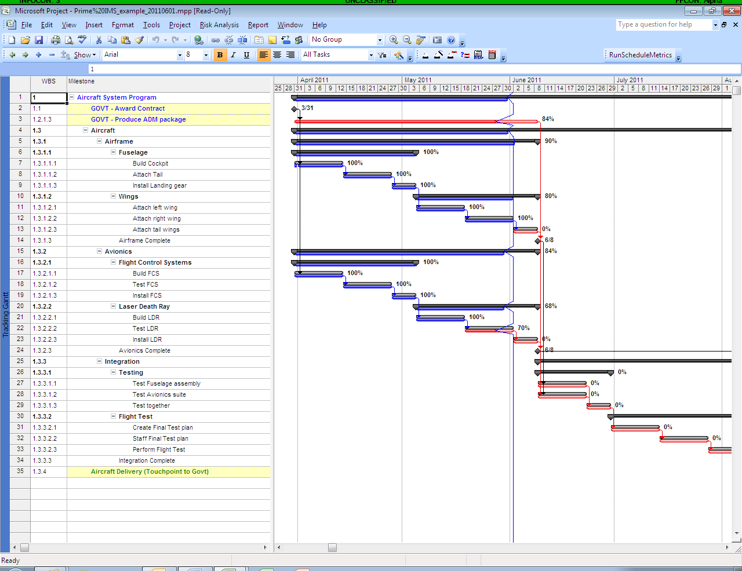

The relationship between the government program schedule and the contractor’s IMS needs to be clearly defined. There are programs that use the contractor schedule to contain both government and contractor tasks, while some programs use separate schedules with touch points between them. Laying out the approach for all program schedules is an essential schedule management effort.

## Set Expectations

**PM Responsibilities.** The PM must set and communicate the expectations and tempo of the scheduling effort.

For the Government schedule, ensure that detail planning sessions (e.g., wall walk, etc.) are a collaborative effort. All SMEs should be involved in order to obtain realistic tasks, sequences, and durations. The PM shall determine how often the schedule should be statused (e.g., weekly) and how often it will be reported to the PM (e.g., monthly). Set the expectation that content reviews and health assessments will be performed monthly. Ensure that touch points (external tasks) are established between the Government schedule and contractor IMS, as appropriate. Direct the SMEs to review their sections of the schedule in detail during each status interval (e.g., weekly).

Setting constraint dates using hard or soft constraints is a useful method of performing “What-If” analyses (for predicting resource availability, or performing “art of the doable” simulations, etc.), but should be avoided in normal maintenance of the schedule. The PM should specify constraint dates only when appropriate, if at all. Hard constraint dates should be avoided.

For the contractor IMS, communicate to the Program Office team how often it will be delivered (as described in the Contract Data Requirements List [CDRL]). The CDRL should also specify the desired schedule output format (i.e., MS Project, etc.), and whether the IMS is an approval item. Set the expectation that a content review and health assessment will be performed by the program office for every submission. Direct the SMEs to review their sections of the IMS in detail for each submission (e.g., monthly). Direct the scheduler to perform an SHA for every IMS submission (e.g., monthly). Promote open communication between the SMEs and contractor Control Account Managers (CAMs). Ensure that touch points (external tasks) are established between the Contractor IMS and the Government schedule, as appropriate. Constraint dates should only be specified in the contract. Ensure that high risk mitigation actions with a schedule impact are integrated into the IMS with all the appropriate touch points (external tasks).

The PM should communicate the frequency of integrated Schedule Risk Assessments (SRAs) in the tailored DI-MGMT-81650. SRAs are typically performed as part of the Integrated Risk Assessment (IRA) during annual Program Office Estimates (POE). An integrated SRA requires participation of Program Office and contractor teams, and must be specified in the requirements document (e.g., SOW, PWS).

**SME Responsibilities.** Use your SMEs to determine if the tasks and durations in the schedules (government or contractor) are sufficient to accomplish the work. SMEs can come from within the Program Office (organic or contractor), from another Program Office (on loan), or from a Directorate functional office (EN, FM, PK, LG, etc.).

For the Government schedule, SMEs are responsible for:

* Defining all tasks required to produce the deliverables listed in the IMP/contract
* Defining the sequence in which the tasks will be performed and any dependent relationships between tasks
* Estimating and justifying the duration of tasks
* Identifying the skills required to perform project tasks
* Validating that the plan calculated by the tool reflects the real timing and technical nature of the planned work
* Assessing the schedule content monthly
* Reporting findings to the PM monthly

For the contractor IMS, SMEs are responsible for:

* Assessing schedule content by reviewing their section(s) of the schedule during every status review cycle, preferably monthly; and identifying changes and their impacts
* Documenting concerns in a risk repository and reporting to program management
* Validating that the plan calculated by the tool reflects the real timing and technical nature of the planned work
* Reporting findings through the PM to the contractor monthly

**Scheduler Responsibilities.** A mechanically sound schedule is required for accurate program decisions, reliable earned value data (if required) and a realistic SRA.

For the Government schedule, the Scheduler is responsible for:

* Transferring the events, accomplishments, and criteria from the IMP into an automated scheduling tool
* Entering the tasks described by the SMEs into the schedule
* Documenting the sequence of tasks in the schedule
* Documenting the duration estimates in the schedule
* Assigning resources to tasks in the schedule, based on SME suggestion and Program Office agreement
* Ensuring that all tasks are linked by relationships in the schedule
* Entering constraint dates in the schedule using soft constraints and limiting the use of hard constraints
* Setting the baseline using the scheduling tool (once the schedule is validated by the PM, SMEs, and scheduler)
* Identifying the critical path for review, especially changes since the last assessment
* Conducting technical schedule quality reviews with the SMEs. Verify the information collected from the SMEs such as durations, relationships, resources, and task sequence are accurate (“This is what I heard. Is that what you meant?”).
* Statusing the schedule on a regular cycle (e.g., weekly)
* Conducting monthly SHA
* Reporting adverse findings to the PM monthly

For the contractor IMS, the Scheduler is responsible for:

* Conducting monthly SHA
* Identifying the critical path for review, especially changes since the last assessment
* Reporting findings (SHA results, changes to critical path, new tasks, etc.) through the PM to the contractor monthly

## Control Configuration

It is the PM’s responsibility to ensure that there is only one master Government Schedule. All Program Office personnel should have read-access to the schedule, but only the Scheduler (and a backup scheduler) should have write-access to it. SHAs, what-if scenarios, and other activities that may alter the schedule should be performed on a copy of the schedule. Only if the results are acceptable to the PM should the same changes be made to the Government schedule.

Part of configuration control is to set the cost and schedule baseline. A baseline is the benchmark against which program performance will be measured. The IMP should document the formal baseline control process, including the creation of logs to document and track changes to the baseline. Although setting the baseline is easy to do using an automated scheduling tool, it is not something that should be done often.

Project scheduling software enables the user to save task start and finish dates, task duration values, and estimated effort as baseline start and finish dates, baseline duration values, and baseline effort. Prior to setting the schedule baseline, however, it is critical that the PM approve the schedule. The PM will base the approval on the results of the technical, health, and risk assessments performed on the schedule. Once the PM is confident that the schedule is mechanically sound, that the schedule includes all technical effort, and that risk handling plans have been documented, the PM will grant approval to set the baseline. The scheduler is responsible for setting the baseline using the scheduling tool.

Ideally, the baseline for a program is set one time, at the beginning of that program. Setting the baseline should be a disciplined, controlled event performed:

* When the PM is reasonably confident in the Government schedule (after SME review, SHA, and SRA), **AND**
* At the same time your contractor baselines their schedule, **AND**
* Only when absolutely necessary (e.g., program beginning, significant change, etc.)

If a rolling wave approach is used it will be necessary to baseline the newly added tasks after each detail planning period – but **only the newly added tasks**. It is therefore very important to make sure that the newly added tasks fall into the same time period as the original planning task that was detailed (i.e., the sum of the new task durations should not exceed the original task duration).

## Perform Assessments

As mentioned previously, the baseline should not be set until the PM is reasonably confident in the Government schedule. Reasonable confidence can be provided by assessing the schedule in three different ways: SME Content Assessment, Schedule Health Assessment, and Schedule Risk Assessment. The following paragraphs provide a brief overview of schedule analysis techniques. For more detail on schedule analysis methods and processes, please refer to the Schedule Analysis Basics Process Guide (A107).

### SME Content Assessment

Do your SMEs still believe that the tasks and durations in the schedule are adequate to accomplish the planned work? To answer that question, SMEs should review their section(s) of the schedules during every status review cycle, preferably monthly, to perform a thorough, hands-on, line-by-line assessment of their section(s) of the schedules. At some point, SMEs should have access to historical information to use as a reference as well.

They should look for missing tasks, out-of-sequence tasks, and appropriate durations. SME should be aware of and mitigate the consequences of changes since the last assessment, and validate that the schedule still reflects the real timing and technical nature of the planned work. They need to identify the impact of changes, and document those concerns in a risk repository, as well as, report them to the PM. SME content assessment applies to both government and contractor schedules. The SMEs should report their findings to the PM after every assessment. The PM should communicate the results to the contractor, as necessary.

### Schedule Health Assessment (SHA)

A mechanically sound schedule is required for accurate program decisions, reliable earned value data (if required) and a realistic SRA. At a minimum, the scheduler should perform the DCMA 14 Point Assessment on all schedules. It can be performed either manually or using an automated tool. The SHA should be performed on a regular basis (e.g., monthly).

The scheduler should review all schedules for mechanical soundness, impacts to other connected schedules and status updates. They should identify the critical path for the SMEs to review, especially changes since the last assessment. The scheduler should ensure appropriate task links (predecessors, successors, and relationship types), minimal use of leads/lags, and minimal use of constraints. Task/float durations, resource assignment, proper status indicators (status date, actual dates in the past, forecasts dates in the future), and key indicator tests results shall also be reviewed. An SHA should be performed on the Government schedule at no less than the same frequency as contractor IMS assessment. The scheduler should report findings to the PM after every assessment. The PM should communicate the results to the contractor, as necessary.

### Schedule Risk Assessment (SRA)

An SRA assesses the confidence in the overall program by simulating reasonable variability in durations. An integrated SRA is a collaborative effort requiring participation of both the government and contractor teams so that all areas of expertise are represented; ground rules and assumptions are agreed upon and documented; the critical path and high-risk tasks are identified; and global edits/banding values are determined and documented. Integrated SRAs and contractor-performed SRAs must be specified in the contract, along with their frequency (e.g., annually).

The SRA team shall identify best, most likely, and worst case durations (known as 3-point estimates) for each critical/high-risk task, and use global edits (3-point estimates for groups/sections of tasks) for remaining tasks. The scheduler shall run the Monte Carlo simulations using 3-point estimates/global edits to determine confidence levels in the finish dates. Scheduling software (e.g., MS Project) and Monte Carlo simulation software (e.g., Risk+) are required, and must be compatible with each other. An SRA should be performed at contact award (part of Integrated Baseline Review [IBR]), after significant changes, or annually, at a minimum. An SRA should also be performed after each detail planning period (i.e., significant changes during rolling wave planning). Document concerns in the program’s risk repository.

## Make Decisions

Schedule management includes planning, managing program office resources, and performing assessments in order to make informed decisions and report status. The PM will determine the status/update cycle (e.g., weekly) for the Government schedule and the review/assessment cycles (e.g., monthly) for both the government and contractor schedules. The PM shall ensure that a pool of resources is available to perform project tasks and assess schedule content throughout program lifecycle. It is up to the PM to specify constraint dates (only when appropriate), and to decide when to baseline the schedules. Only the PM can direct a program to re-baseline the Government schedule. This should only be done under specific circumstances, such as an unrecoverable breach, or Nunn-McCurdy type situation. Contractors may change the baseline in their schedule subject to the limits imposed by the contract.

The PM must be able to affect changes/corrections to the schedules and be able to direct development of corrective action plans and risk mitigation and handling plans from both the Program Office and contractor teams when necessary. The PM must decide which risks receive program resources and determine the risks and issues to be elevated to the PEO.

## Report Schedule Status

PMs should communicate the status of the program as compared to the program schedule baseline in terms of schedule and schedule risk. This includes tasks/ activities that completed early, on-schedule, and late. Furthermore, it is important for the PM to understand and communicate the impact of task completion (or failure to complete) on the program plan, and should articulate impact in terms of resource and duration adjustments. PMs should be able to discuss the critical path of activities to program completion, or the driving path to any milestone. The PM should report the following information during execution reviews:

* Results of Schedule Health Assessment
  + - * Problem Areas
      * Impacts
      * Mitigation or Corrective Action Plans
* SME assessment of Variance and Critical Path
  + - * Changes to forecast or actual start or finish dates
      * Changes to Critical Path (tasks or dates)
      * Impacts
      * Mitigation or Corrective Action Plans
      * Additions to risk register (e.g., AFERMS)
* Results of Schedule Risk Assessment (when appropriate)
  + - * Longer-duration predictions coming true
      * Impacts
      * Mitigation or Corrective Action Plans
* Resource Contention
  + - * Problem Areas (e.g., identified during SHA or SME content review)
      * Impacts
      * Mitigation or Corrective Action Plans
* The PM should be able to answer 5 questions for the PEO

1. What is your strategy for the development and management of the IMS? WBS -> IMP -> IMS; touch points between government/contractor schedules; monthly SME review & SHA; periodic SRA
2. What has changed on the critical path since the last review? How does this impact the next key events/milestones? Results of SME review, SHA & critical path analysis
3. What are the risks and handling plans associated with the changes? Results of SME review and risk handling plan
4. How is subcontractor or government workload being captured and integrated into your schedule (e.g., GFI/GFE)? Separate schedules, touch points, integrated schedules, etc.
5. What gives you confidence you’ll be able to achieve the program objectives? All of the above - Built correctly and assessed well (SME, SHA, SRA) allows planning vs. reacting

# Schedule Management Tools

The following table provides the mandatory and recommended tools available to the PM for schedule development/management.

|  |  |
| --- | --- |
| **Tool** | **Description** |
| MS Project | Automated scheduling tool (recommended) |
| DCMA 14PA Macro | Schedule health assessment tool (recommended) |
| Project Management Resource Tool (PMRT) | AF-level (mandatory) |
| wInsight | EVM presentation tool (optional) |
| Milestones Professional | Schedule presentation tool (optional) |
| Comprehensive Cost and Requirement (CCAR) | Used to report schedule status |

# Training

There are numerous training opportunities related to scheduling that are offered by AFLCMC/AZA (ACE), the Defense Acquisition University (DAU), and the Air Force Institute of Technology (AFIT) as listed below.

| **Course Title** | **Provider** | **Length** | **Notes** |
| --- | --- | --- | --- |
| Schedule Development Basics (Hands-On) | AFLCMC/AZA (WPAFB ACE) | 1 day | - Focus Week  - Journeyman Training Week  - By Request |
| Schedule Risk Assessment Basics (Knowledge Areas) | AFLCMC/AZA (WPAFB ACE) | 2 hrs | - Conf Rm or DCO  - By Request |
| Schedule Risk Assessment Basics (Hands-On) | AFLCMC/AZA (WPAFB ACE) | ½ day | - Conf Rm or DCO  - By Request |
| Microsoft Project (Basic)  [as training budget permits] | AFLCMC/AQPC (OmniCom*) | 1 day | - Focus Week  - Journeyman Training Week |
| Microsoft Project (Intermediate)  [as training budget permits] | AFLCMC/AQPC (OmniCom*) | 1 day | - Focus Week  - Journeyman Training Week |
| Program Scheduling (CLM 012) | DAU | 4 hrs | CBT |
| Predictive Analysis & Scheduling (CLC 040) | DAU | 1-2 hrs | CBT |
| AF Fundamentals of Acquisition Management (FAM 104) | AFIT | 3 weeks | AFIT – Resident (WPAFB) |
| Intermediate Project Management Skills Course (IPM 301) | AFIT | 2 weeks | AFIT – Resident (WPAFB) |
| Principals of Schedule Management (EVM 263) | DAU | 3 days | DAU - Resident |
| Program Management Courses (PMT 252, PMT 257, PMT 355, PMT 360, PMT 400, PMT 401) | DAU | Varies | DAU – Varies (Distance, Learning, Facilitated/Online, and Resident) |

# Process Audit

AFLCMC/AQ is the office of primary responsibility (OPR) for this process guide. The Acquisition Center of Excellence (ACE) Office of AFLCMC/AQ will be the primary office responsible for ensuring the effectiveness of the schedule management process. Effectiveness of this process will be assessed while planning/overseeing schedule development, during program support reviews, and peer reviewed system engineering assessments. The process guide will be reviewed annually and updated as necessary to maintain compliance with Air Force instructions and policies. Questions and suggestions for improvement in the process or in this guide should be addressed to the AFLCMC/AQ Workflow mailbox.

**DEFINITION OF TERMS**

**14PA** - DCMA 14 Point Assessment.

**Baseline Task** - a Total Task with a baseline finish date prior to or equal to the status date. Used in 14PA calculations for BEI (Complete Tasks/Baseline Tasks).

**Complete Task** - a Total Task that has an Actual Finish Date on or before the Status date. Used in 14PA calculations for BEI (Complete Tasks/Baseline Tasks).

**Critical Path** - the longest path of logically related activities with the lowest total float representing the shortest amount of time in which the schedule can be completed.

**Driving Path -** the longest path of logically related activities with the lowest total float representing the shortest amount of time to a selected task/milestone. A driving path might or might not be on the critical path.

**Float/Slack** - the amount of time that an activity/milestone can be delayed before impacting another task or project completion. (Two subordinate categories are Free Float and Total Float defined below).

**Free Float** – the amount of time an activity/milestone can slip before impacting its immediate successor(s).

**Hard Constraint** - a method to require a task or milestone to start or finish at a specific point in time (Must Finish On [MFO], Must Start On [MSO], Start No Later Than [SNLT], and Finish No Later Than [FNLT]); disrupts the logic from predecessor/successor relationships; and should be avoided.

**Incomplete Task** - a Total Task that does not have an Actual Finish date. Used in 14PA calculations.

**Lag** - a delay between tasks; a task with a positive number in the predecessor field (e.g., 21fs+2d).

**Lead** - an overlap between tasks; a task with a negative number in the predecessor field (e.g., 21fs-2d).

**Milestone Task** - a zero-duration task marking a significant event; milestone tasks may or may not have resources assigned.

**Schedule Granularity** - the minimum duration values to be used in the schedule; the shorter the duration, the better the visibility into program activities, but the higher the schedule maintenance activities.

**Schedule Margin** - A management method for accommodating schedule contingencies. It is a designated buffer and shall be identified separately and considered part of the baseline. Schedule margin is the difference between contractual milestone date(s) and the contractor’s planned date(s) of accomplishment (per DI-MGMT-81861).

**Soft Constraint** - a method to allow a task or milestone to start or finish at a specific point in time (As Soon As Possible [ASAP], Start No Earlier Than [SNET], Finish No Earlier Than [FNET]). Allows tasks to slip based on the predecessors/successors, but not move ahead. Should be minimized.

**Total Float** – the amount of time an activity/milestone can slip before impacting the scheduled project completion date.

**Total Task** - any task that is **NOT**: a Summary/Rollup task, or a Level of Effort task, or a Milestone/zero-duration task (i.e., Baseline Duration = 0).