

Air Force Life Cycle Management Center (AFLCMC)

Standard Process

for

*Product Support*

*Business Case Analysis (PS-BCA)*

Process Owner: AFLCMC/LG-LZ

Date: 15 July 2021

Version: 1.9

Record of Changes

|  |  |  |
| --- | --- | --- |
| Record of Changes | | |
| Version | Effective Date | Summary |
| 1.0 | 16 May 13 | - Standard process reviewed by S&P Board on 18 Apr 13 - After requested revisions it was approved on 16 May 13 |
| 1.1 | 13 Mar 14 | - Changed PS Oversight Board to PS Steering Board and PS Review team to PS Advisory Group |
| 1.2 | 5 Aug 15 | - Revised to updated governance structure, final report requirements and other administrative changes |
| 1.3 | 24 Feb 16 | - Added Metric attribute table in section 5.0 |
| 1.4 | 31 Mar 16 | - Change “Enterprise PS-BCA IPT” to “PS-BCA Vector IPT”. This change is due to SAF/AQD taking more of an active role in PS-BCA Process for the Air Force  - Removed second “AFLCMC” from title |
| 1.5 | 15 Jun 17 | - Revised to align with AFPAM 63-123 Product Support Business Case Analysis  - Incorporated: Decision Tree, Core and Depot Source of Repair (DSOR) Compliance, updated Process Flowchart, IAP meeting request process, IAP/WBS chart, cost model requirements, re-accomplished WBS (as attachment) |
| 1.6 | 15 Jun 18 | - Minor changes throughout to provide more clarity  - Updated verbiage to align with Process Map verbiage  - Added comments placing more emphasis on use of WBS  - Changed “MDA” references to “Final Approval Authority”. Ref: AFI 63-101 Table 1.1, MDA Delegation  - Removed “Out-of-Cycle” consideration comment (7.6.3)  - Added para 7.8 Report Coordination process  - Added Attachment 4 Final Report coordination Instructions and Template |
| 1.7 | 21 Jun 19 | - Added pre-assessment guidance to include Decision Tree and Organic Strategy Assessment paragraphs and figures  - Replaced process flow chart w/new streamlined process  - Updated cost model requirements, added Cost Review Process table/responsibilities attachment  - Added Document Approval section  - Added Implementation Plan section  - Updated WBS to align with new/updated processes  - Added attachment providing guidance/parameters for DSOR and Core compliance  - Updated Roles and Responsibilities section to include Product Support Enterprise Review (PSER) forum |
| 1.8 | 16 Jul 20 | - Minor changes throughout to provide more clarity  - Added Organic Strategy Assessment pre-approval  - Added attachments for Legacy and Revalidation MFRs  Approved at **16 Jul 2020** SP&P Board |
| 1.9 | 15 Jul 21 | - Minor changes throughout Standard Process and WBS (attachment 5) to provide more clarity  - Updated para 7.2.1 to include maximum use of government personnel, contractor support justification  - Attachment added for Contractor Support MFR example  Approved at **15 Jul 2021** SP&P Group |

Table of Contents

1. Description……………………………………………………………………………………5
2. Purpose……………………………………………………………………………………......5
   1. Purpose………………………………………………………………………………..5
   2. Scope………………………………………………………………………………….5
3. Entry/Exit Criteria and Inputs/Outputs……………………………………………………….6
   1. Entry Criteria…………………………………………………………...…………….6
   2. PS-BCA Pre-Assessment……………………………………………………………..6

Figure 3.1 Decision Tree…………………………………………………………………...…….6

Figure 3.2 Organic Strategy Assessment………………………………………………………....7

* 1. Exit Criteria…………………………………………………………………...………7
  2. Inputs………………………………………………………………………………….8
  3. Outputs…………………………………………………………………………..……8

1. Process Workflow and Activities………………………………………………………….….8
   1. Supplier, Input, Process, Output, and Customer (SIPOC)…………………………....8

Table 4.1 SIPOC……………………………………………………………………………..….8

* 1. Process Flowchart…………………………………………………………………….9

Figure 4.1 Process Flowchart…………………………………………………………………….9

* 1. Work Breakdown Structure (WBS)……………………………………………..……9

1. Measurement………………………………………………………………………………….9
   1. AFLCMC PS-BCA Standard Process Metric…………………………………...……9

Table 5.1 Standard Process Metric Attribute………………………………………………….…10

* 1. Collection……………..…………………………………………………………….10

1. DSOR and Core Compliance……………………………………………………………..…10
   1. DSOR and Core Determinations……………………...……………………………..10
   2. PS-BCA Compliance...…………………………………………………………...…10
   3. Non-compliant Courses of Action (COAs)……………………………………….…10
2. Roles and Responsibilities………………………………………………………………..…11
   1. AFLCMC/LG-LZ (Process Owner)…………………………………………………11
   2. PM/Product Support Manager………………………………………………………11
   3. PS-BCA Integrated Project Team (IPT)………………………….....……………....11
   4. Cost IPT………………………….………………………………………………….12
   5. Weighting and Scoring Team…………………………………………………….....12
   6. Incremental Approval Points (IAP) (O-6/GS-15 and GO/SES Governance)…….....12
3. Governance Process…………………………………………………………………………12
   1. Requesting Product Support Enterprise Review (PSER) (O-6/GS-15 IAP)..….……12
   2. Requesting Product Support Integration Council/Product Support Steering Board (PSIC/PSSB) (3-Star/SES Governance )…………………………...………….……13
4. Cost Model Requirements……………………………………………………………...……13
   1. Cost Model…………………………………………………………...……….......…13
   2. Review Process……………………………………………………………………...13
   3. Governance Process………………………………………………………………....14
   4. Validation………..…………………………………………………………………..14

Table 9.1 Cost Review Process…………………………………………………………………..14

10.0 Documentation Approval………………………………………………………….……….14

10.1 Cost Model…………………………………………………………………………14

10.2 Final Report…………………………………………………………………..……14

11.0 Implementation Plan……………………………………………………………………….15

11.1 Development..…………………………………………………………………..…..15

11.2 Approval and Execution….……………………..………………………………….15

12.0 Tools……..…………………………………………………………………………..…….16

13.0 Training…...………………………………………………………………………………...16

14.0 References to Law, Policy, Instructions or Guidance…………………………………...….16

Attachments

1. Legacy Memorandum for Record (MFR) Format…………………………………………...17
2. Revalidation MFR Format…………………………………………………………………...18
3. Organic Strategy Assessment Narrative……………………………………………………..21
4. Contractor Support MFR Example…………………………………………………………..22
5. WBS for PS-BCA Process……………………………………….…………………………..23
6. Cost Team Roles/Responsibilities and Cost Review Expectations………………………….26
7. Product Support Governance Structure………………………………………………..…….27
8. Final Report Coordination Instructions and eSSS Template…………………………...........28
9. Depot/Core Compliance…………………………………………………………………...…31
10. Change Management Plan………………………………………………………………...…33

**Product Support Business Case Analysis (PS-BCA) Process**

**1.0 Description.**

1.1 The Product Support Business Case Analysis (PS-BCA) process is a structured methodology that aids in product support decision making. The PS-BCA does not replace the judgment of a decision maker; it provides an analytic, standardized, and objective foundation upon which credible decisions can be made. The PS-BCA identifies and compares Courses Of Action (COA) for sustainment strategy solution(s) to include evaluation of Product Support Integrator/Product Support Provider (PSI/PSP) options by examining the mission and business impacts (both financial and non-financial), risks and sensitivities.

1.2 The PS-BCA should be a comprehensive, fair and accurate comparison when evaluating multiple COAs and must be repeatable, traceable and trackable by a third party. It should take into account broad Department-wide impacts and context throughout the analysis.

1.3 The PS-BCA concludes with a recommendation, associated specific actions and an implementation plan to achieve stated organizational objectives and desired outcomes.

**2.0 Purpose.**

2.1 Purpose. This document provides a standard process for Product Support Managers (PSMs) to follow while conducting a PS-BCA. The PS-BCA identifies a product support strategy that is cost effective, financially feasible, optimizes readiness and manages risk. The PSM conducts a PS-BCA for major product support decisions, especially those that result in new or changed requirements. The PS-BCA aids leadership in significant strategic and investment decisions across all applications of product support. For example, PS-BCAs support decisions on whether or not to transition between organic and/or contractor support, expand or streamline support processes, or consider hybrid approaches with targeted areas of improvement opportunity.

2.2 Scope. A PS-BCA is required by FY2010 NDAA Sec. 805, Public Law 111-84, Life Cycle Management and Product Support (10 USC 2337) to support milestone decisions, every 5 years, or when a change occurs to the product support strategy. A PS-BCA is required for Acquisition Category (ACAT) I, IA, and II programs but is at the discretion of the Milestone Decision Authority (MDA) for ACAT III programs. For ACAT III programs, the MDA ensures rationale for not conducting a PS-BCA is documented in the Life Cycle Sustainment Plan (LCSP). The PS-BCA is revalidated every 5 years or prior to any product support strategy change, whichever occurs first. Additionally, the requirement to complete a PS-BCA remains through Operations & Sustainment (O&S) phase for all ACAT programs (regardless of if the program is listed on the open/closed Acquisition Master List or the active/inactive Investment Master List). This applies to all programs whose PEO/MDA is within the AFLCMC. Programs outside of AFLCMC/Joint programs, should contact owning service/center where PEO/MDA resides to request PS-BCA requirements. GR&A and/or tailoring may be used to exclude/include requirements as needed.

NOTE: In accordance with (IAW) AFI 63-101/20-101 para 7.6.5, for legacy programs that are beyond MS-C and do not have a PS-BCA, the PSM is not required to conduct a PS-BCA unless a change to the product support strategy is being considered or the current strategy is not meeting operational, logistics, or cost requirements. If determined a PS-BCA is not required, the PSM must document the current product support strategy is affordable and effective, obtain SAF/AQD approval for ACAT I and IA programs and MDA approval for ACAT II programs and include this determination as an annex to the LCSP. **See Attachment 1 for Legacy MFR format.**

**3.0 Entry/Exit Criteria and Inputs/Outputs.**

3.1 Entry Criteria. Per AFI 63-101/20-101, Integrated Life Cycle Management; conduct a PS-BCA to support a milestone decision beginning at milestone C, every 5 years, or prior to a change to the product support strategy. Each iteration of a PS-BCA should build on the previous PS-BCA and use the previously approved and/or implemented strategy as the baseline to any pre-assessment. The levels of detail in the PS-BCA may differ according to where the program is in the life cycle and the scope of the analysis.

3.2 PS-BCA Pre-Assessment. Pre-assessments will be completed if/as appropriate, upon initiation of the PS-BCA. There are two separate pre-assessments: The PS-BCA Decision Tree, which will be completed on all programs (see NOTE below); and the PS-BCA Organic Strategy Assessment (OSA), which may be completed only on pre-MS C programs planning for organic support. Programs are highly encouraged to contact AFLCMC/LZS for direction and guidance prior to initiating any pre-assessment activities. If appropriate, AFLCMC/LZS may recommend engagement with additional stakeholders during the pre-assessment step to mitigate potential PS-BCA approach or strategy disconnects in future steps.

3.2.1 PS-BCA Decision Tree (see **Figure 3.1** below). This is designed to assist the PSM to determine if a full PS-BCA or a Revalidation/Update is required. AFLCMC/LZS will provide guidance and assistance throughout this process to ensure each step is adequately considered.

**Figure 3.1 Decision Tree**

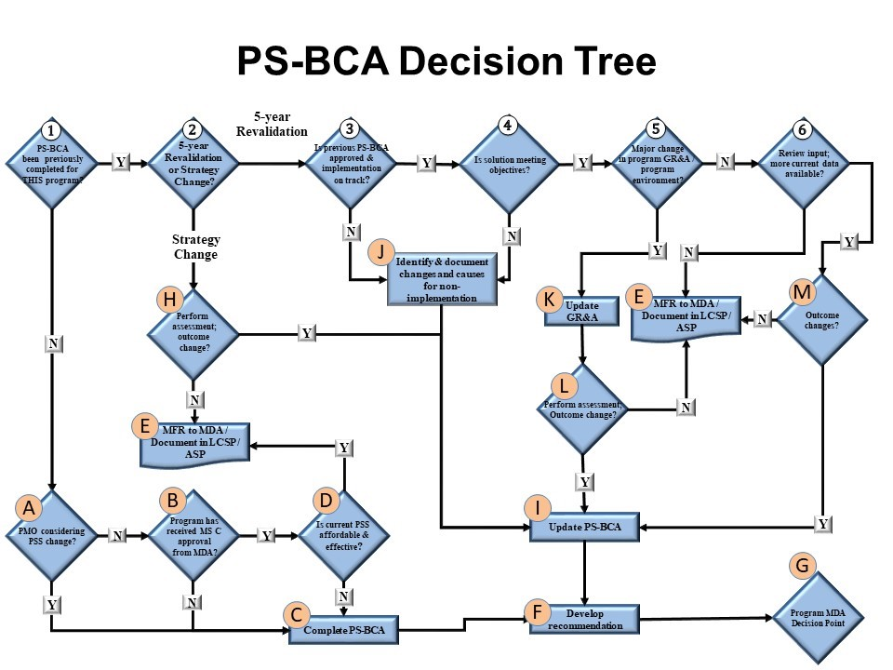

**NOTE: If a previous PS-BCA has been completed (Step 1), a revalidation may be completed by following the remaining steps of the Decision Tree. This streamlined/condensed process will result in a validation or update of the previous PS-BCA.**

**See AFPAM 63-123 for full narrative description.** All Memorandums for Record (MFR) will be coordinated to the PS-BCA approval authority as required by AFI 63-101/20-101. **See Attachment 2 for Revalidation MFR format.**

3.2.2 PS-BCA OSA (see **Figure 3.2** below). This is designed to assist the PSM in completing a *Product Support Strategy Assessment* for programs planning for organic support. Program offices must gain Product Support Enterprise Review (PSER) approval prior to initiating the OSA. The program office must request a PSER by submitting a request to AFLCMC/LZS Workflow ([aflcmc.lzs@us.af.mil](mailto:aflcmc.lzs@us.af.mil)) no later than (NLT) 2 weeks prior to requested meeting date. AFLCMC/LZS can assist the program office in preparing for and requesting the meeting. The PSER approved OSA approach and strategy will help determine what actions are required with respect to the PS-BCA. AFLCMC/LZS will provide guidance throughout this process to ensure each step is adequately considered.

**Figure 3.2 Organic Strategy Assessment**

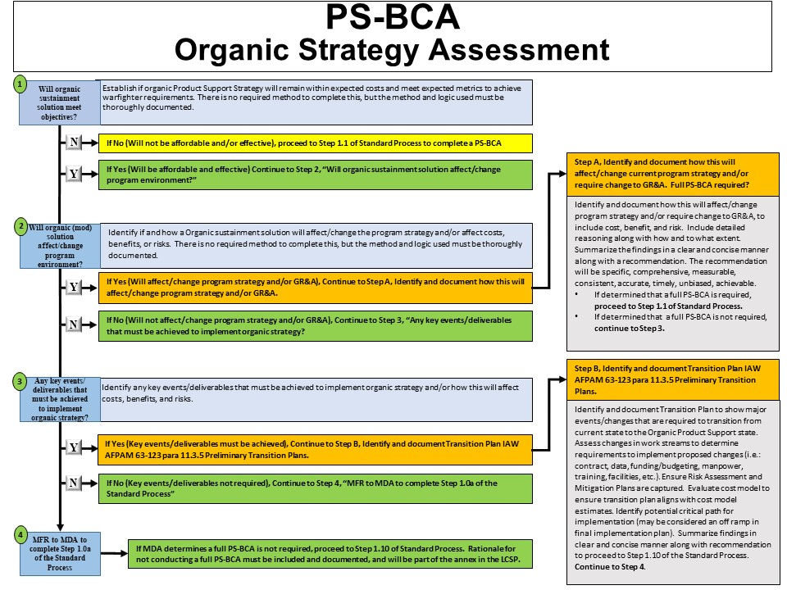

**See Attachment 3 for narrative description. See WBS steps in Attachment 5.**

3.3 Exit Criteria. The PS-BCA is complete when the analysis has been briefed through the standard process governance structure **(Attachment 7)** and the final report, to include Transition Plan, is approved by the approval authority. The approved strategy and decision resulting from the PS-BCA shall be documented in the LCSP.

3.4 Inputs

3.4.1 Completed pre-assessments if/as appropriate

3.4.2 Program data, previous PS-BCA

3.4.3 Program knowledge and program documentation as needed

3.5 Outputs

3.5.1 Final Report with all supporting data and documentation, to include Cost Model

3.5.2 Product support recommendation supported by analysis

3.5.3 Approved Transition Plan

3.5.4 Incorporate completed PS-BCA findings and approved recommendation in the LCSP and in official program files.

**4.0 Process Workflow and Activities.**

4.1 The Supplier, Input, Process, Output, and Customer (SIPOC) table provides a snapshot of the SIPOC analysis for a PS-BCA (see **Table 4.1** below).

**Table 4.1 SIPOC**

|  |  |  |  |  |
| --- | --- | --- | --- | --- |
| **Supplier** | **Input** | **Process** | **Output** | **Customer** |
| * Program Office * AF Sustainment Center (AFSC) * Other product support providers * Using Command(s) * Original Equipment Manufacturer(s) * Other stakeholders | * Program data, documentation and knowledge from a program office, sustainment center, and/or other stakeholders * Previous PS- BCA * New or revised PS strategy * Analogous system data | * Conduct a PS- BCA, which is a structured methodology to aid decisions by identifying and comparing COAs and documents how mission and business is impacted. | * Final recommendation briefed through the standard process structure * Final report approved by approval authority as required by AFI 63-101/20-101 * Final Transition Plan approved by approval authority * Findings and approved recommendation incorporated in the LCSP | * PM * AFLCMC * AFMC * SAF/AQ * OSD * Using Command(s) |

4.2 Process Flowchart. The PS-BCA process is a high-level step-by-step process for key events by organizational groupings (see **Figure 4.1** below).

**Figure 4.1 Process Flowchart**

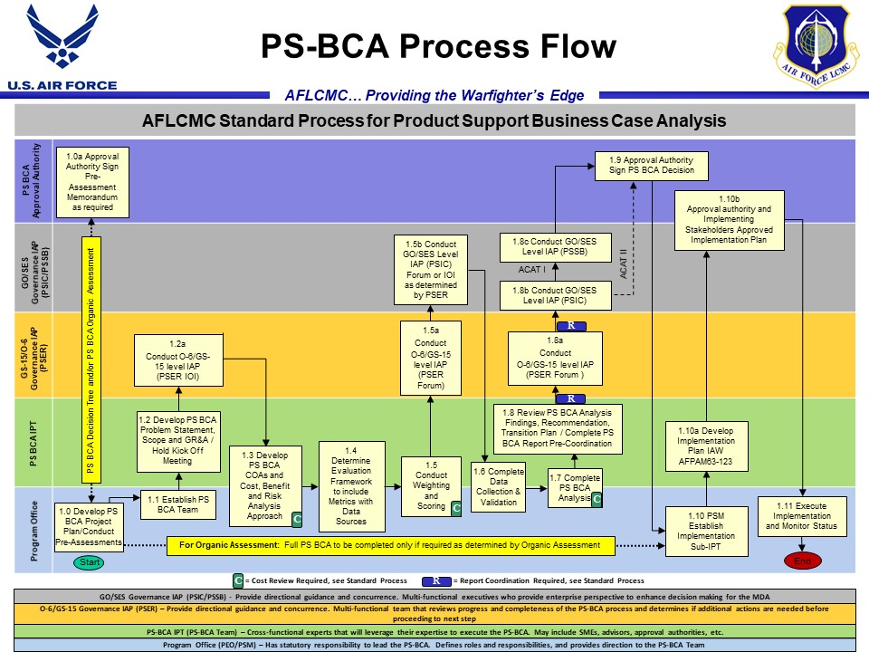

**See AFPAM 63-123 for full narrative description**

4.3 Work Breakdown Structure (WBS). Each event in the process flowchart is further broken down in the WBS. You must reference the WBS to ensure you understand requirements at each step of the PS-BCA process. You may utilize the WBS activities to form the basis of a schedule or you may tailor and add columns of supporting information. Ensure that all activities/ processes are completed IAW provided references. The WBS is contained in **Attachment 5**.

**5.0 Measurement**

5.1 The AFLCMC/LZS collects and measures PS-BCA Standard Process data. Table 5.1 provides metric detail.

**Table 5.1 Standard Process Metric Attribute**

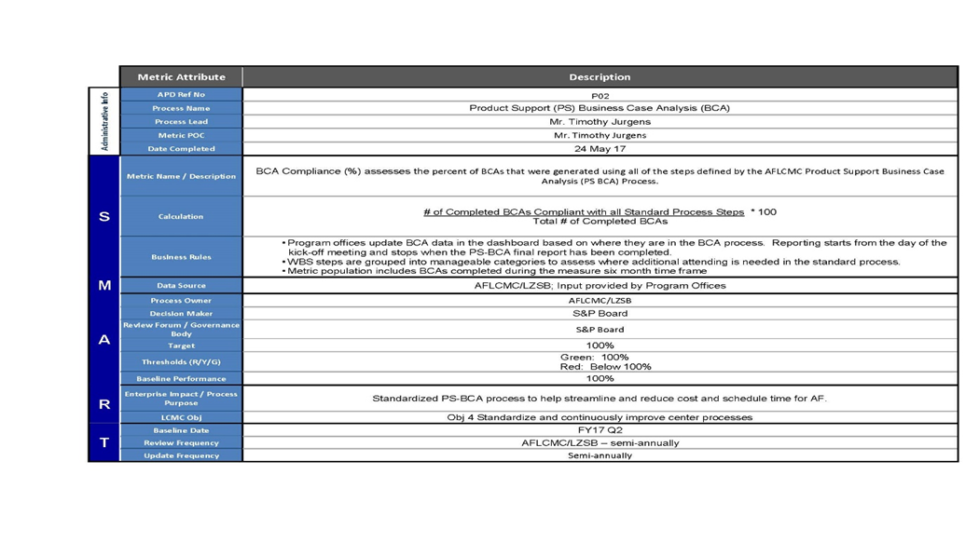

**6.0 Depot Source of Repair (DSOR) and Core Compliance**

6.1 DSOR and Core determinations. All AFLCMC PS-BCAs will include program approved DSOR and Core determination decisions at the appropriate level within the Ground Rules and Assumptions (GR&A). For example, if the potential COAs include evaluations at the system, subsystem, Technology Repair Center and/or component level, the corresponding DSORs should be noted to include approved date and candidate depot assigned. Definitions for DSOR and Core designation are contained in **Attachment 9.**

6.2 PS-BCA compliance. With limited exception, all PS-BCA COAs should be 100% compliant with the programs approved Core and DSOR determination decisions. This does not preclude COAs from evaluating potential approaches for overall Depot Maintenance Management, partnership opportunities and/or relationship between depot maintenance and the other 11 Product Support Elements (PSEs); however, the Source of Repair (SOR) portion of the assessment should be treated as a constant across all COAs in the PS-BCA. (NOTE: This does not preclude the program office from evaluating potential changes to SOR via the Depot Maintenance Activation Working Group (DMAWG) process; however, that is a separate process from the PS-BCA).

6.3 Non-compliant COAs. If a program chooses to include COAs in the PS-BCA that are not 100% compliant with the approved DSOR determination decisions, it must be clearly articulated throughout the analysis, to be included in GR&A, COAs, Findings and Recommendations, and Transition Plan. Additionally, throughout the process, during any Governance Level review, and in the PS-BCA Final Report, it must be clearly noted that “This PS-BCA is being evaluated to determine the best value for the systems under review; however, this assessment does not negate the AF’s Enterprise approved Core and DSOR determination decision which can only be changed through the official AFMC/A4 Workload Shift Process and in conjunction with the program’s DMAWG process.”

**7.0 Roles and Responsibilities**

7.1 AFLCMC/LG-LZ (Process Owner)

7.1.1 Maintains and coordinates any changes to this process, “AFLCMC Standard Process for Product Support Business Case Analysis (PS-BCA)”.

7.1.2 Maintains and manages changes to process documentation, which will reside on a SharePoint site that hosts all the documentation for the Center’s standard processes.

7.1.3 Provides training to the AFLCMC workforce regarding this process.

7.1.4 Provides guidance to programs completing/throughout the PS-BCA process.

7.1.5 Will collect, maintain and analyze AFLCMC PS-BCA Standard Process metrics data.

7.1.6 Retains copy of finalized PS-BCAs, subject to restrictions due to proprietary data.

7.1.7 Provides functional guidance to AFLCMC/CC and AFMC/A4 in support of PSER (O-6/GS-15 IAP) and PSIC/PSSB (3-Star/SES Governance), Final Report, and coordination process.

7.2 Program Manager (PM)/Product Support Manager (PSM)

7.2.1 On behalf of the PM, the PSM is responsible for conducting the Product Support BCA using government personnel to the maximum extent possible. If the PM/PSM determines a need to seek contractor support, they must demonstrate manpower restrictions and gain PEO level approval prior to awarding a contract **(Attachment 4)**.

7.2.2 Complete pre-assessment(s) as appropriate, upon initiation of the PS-BCA. Pre-assessments include the PS-BCA Decision Tree and/or the PS-BCA OSA.

7.2.3 Establish and oversee an enterprise-level Integrated Project Team (IPT). See AFPAM 63-123 for a description of key IPT members that may/will be involved in the PS-BCA.

7.2.4 During the Step 1.2 Kick Off meeting, ensure training is provided by AFLCMC/LZS for the PS-BCA process, and by AFLCMC/FZC for timing and expectations of all cost reviews.

7.2.5 Establish and oversee PS-BCA Cost IPT.

7.2.6 Oversees the team conducting and writing sections of the PS-BCA.

7.2.7 As directed by the PS-BCA Approval Authority Decision Memorandum, stand up an Implementation IPT consisting of representatives from all organizations tasked with implementation and/or execution of the selected COA.

7.2.8 Develop Implementation Plan IAW AFPAM 63-123 requirements.

7.2.9 Collect and provide AFLCMC PS-BCA Standard Process metrics data via the AFLCMC Dashboard or as requested by AFLCMC/LG-LZ.

7.3 PS-BCA Integrated Project Team (IPT)

7.3.1 The structure of the IPT will vary depending on the maturity and mission of the program. At various steps in the process, the IPT may flex to reach additional SMEs.

7.3.2 Work together through each step of the PS-BCA process. This begins with the initial development of the problem statement and continues through the final decision and completion of the final report.

7.3.3 Leverage cross-functional expertise to ensure all support functions are considered in each COA. See AFPAM 63-123 for a description of key IPT members that may/will be involved in the PS-BCA.

7.4 Cost IPT

7.4.1 Cost IPT membership is determined at Step 1.1 of the PS-BCA process, to include membership from agencies identified in **Attachment 6**, Roles/Responsibilities and Cost Review Expectations, and notified to attend the Kick Off meeting at Step 1.2.

7.4.2 During the Step 1.2 Kick Off meeting, AFLCMC/FZC will deliver a presentation on the timing and expectations of all cost reviews.

7.4.3 Review financial related GR&As, CES/WBS, COAs, and risk analysis approach.

7.4.4 Review cost model including data sources, collection plan, methodologies, normalization and escalation factors, uncertainty, and sensitivity analysis.

7.4.5 Review and ensure readiness of all FM elements for approval, to include final cost model (all sources, data, methodologies, and calculations) and comparative analysis.

7.4.6 Be engaged at key steps as outlined in the Roles/Responsibilities and Cost Review Expectations **(Attachment 6)**.

NOTE: Members of the Cost IPT must understand the purpose and scope of the PS-BCA in order to provide the appropriate level of support throughout the process.

7.5 Weighting and Scoring Team

7.5.1 The weighting and scoring plan should be developed and executed by a select group of experts as identified in the approved charter.

7.5.2 Recommended members include Warfighter MAJCOM/A4, AFMC/A4 (functional), AFSC/LGX, and Program Office. Any variance from this may drive additional sensitivity analysis.

7.6 Incremental Approval Points (IAP) (O-6/GS-15 and General Officer/Senior Executive Service (GO/SES) Governance)

7.6.1 Provide directional guidance and concurrence through the PS-BCA process.

7.6.2 Ensure PS-BCA strategy integrates a DoD and AF enterprise-wide perspective.

7.6.3 GS-15/O-6 IAP IPT should be engaged at key steps as outlined in the WBS **(Attachment 5)**.

**8.0 Governance Process**

8.1 Requesting Product Support Enterprise Review (PSER) (O-6/GS-15 Governance)

8.1.1 Step 1.2a of the standard process requires an Item of Interest (IOI) memorandum with approved Charter and GR&As attached. Intent is to gain O-6/GS-15 level approval to proceed with analysis. AFLCMC/LZS will provide a template. Program office will complete and provide the IOI to AFLCMC/LZS who will manage the coordination process.

8.1.2 Steps 1.5a and 1.8a of the standard process require a PSER. The PSER team meets bi-weekly. When ready to request the PSER, the program office will submit a request to AFLCMC/LZS Workflow (aflcmc.lzs@us.af.mil) to include all required program material, including Cost IPT confirmation that appropriate cost model requirements/reviews have been met. Request must be received NLT 2 weeks prior to requested meeting date.

8.1.3 Once a determination is made that a program is ready for the PSER, AFLCMC/LZS will notify the program office of the scheduled PSER date (Note: PSER will be scheduled between 7 and 14 working days from point of notification based on the bi-weekly schedule). AFLCMC/LZS will also provide read ahead charts to PSER Standing Members.

8.1.4 Final charts will be provided NLT 3 business days prior to scheduled date.

8.1.5 The PSER will determine if all process steps have been adequately completed to proceed to next step, and/or may determine if additional actions are needed. At Step 1.5a, the PSER will determine if Step 1.5b will be conducted via IOI or the PSIC forum.

8.2 Requesting PSIC/PSSB (3-Star/SES Governance)

8.2.1 Steps 1.5b, 1.8b, and 1.8c (ACAT I) Governance meet quarterly (PSIC/PSSB). Request must be made NLT 10 weeks prior to desired meeting time using the Topic Submission Form located on the community PSSB/PSIC Share Point (link below). Include AFLCMC/LZSB in all correspondence.

<https://usaf.dps.mil/sites/41289/LG%20Pages/Product%20Support%20Governance.aspx>

8.2.1.1 Organizations will identify a briefer and provide draft charts NLT 10 calendar days prior to scheduled event.

8.2.1.2 Final charts to be provided NLT 3 business days prior to scheduled event.

8.2.1.3 The PSIC and PSSB will review the PS-BCA process at the enterprise-level to ensure all steps have been adequately completed and to provide guidance and recommendations from an integrated, enterprise perspective.

**9.0 Cost Model Requirements**

9.1 Cost Model. The PS-BCA cost model is a decision-support tool used to produce cost estimates for each COA. In order to effectively support the decision maker, it needs to represent the Product Support Strategy (PSS) relationships. The PS-BCA IPT should have a basic understanding of how the cost model works to ensure that it accurately represents the PSS for all COAs.

9.2 Review Process (see **Table 9.1** below). A minimum of three periodic reviews should be conducted to ensure the cost model, along with the data, ground rules and assumptions, uncertainty, and methodologies used, accurately represents the PSS cost behavior for each COA. Technical and functional personnel should be included in the reviews to provide perspective and consistency with the PSS. See **Attachment 6**.

9.3 Governance Process. The Cost IPT review process will also inform the PSER review process. AFLCMC/LZS will work with the PO and AFLCMC/FZC prior to any PSER to ensure appropriate cost model requirements/reviews have been met.

9.4 Validation. The PO will ensure all cost reviews have been completed as required and the cost model is ready for approval at the appropriate level. The PS-BCA final report will include the documented validation.

**Table 9.1 Cost Review Process**

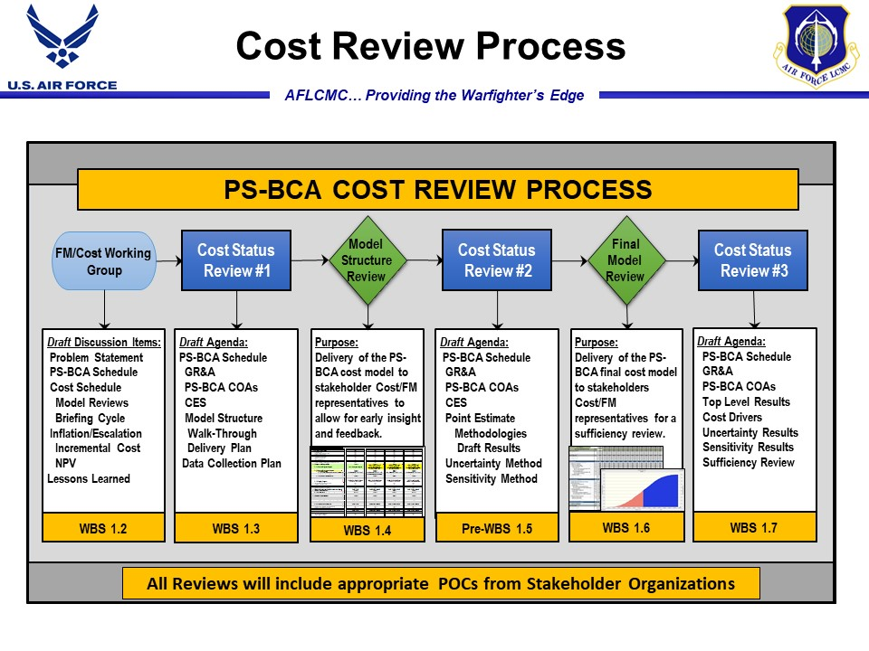

**10.0 Documentation Approval**

10.1 Cost Model. The PO will have their cost model completed and validated prior to Step 1.8 of the Standard Process. Validation will be completed by SAF/FMC and AFCAA for ACAT I programs, and HQ AFMC/FMC for ACAT II and ACAT III programs. The PS-BCA Final Report will include the documented validation of the Cost Model. (See **Table 9.1** and **Attachment 6** for review cycles)

10.2 PS-BCA Final Report

10.2.1 Pre-coordination. Initial Findings, Recommendation, and Final Report, to include Transition Plan and cost data/model, will be coordinated for review NLT 15 working days prior to proceeding to Step 1.8a. This is to ensure compliance with expectations prior to meeting the PSER, and subsequent PSIC/PSSB. (See **Attachment 8** for instructions)

10.2.2 Final coordination

10.2.2.1 Final coordination for ACAT II and ACAT III programs will be completed upon confirmation of satisfactory adjudication of all critical CRM comments, and verification of cost model approval. This will be determined at Step 1.8a PSER.

10.2.2.2 In addition to meeting the requirements for ACAT II and ACAT III programs, ACAT I programs require approval from SAF/AQD. Program offices should complete this additional coordination following approval at Step 1.8c PSSB.

10.2.3 Once the cost model and Final Report have been coordinated and approved, approval to proceed to Step 1.10 may be granted, allowing the program office to immediately begin implementation planning.

**11.0 Implementation Plan** (see AFPAM 63-123, Table 11.6 Implementation Plan Outline)

11.1 The PM/PSM will develop a detailed Implementation Plan for the recommended COA. The

Implementation Plan builds and expands upon the preliminary Transition Plan for the

recommended COA.

11.1.1 Develop Implementation IPT Charter to clearly identified roles and responsibilities for all members

11.1.2 Develop a detailed and executable Implementation Plan to support recommendation.

11.1.3 Include a Communications Plan, Project Plan, Budget Plan, Change Management

Plan (including Stakeholder Action Plan), Training Plan, and defined execution/monitoring reporting procedures.

11.1.4 Implementation Plan will include potential trigger points that would require

additional analysis.

11.1.5 Implementation Plan will include detailed schedule with all key events/deliverables

and off-ramps.

11.1.6 Implementation Plan must provide a timeline to ensure each scheduled task is

completed (include critical path) and that a fully integrated schedule is established for full implementation of the recommendation.

11.1.7 For potential trigger points, provide details and availability of data needed for

additional analysis along with executable action plans.

11.2 Implementation Plan Approval and Execution

11.2.1 The Implementation Plan will be approved at Step 1.10b. The PSM will coordinate the IPT developed Implementation Plan, to include execution/monitoring reporting procedures, with all required stakeholders as defined in the PS-BCA Approval Authority Decision Memorandum in Step 1.9. This must be completed prior to proceeding to the final approval authority.

11.2.2 Following stakeholder coordination and approval the PSM will coordinate the Implementation Plan to the final approval authority for approval to proceed to Step 1.11.

11.2.3 Following final approval, and IAW Step 1.11 the PSM will execute the approved Implementation Plan and provide status updates as defined in the execution/monitoring reporting procedures portion of the plan.

**12.0 Tools**

12.1 To aid in the execution of the PS-BCA, AFLCMC/LZS hosts a SharePoint site that houses additional information such as guidebooks, templates, examples, etc.

12.2 Additional resources may be found at the SharePoint site below:

<https://usaf.dps.mil/sites/41289/LG%20Pages/PS%20BCA.aspx>

**13.0 Training**

13.1 AFLCMC Training.

13.1.1 As part of the PS-BCA standard process, AFLCMC/LZS will provide detailed PS-BCA training during the PS-BCA Kickoff as identified in Step 1.2 of the process flowchart.

13.1.2 AFLCMC/LZS will provide periodic PS-BCA awareness classes during LG Initial/Journeyman training and AFLCMC Focus Week for all functional areas.

13.1.3 AFLCMC/LZS will provide training upon request for any program planning to complete a PS-BCA. Specific areas of concern (ex: pre-assessment) may be addressed.

13.2 DAU Training.

Continuous Learning Module (CLL) 015, Product Support Business Case Analysis; CLL 040, Business Case Analysis Tools; and LOG 235, Performance Based Logistics, provide additional information on executing PS-BCAs.

**14.0 References to Law, Policy, Instructions or Guidance**. Process standardization is required by AFMC and AFLCMC Strategic Plans. References that relate to this process included the following:

14.1 10 USC 2337

14.2 USD AT&L Policy Memo, Strengthened Sustainment Governance for Acquisition Program Reviews, 5 Apr 10

14.3 DoDI 5000.02, Operation of the Defense Acquisition System, 7 Jan 15, as amended

14.4 AFI 63-101/20-101, Integrated Life Cycle Management, 9 May 17

14.5 AFI 65-501, Economic Analysis, 29 Oct 18

14.6 AFMAN 65-506, Economic Analysis, 6 Sep 19

14.7 AFPAM 63-123, Product Support Business Case Analysis Pamphlet, 1 Jun 17

14.8 DAFPAM 63-128, Integrated Life Cycle Management, 3 Feb 21

**Attachment 1 Legacy MFR Format**

[Date]

MEMORANDUM FOR RECORD

FROM:

SUBJECT: [program name] Product Support Strategy Assessment

References:

(a) Title 10, United States Code, Section 2337

(b) Air Force Instruction 63-101/20-101, *Integrated Life Cycle Management*

(c) Air Force Pamphlet 63-123, *Product Support Business Case Analysis*

(d) AFLCMC *Standard Process for Product Support Business Case Analysis*

1. The purpose of this memorandum is to document that the [program name] Product Support Strategy (PSS) is affordable and effective, and that changes to the product support strategy are not being considered at this time.

2. The [program name] program PSS is within expected costs and performance metrics and is achieving warfighter requirements. This determination has been validated through review of the sustainment measurements reported in the [program name] Defense Acquisition Executive Summary (DAES). The three measurements are: Materiel Availability, Materiel Reliability and Operating and Support (O&S) Costs. All three Current Estimates (CE) are better than their respective Current Baseline goals. Specifically, Material Availability CE is [xx%], well above the Baseline goal of [xx%] and the Material Reliability CE of [xx hours] far exceeds the Baseline goal of [xx hours]. Similarly, the O&S CE is [$XXB], under the Baseline goal of [$XXB] (both in BY92$).

3. [Include a brief description of any assessment of the PSS that was accomplished, if applicable]. The [program name] program office also conducted an assessment to consider whether alternative PSS might be more affordable or effective. This assessment was completed on [DATE], and it was found that the current PSS is the best value alternative.

4. In accordance with References (a), (b) and (c), I have determined that the appropriate analyses have been conducted to validate the PSS and that no further analysis of the [program name] PSS is necessary at this time.

5. For any questions regarding this memo, please contact the [program name] Product Support Manager, [PSM Name], at DSN [XXX-XXXX].

[PEO Signature Block]

Attachment:

[Copy of Assessment (If applicable)]

1st Ind, [MDA]

Concur/non-concur

[MDA Signature Block]

**Attachment 2 Revalidation MFR Format**

[Date]

MEMORANDUM FOR RECORD

FROM:

SUBJECT: [program name] Product Support Business Case Analysis (PS-BCA) Revalidation

References: (a) Title 10, United States Code, Section 2337

(b) Air Force Instruction 63-101/20-101, *Integrated Life Cycle Management*

(c) Air Force Pamphlet 63-123, *Product Support Business Case Analysis*

1. The purpose of this memorandum is to document that the [program name] has revalidated the PS-BCA that was completed in Jul 15. Based on the results of the revalidation effort, the current [program name] Product Support Strategy is affordable and effective, and no changes to the product support strategy are being considered at this time.
2. The previous recommendation was implemented and completed in Sep 16. The [program name] PSS is within expected costs and metrics and is achieving warfighter requirements. No major changes in Program GR&A/Program Environment have occurred, and the review of previous and current data suggest no significant changes to the projected outcome.
3. In accordance with References (a), (b), and (c), I have determined that the appropriate analyses have been conducted to validate the product support strategy and that no further analysis of the [program name] product support strategy is necessary at this time.

1. The current support strategy is documented in the [program name] Life Cycle Sustainment Plan. This strategy will remain in effect until the next five year review cycle, or until there is a change to the product support strategy. At that time, another review will be conducted.
2. For any questions regarding this memo, please contact the [program name] Product Support Manager, Ms. Jane Doe, at DSN 456-7899, [jane.doe@us.af.mil](mailto:jane.doe@us.af.mil).

[PEO Signature Block]

Attachment:

Product Support Revalidation Decision Tree Analysis

1st Ind, [MDA]

Concur/non-concur

[MDA Signature Block]

**Attachment 3 Organic Strategy Assessment Narrative**

**Step 1, Will organic sustainment solution meet objectives?** Identify and document the reasons why the solution will or will not meet objectives. This must include support data for projecting both cost affordability, and meeting expected performance/sustainment metrics. An example could be determining if work streams can be realistically expected to perform as projected (e.g., maintenance organizations ability to meet flow days, supply organizations ability to fill customer requisitions in a timely manner)

**Step 2, Will organic (mod) solution affect/change program environment?** Identify and document the reasons the solution will/will not affect/change program environment. This must include support data for projecting cost, benefit, and risk factors, and/or any GR&A changes/additions. If “Yes, the solution will affect/change program strategy and/or GR&A”, continue to **Step A** of assessment

**Step A, Identify and document how this will affect/change program strategy and/or GR&A**

* Identification and documentation will include cost, benefit, risk, and any other substantiating data
* Identification and documentation will include detailed reasoning along with how/to what extent
* Summarize the findings in a clear and concise manner along with a recommendation
* Recommendation will be specific, comprehensive, measurable, consistent, accurate, timely, unbiased, and achievable
* If determined that a full PS-BCA is required, proceed to Step 1.1 of Standard Process
* If determined that a full PS-BCA is not required, continue to Step 3

**Step 3, Any key events/deliverables that must be achieved to implement organic strategy?** Identify and document any key events/deliverables that must be achieved to implement strategy, to include any funding requirements. If “Yes, key events/deliverables must be achieved”, continue to **Step B** of assessment

**Step B, Identify and document Transition Plan IAW 63-123 para 11.3.5 Preliminary Transition Plans**

* Show major events/changes that are required to take place during the transition from the “as-is” to the Organic Product Support state
* Assess changes in work streams or “Transition events” to determine actions required to implement proposed changes (i.e.: contract, funding/budgeting, manpower, facilities, training, enter into data systems, etc.)
* Ensure PS-BCA Risk Assessment/Mitigation Plans are reflected in transition planning
* Evaluate cost model to ensure transition plan aligns with cost model estimates
* Identify potential critical path for implementation (may be considered an off ramp in final implementation plan)
* Summarize findings in a clear and concise manner along with a recommendation to proceed to Step 1.10 of the Standard Process. Continue to Step 4 of assessment

**Step 4, MFR to MDA to complete Step 1.0a of Standard Process.** If MDA approves/determines a full PS-BCA is not required, proceed to Step 1.10 of Standard Process. Rationale for not conducting a full PS-BCA must be included and documented, and will be part of the annex in the LCSP

**Attachment 4 Contractor Support MFR Example**

[Date]

MEMORANDUM FOR RECORD

FROM:

SUBJECT: Product Support Business Case Analysis (PS-BCA) Contractor Support

References: (a) Title 10, United States Code, Section 2337

(b) Air Force Instruction 63-101/20-101, *Integrated Life Cycle Management*

(c) Air Force Pamphlet 63-123, *Product Support Business Case Analysis*

(d) AFLCMC *Standard Process for Product Support Business Case Analysis*

1. The purpose of this memorandum is to document that the [program name] will require contractor support to conduct a PS-BCA. While the [program name] will use government personnel to the maximum extent possible, current manning is not adequate to support additional requirements to complete a comprehensive analysis.
2. Data from recent PS-BCAs shows the average number of contractors required to complete analysis is 13, with relevant experience ranging from 15-30 years. This core team provides expertise in eight different subject areas and is complimented by additional Subject Matter Experts (SME) as required throughout the analysis, expending an average of 9300 hours per analysis.
3. The average number of government personnel required to participate in the same contractor supported PS-BCAs is 68. This includes various levels of SMEs from each Product Support Element being assessed, placing additional workload on already existing functional requirements.

1. In accordance with References (a), (b), (c), and (d), I have determined that contractor support is required to adequately complete a Product Support Business Case Analysis for the [program name].
2. For any questions regarding this memo, please contact the [program name] Product Support Manager, Ms. Jane Doe, at DSN 456-7899, [jane.doe@us.af.mil](mailto:jane.doe@us.af.mil).

[PEO Signature Block]

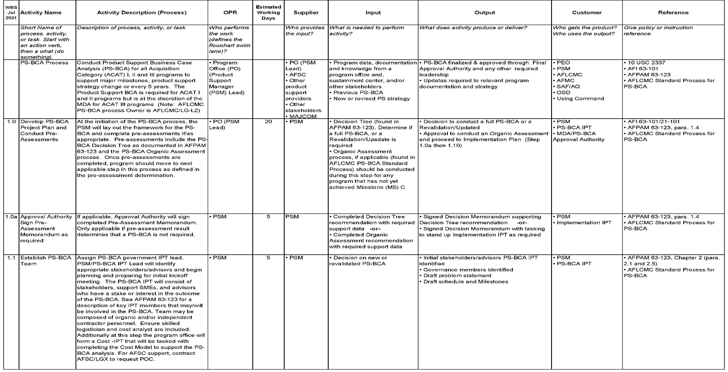

**Attachment 5 WBS for PS-BCA Process**

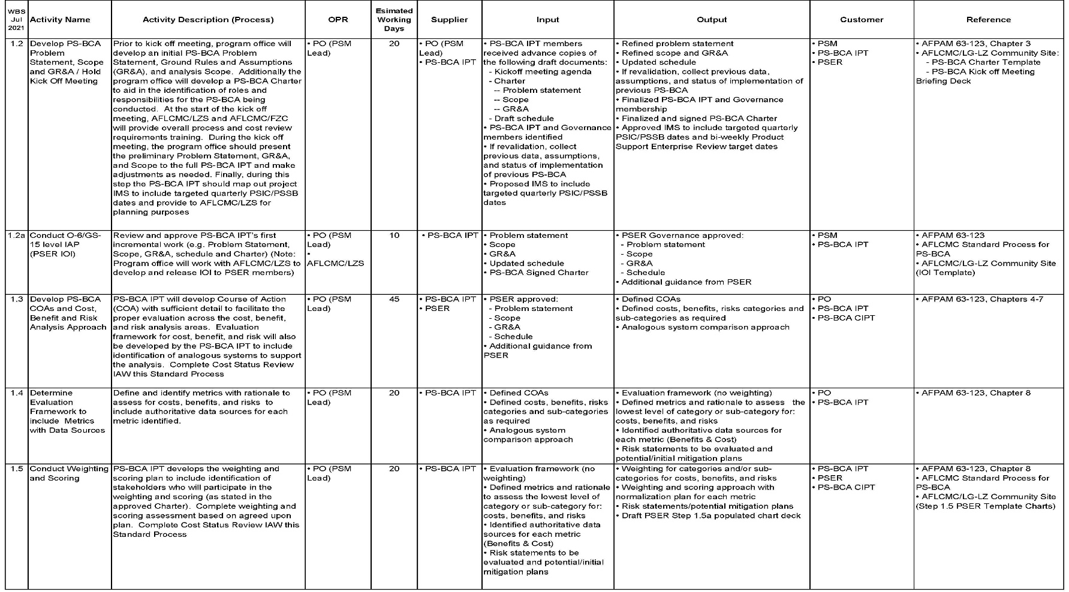

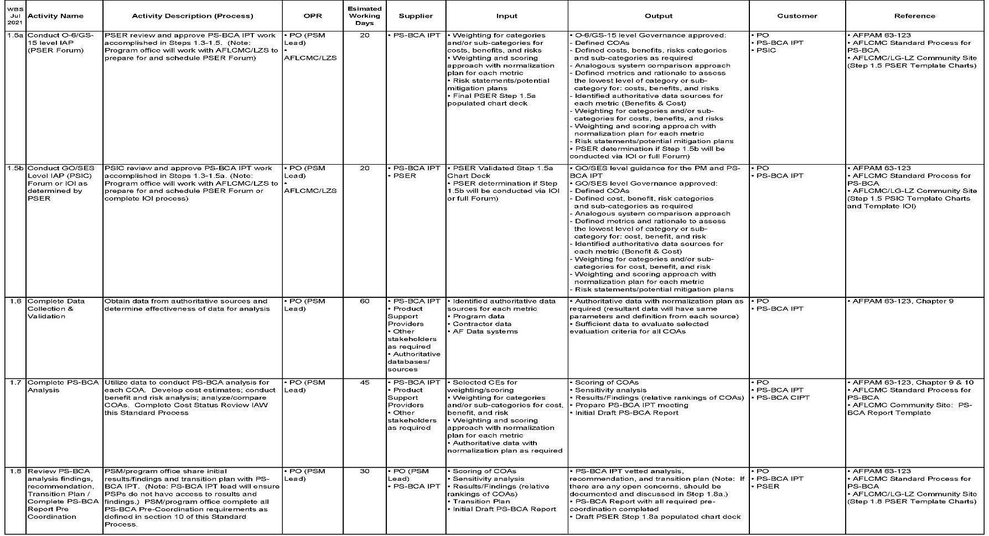

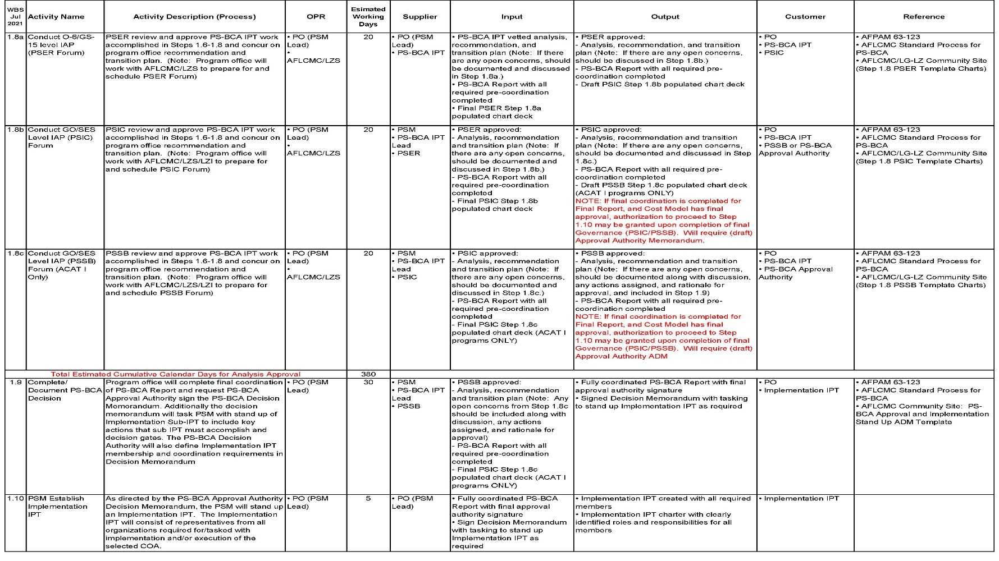

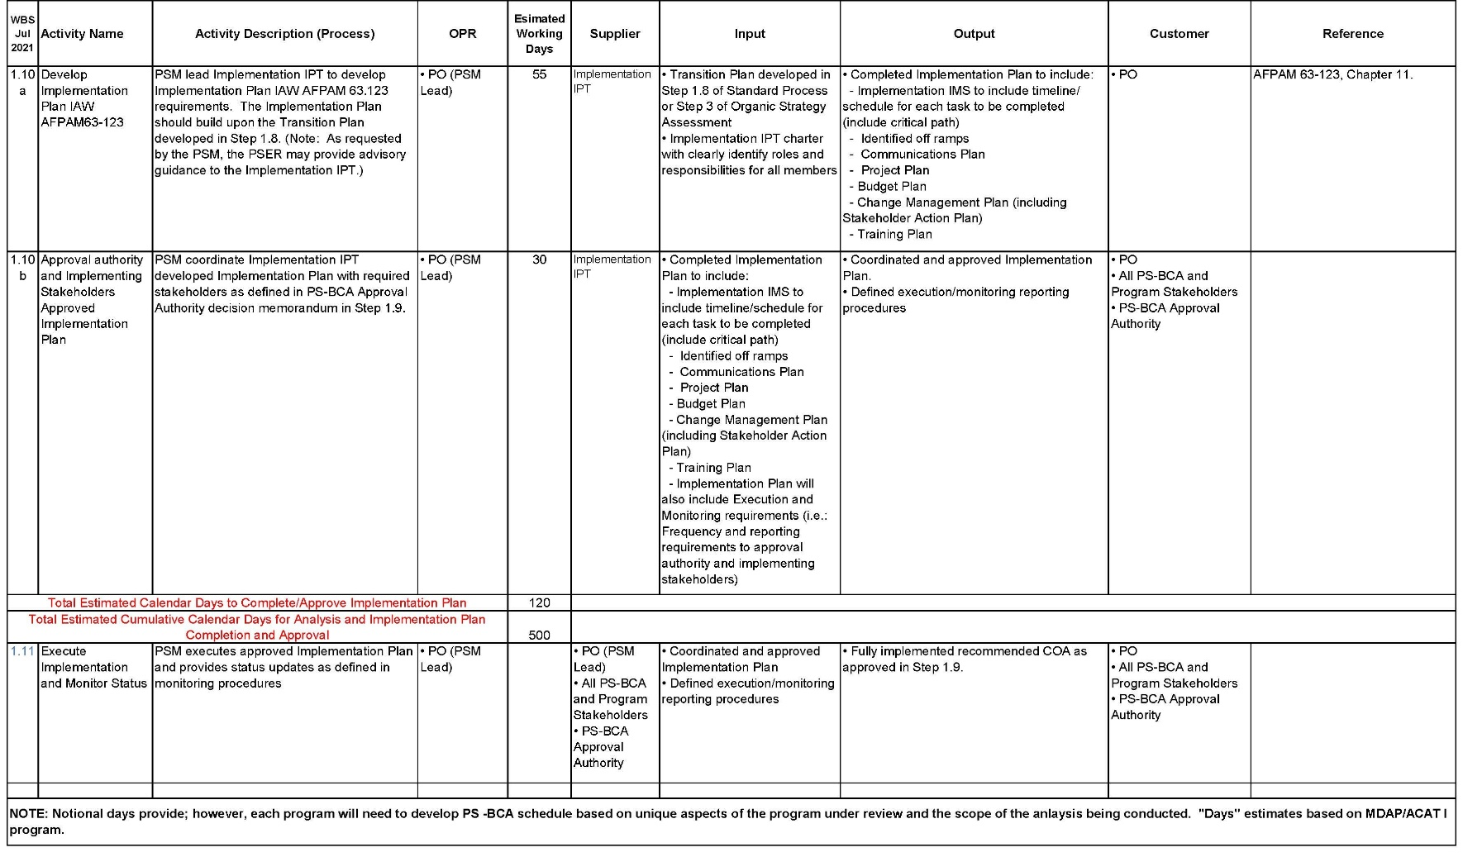

**To view WBS in excel, follow link below:**

https://usaf.dps.mil/:x:/r/sites/41289/_layouts/15/Doc.aspx?sourcedoc=%7B20F54BBE-AE62-4C69-992F-90B90F83AE57%7D&file=PS%20BCA%20WBS%20Jul%202021.xlsx&action=default&mobileredirect=true



**Attachment 6 Cost Team Roles/Responsibilities and Cost Review Expectations**



**Attachment 7 Product Support Governance Structure**

**Approval Authority (as defined in AFI 63-101/20-101)**

**Product Support Steering Board (3-Star/SES Board)**

**Co-Chair**: AFLCMC/CC, AFSC/CC and AFNWC/CC (when Nuclear Issues)

**Standing Members:** SAF/AQD, HQ AFMC/A5R/A4/FM/EN/PK, AFLCMC/LG, AFSC/LG and AFNWC/LG

**CENTER Functionals:** OSFs/ASDs/SMC/AFLCMC/AFNWC/AFSC (as applicable) PEO, Others as required by PEO

**Product Support Integration Council (Executive IAP*)**

**Co-Chair:** AFLCMC/LG, AFSC/LG, and AFNWC/LG (when Nuclear Issues)

**Standing Members:** SAF/AQD, HQ AFMC/A5R/A4F/FM

**CENTER Functionals:** OSFs/ASDs/SMC/AFLCMC/AFNWC/AFSC (as applicable) PEO, Others as required by PEO

**PSER (GS-15/O-6 IAP*)**

**Chair:** AFLCMC/LZS

**SAF:** AQD, FMC (as required)

**MAJCOM:** HQ AFMC/A4F/FM, AFSC/LGX, Others as required

**CENTER Functionals:** SMC/AFLCMC/AFNWC/AFSC (as applicable)

PM, End User, Others as required by PM

**\* Incremental Approval Point (IAP)**

**Product Support Business Case Analysis (PS-BCA) Final Report Staffing INSTRUCTIONS:**

**Attachment 8 Final Report Coordination Instructions and eSSS Template**

Workflows have been added for your convenience. Keep only what’s appropriate and delete the rest before you begin staffing. Prior to Step 1.8 of the WBS, the PS-BCA cost model is required to be reviewed/approved by HQ AFMC/FMC. ACAT I and Special Interest Programs are required to be reviewed by SAF/FMC. This is to assess methodology, repeatability, and traceability. This must be completed and annotated as part of Step 1.7 of the WBS.

The Program Office (PO) Action Officer (AO) will complete the below Electronic Staff Summary Sheet (eSSS) and send, via applicable workflows to **AFLCMC/LG-LZ, AFLCMC/FM/FZ, AFSC/LG, AFSC/FM-FZ, and HQ AFMC/A4F (A4F will task appropriate functional managers)** for review/coordination. Respective offices listed above will forward CRM back to PO AO for adjudication. NOTE: HQ AFMC/CC, CV or CA Coordination is not required unless requested by the PEO.

Instruction in email traffic to respective workflows must state “Send all coordinated CRMs (2-digit level) back to PO AO for adjudication.” PO AO will adjudicate Critical comments at each level of coordination.

**The PSM and PM will sign the PS-BCA**

**Final approval of PS-BCA is dependent on ACAT level:**

**All ACAT I and Special Interest programs will be Approved/Signed by SAF/AQD**

**ACAT II & III will be Approved/Signed by the PEO or other delegated authority IAW AFI 63-101/20-101 table 1.1. Milestone Decision Authority (MDA) Delegation**

**Product Support Business Case Analysis (PS-BCA) Final Report Staffing TEMPLATE:**

There will be a “pre-coordination” and a “final coordination” process. Below illustrates Program Office, Center Level, HQ AFMC and SAF level Coordination. If the program office wants to include additional review/coordination, for any reason, it must be identified by the program office.

Pre-coordination must be completed prior to proceeding to final coordination. All pre-coordination may be completed simultaneously. The eSSS will show coordination requirements for all applicable offices. You will need to include a single CRM, consolidating all feedback/adjudication from pre-coordination prior to advancing to final-coordination. See below for routing instructions.

Pre-coordination: Programs can coordinate with AFSC, AFLCMC and HQ AFMC offices simultaneously. Send via SOCCER to workflow addresses provided on template. AFMC/A4F will be the HQ AFMC liason and will task out within AFMC as required. Recommend you “cc” your primary POC from each office for awarenss.

Final coordination (ACAT I programs): PEO/PM will send an eSSS forward for official coordination.

All adjudicated comments must be provided to AFLCMC/LZS prior to final Governance Review

////////////////////////////////////////////////////////////////////////////////////////////////////////////////////////////////////////////

(Insert appropriate Directorate (see examples). Build eSSS with appropriate offices symbols required to coord/sign PS-BCA Final Report Document)

Examples:

AFLCMC/HB COORD

AFLCMC/WI COORD

AFLCMC/WW COORD

AFSC/LG COORD

AFSC/FM-FZ COORD [afsc.lgx.workflow@us.af.mil](mailto:afsc.lgx.workflow@us.af.mil)

AFLCMC/LG-LZS COORD [AFLCMCAQL.Workflow@us.af.mil](mailto:AFLCMCAQL.Workflow@us.af.mil)

AFLCMC/FM/FZ COORD AFLCMC.FM.FZ.workflow@us.af.mil

HQ AFMC

HQ AFMC/A4F COORD [afmc.a4f.work@us.af.mil](mailto:afmc.a4f.work@us.af.mil)

HQ AFMC/A5Q COORD

HQ AFMC/A9A COORD

HQ AFMC/FMC COORD

Final coordination/approval (ACAT I only)

SAF/AQD COORD

**-----------------------------------------** STAFF SUMMARY -----------------------------------------

**AO:**  NAME of Action Officer, AFLCMC/XXX, DSN XXX-XXXX

**SUSPENSE:** DATE

**SUBJECT:  A – TITLE OF PS-BCA (SOCCER # if applicable)**

**1.  PURPOSE:**  To request coordination on the XXX Program Product Support Business Case Analysis (PS-BCA) Final Report.

**2.  BACKGROUND:**

**3.  DISCUSSION:**

**4. VIEWS OF OTHERS**:  N/A

**5.  RECOMMENDATION:**  Provide all comments via Tab 2, PS-BCA Comment Resolution Matrix, for adjudication

**Tabs:**

1.  XXX Program PS-BCA Report

2. XXX PS-BCA Comment Resolution Matrix

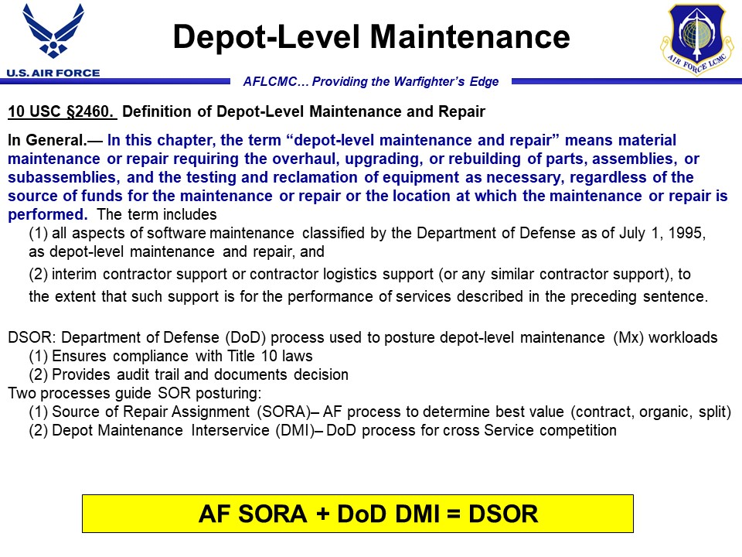

**Att Attachment 9 DSOR and Core Compliance**

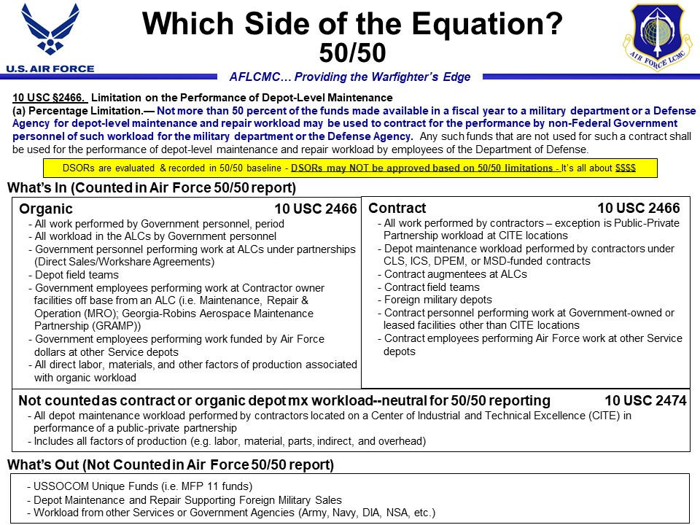

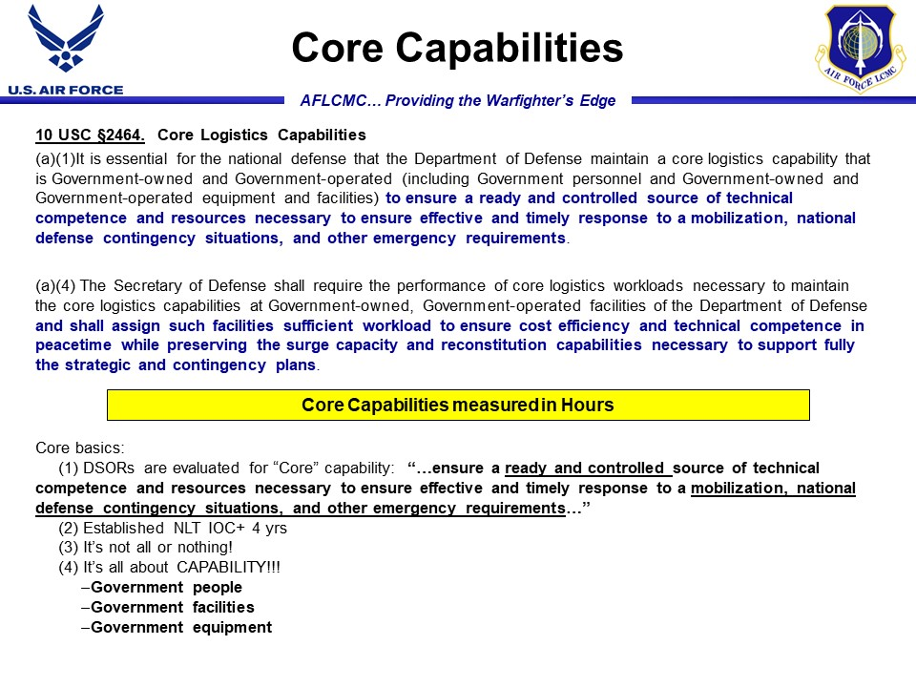

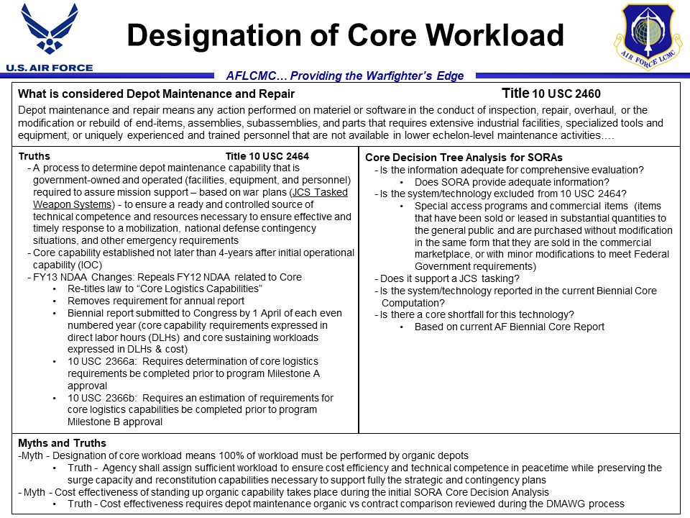

**Standard Process for Product Support Business Case Analysis**

**Att Attachment 10 Change Management Plan**

**Change Management Plan**

1. **Overview**
   1. Define the change: Streamlined current process and added pre-assessment guidance to assist PSMs to determine appropriate level of analysis required
   2. Desired Effect: Change Management Plan (CMP) intended to provide the updated AFLCMC Standard Process for Product Support Business Case Analysis (PS-BCA) to all AFLCMC programs planning for or considering conducting a PS-BCA.
   3. Measures for success: Monthly Program Management Reviews show status of all on-going PS-BCAs and semi-annual S&P Board reviews show compliance metrics.
   4. Barriers to implementation: Addition of pre-assessments for programs familiar with current process.
2. **Change Management Approach**
3. Stakeholder(s) Identification: Any AFLCMC program requiring a PS-BCA.
4. Communication plan: Updated AFLCMC Standard Process will be provided to all programs currently completing or planning for a future PS-BCA. Also, the process will be available on SharePoint site along with other currently available guidance
5. Training plan: Target audience is any AFLCMC personnel desiring a need to understand the PS-BCA process. Training will be provided during Focus Week, LG-LZ Roadshows and one-on-one as needed/requested.
6. Resistance management plan: Communicate and training on rationale and benefit of streamlined process in completing PS-BCA requirement.
7. **Plan for Post-Change Assessment**
   1. Assessment of the desired change effect: Continous engagement, feedback and guidance to programs completing a PS-BCA
   2. Control mechanisms and corrective actions: Leadership is briefed on a monthly basis on status of all programs completing a PS-BCA and engages as necessary to ensure programs are complying with process.