Air Force Life Cycle Management Center (AFLCMC)
Standard Process
For
Logistics Health Assessment (LHA)

Process Owner: AFLCMC/LG-LZ
Date: 16 February 2023
Version: 1.13

Record of Changes.

Record of Changes
Version | Effective Date | Summary
1.0 | 21 Mar 2013 | Basic document. Approved by S&P Board on 21 Mar 2013.
1.1 | 16 May 2013 | Added/incorporated clarification comments from EN and PK. Approved by S&P Board on 16 May 2013.
1.2 | 1 July 2013 | Incorporated LHA Business Rules Attachment. Updated links.
1.3 | 17 October 2013 | Changed System Metric and Reporting Tool (SMART) to Acquisition Workbench. Update language to reflect life cycle considerations.
1.4 | 27 December 2013 | LHA Compliance Decision Model.
1.5 | 27 July 2015 | LHA data will now be pulled 2nd business day after the due date, time metric clarified, added AFMC Council Metric, training now conducted by AFLCMC/LG-LZ, Cost/Schedule category added, AFI 63-101/20-101, AFLCMC Memorandum updated, LHAs now to be performed twice a year vice quarterly (March and September), LHA Business Rules (Attachment 1), and comments are now required on all questions.
1.6 | 21 December 2015 | Adjusted the LHA Business Rules (Atch 2) to align with the changes in the LHA SP.
1.7 | 13 December 2016 | Updated Standard Process to add new LHA Compliance and Quality metric approved by S&P Board and to align Business Rules to updated LHA scoring methodology (Atch 2).
1.8 | 26 February 2018 | Updated Standard Process and Business Rules to reflect the LHA frequency changing from a semi-annual assessment to an annual assessment starting in Jun 18 and updated LHA metric to reflect LHA compliance and the top 5 Product Support risk drivers each LHA cycle.
1.9 | 21 February 2019 | Updated Standard Process to reflect the change in ownership organization from AFLCMC/LZIA to AFLCMC/LZSB. Also, change to Figure 2, LHA Compliance and Product Support Risk Metric SMART Attributes, for exclusion of Low Risk (In-Process) responses from risk calculation / identification. Eliminated references to WSER. Eliminated references to WSER in Attachment 1, LHA Business Rules. Approved at 21 FEB 2019 S&P Board.
1.10 | 15 April 2020 | Updated Standard Process and Business Rules to reflect the consolidation of the LHA and ILA question sets and to account for the rehosting of the LHA to Cloud One.
1.11 | 3 November 2020 | Updated the Standard Process for other necessary updates reflecting the re-hosting of the LHA to Cloud One.
1.12 | 8 February 2021 | Modified waiver process. Updated language to reflect SAM functionality. Approved at 18 Feb 21 SP&P Group.
1.13 | 16 February 2023 | Removed/updated application usage and replaced with official Excel submission instructions. Updated References. Removed application usage from Business Rules. Updated waiver submission process. Approved at 16 Feb 23 SP&P Group.

Table of Contents
1. Description 4
2. Purpose/Scope 5
3. Potential Entry/Exit Criteria and Inputs/Outputs 5
4. Process Workflow and Activities 6
5. Measurement 9
6. Roles and Responsibilities 11
7. Official AFLCMC Question Sets (Excel Spreadsheets) 12
8. Training 12
9. Definitions, Guiding Principles, or Ground Rules & Assumptions 12
10. Acronyms 15
11. References to Law, Policy, Instructions or Guidance. 16

Description
  - The Logistics Health Assessment (LHA) provides the Life Cycle community a standard, tailorable, user-friendly tool to report on and ensure long-term sustainment and availability considerations that can be identified and integrated into early program/system decisions and re-evaluated throughout the life cycle of the program/system. This assessment enhances the potential for systems to be fielded and managed with a product support structure in place and optimizes the warfighter’s ability to meet mission performance requirements. The LHA contains 14 question sets addressing the 12 Integrated Product Support Elements (PSEs), Product Support Cost/Schedule and Environment Safety and Occupational Health (ESOH). Additionally, a non-graded demographic question set is included. The LHA covers all program phases from Materiel Solution Analysis (MSA) through Operations & Support (O&S) [Department of Defense Instruction (DoDI) 5000.02]. Additionally, by identifying potential risks, the LHA becomes a predictive tool. The Product Support Manager (PSM) or designated representative shall ensure all questions, regardless of the answer selected, have a rationale for rating/issue explanation to provide a historical record and verification of status. Program resources include referencing the program/system’s Acquisition Strategy, Statement of Work (SOW)/contract, or other acquisition documents, e.g., Life Cycle Sustainment Plan (LCSP), Systems Engineering Plan (SEP), Test and Evaluation Master Plan (TEMP), etc.

  - In accordance with Air Force Instruction (AFI) 63-101/20-101 Para. 7.9.1 and Air Force Life Cycle Management Center (AFLCMC) Memorandum, “Logistics Health Assessment Process Change for AFLCMC Programs” dated 15 August 2017, all AFLCMC Acquisition Category (ACAT) programs [managed IAW Department of Defense (DoD) 5000.02] on the Active Acquisition Master Listing (AML) and Weapon System flying platforms in O&S will complete an LHA once per year to capture enterprise compliance and facilitate an enterprise product support health assessment.
Depending on individual program requirements, additional out of cycle LHAs can be accomplished if required (e.g., meeting program acquisition milestone/review, etc.). As an example, existing programs/projects that are planning on becoming a Program of Record (PoR) would be required to complete an LHA in advance of being placed formally on the AML. Such an LHA would be completed and ready for the Milestone Decision Authority (MDA) to approve the current state of the LHA and Product Support Strategy (PSS). Programs not required to complete an LHA may complete one if they so choose to assess the program product support health. Such an LHA would be completed and ready for the MDA to approve the current state of the LHA and PSS. Directorates are encouraged to internally require non-AML programs to complete LHAs at their discretion, and these LHAs will also be tracked and included in the baseline analysis. LHAs are accomplished at every phase of the life cycle.

Performing LHAs across all phases of programs will enable leadership to have a life cycle (cradle to grave) view of individual systems and ultimately an enterprise product support view across center programs. In addition, the LHA provides Integrated Product Teams (IPTs) and Programmatic Leaders insights into Program/Project gaps or deficiencies that need to be addressed, improved or corrected in order to provide the proper level of Product Support for the warfighter as well as ensure compliance. The LHA is also a tool that can be used to identify and provide additional workload requirements that may need to be included in the Government Cost Estimating (GCE) process to help improve financial/funding fidelity, planning and reporting. The LHA also directly feeds into the creation or update of the PSS.

Preferably, the system-level Program Manager (PM) and Product Support Manager (PSM) should be the review and approval authorities for individual LHAs (depending on program set up, PM and PSM may be dual hatted and may perform both review and approval function) with oversight and guidance from the Logistics Organizational Senior Functional (OSF) in the Program Executive Officer (PEO) Directorate in which the program resides.

Major Defense Acquisition Programs (MDAPs) planning to accomplish an Independent Logistics Assessment (ILA) will utilize their completed LHA (to include question responses, comments included, and risks identified) as the ILA Program Office Self-Assessment (SA). In addition to the completed LHA, a program shall also create a library of program related documentation to be used to verify the program office responses included in the LHA.

  - LHA data will be pulled by AFLCMC/LG-LZ on the 2nd business day following the LHA completion. See data pull schedule below, Table 1.
Table 1. Data Pull Schedule
LHA Due Date | AFLCMC/LG-LZ Data Pull
30 June | 2nd Business Day in July

Purpose/Scope
  - Purpose. The LHA is designed to ensure supportability considerations are addressed and managed effectively throughout the entire life cycle of the program/system. The LHA score and rating is the basis for a program’s PSS planning, implementation, execution, and recommendations across all program life cycle phases. The LHA will inform AFLCMC leadership and PEOs/MDAs of the supportability “health” of a program.
  - Scope. This Standard Process (SP) applies to AFLCMC and does not replace or supersede any existing laws, regulations, directives, policies, or instructions.
  - The LHA supports strategic planning (mission, vision, and objectives).

Potential Entry/Exit Criteria and Inputs/Outputs
  - Entry Criteria. A program in the “Active” status on the AML and Weapon System flying platforms in O&S will perform an LHA. Additionally, any program/project seeking to become a PoR will be required to complete an LHA in advance of the MDA, even though not yet on the AML. Once the initial LHA has been performed, this process will continue once per year to reflect updates in Product Support status. The required LHA completion date is 30 June. Programs may choose to conduct an LHA(s) more often if they so choose.
  - Exit Criteria. Final exit of the LHA process is when the program is no longer in the “Active” status on the AML or the Weapon System flying platform in O&S is no longer reported in the USAF active inventory.
  - Inputs. The completion of an LHA is an IPT activity, preferably with the assigned program Logistician as the primary functional point of contact. The LHA assessment is initially performed by Logistics and further enhancement, clarity and information is provided by other functionals as required. [Reference Work Breakdown Schedule (WBS) Table 3].
  - Outputs. A completed, reviewed, and approved LHA.

Process Workflow and Activities
  - Process Supplier-Inputs-Process-Outputs-Customer (SIPOC), Table 2.
Table 2. SIPOC
Supplier | Inputs | Process | Outputs | Customer
PSMs, Program Logisticians, PM, AFLCMC/LG-LZ, Other Functionals | Program information | Provides the program life cycle communities a standard, tailorable, user-friendly tool to report on and ensure long-term sustainment and availability considerations that can be identified and integrated into early program decisions. | LHA documented, reviewed & approved via official standardized LHA Question Sets (Excel spreadsheets) | HHQ, Center Senior Leadership PEOs, OSFs, PMs, PSMs, AFLCMC/LG-LZ, Process users, Other Functionals

  - Process Flowchart. The high-level process flowchart below (Figure 1) depicts the LHA process.
Figure 1. Process Flowchart.
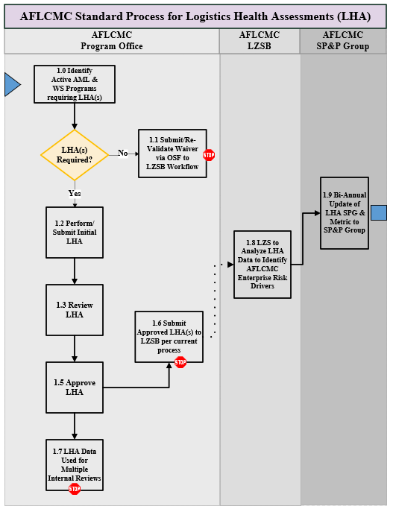

  - Work Breakdown Structure (WBS) gives the detail for process flowchart activities.

Table 3. WBS
Lvl | WBS | Activity | Description | OPR | Time (Hours/Days)
1 | 1.0 | Logistics Health Assessment (LHA) | Programs identified in the “Active” status on the AML and Weapon System flying platforms in O&S are required to complete an LHA | Owner: AFLCMC/LG-LZ
2 | 1.1 | Complete LHA Preparation Steps | Programs review the Compliance Decision Model (with Waiver Guidance) (Fig. 4) to determine if an LHA is required or if a waiver or re-validation of a waiver is required. If determined an LHA is required, obtain appropriate LHA question set found here. If waiver is appropriate, follow waiver guidance on the bottom of Compliance Decision Model (Figure 4) and submit via LZS Dropbox found here | PSM/Program Logistician | 1 hour
2 | 1.2 | Perform/Submit Initial LHA | Complete appropriate LHA via official AFLCMC Question Sets (Excel spreadsheets) | Program Logistician/any participant in LHA Rater | 15 Hours
2 | 1.3 | Review LHA | Conduct review according to Directorate review process | Functional lead Logistician/PSM or assigned delegate | 1 Hour
2 | 1.4 | LHA Pre-Approval Brief | Brief LHA results to PM, which may include:  - Question set overview  - Answer count by response type  - Changes detailed | PSM or assigned delegate | 1 Hour
2 | 1.5 | Approve LHA | Approve LHA | PM, PSM, OSF, or assigned delegate | 1 Hour
2 | 1.6 | Submit LHA | Submit via LZS Dropbox found here | Program Logistician or Delegate | 1 Hour

Lvl | WBS | Activity | Description | OPR | Time (Hours/Days)
2 | 1.7 | Use LHA data for multiple internal reviews | Provide LHA data to applicable Review(s) (e.g., ILA, Program Sustainment Reviews, etc.) in required format | PSM/Program Logistician | Through annual cycle of the LHA data and as needed
2 | 1.8 | Analyze LHA Data to Identify AFLCMC Enterprise Risk Drivers | Utilize roll-up reports, investigate for any trends / root causes for red categories / questions across the AFLCMC Enterprise and identify potential mitigation strategies. Provide feedback to Logistics OSFs during OSF Crosstalks | AFLCMC/LG-LZ | 20 Days
2 | 1.9 | Biannual Update of LHA SPG & Metric to AFLCMC SP&P Group | AFLCMC Standard Process & Product (SP&P) Group members review LHA metrics | AFLCMC SP&P Group | 2 hours

Measurement
  - Process Results: Measure programs in the “Active” status on the AML and Weapon System flying platforms in O&S completing LHA.
  - Compliance and Product Support Risk Metric. Figure 2 depicts the Specific, Manageable, Actionable, Relevant, Trending (SMART) attributes for the LHA Compliance and Product Support Risk metric and Figure 3 depicts the LHA Compliance and Product Support Risk metric that is shown to the AFLCMC Standard Process & Product (SP&P) Group.
  - Final business rules for the LHA Standard Process and this metric have been approved by the AFLCMC SP&P Group (Attachment 1).

Figure 2. LHA Compliance and Product Support Risk Metric SMART Attributes
 | Metric Attribute | Description
Administrative Info | APD Ref No | P01
 | Process Name | Logistics Health Assessment (LHA)
 | Process Lead | Amanda J. Abdinor
 | Metric POC | Amanda J. Abdinor
 | Date Completed | 1 Oct 2022
S | Metric Name / Description | Logistics Health Assessment (LHA) Compliance & Product Support Risk  Description: The measure LHA Compliance is the percentage of programs that completed the LHA. The LHA Product Support Risk measures the total percentage of risk identified by the top 5 Product Support Elements (PSE) for each LHA cycle across the AFLCMC enterprise.
 | Calculation | Compliance: Percentage of LHA eligible programs that completed the LHA.  Product Support Risk: The percentage of the total LHA questions which had responses of Med/High risk identified from all completed LHAs for the respective LHA cycle broken down by Product Support Element.
 | Business Rules | Please see “Attachment 1: LHA Business Rules” within the LHA Standard Process
M | Data Source | Consolidated Excel Spreadsheet from individual LHA Excel Spreadsheets
A | Process Owner | AFLCMC/LZSB
 | Decision Maker | AFLCMC/LG
 | Review Forum / Governance Body | SP&P Group
 | Target | 90% LHA Compliance
 | Thresholds (R/Y/G) | LHA compliance has a goal of 90% completion rate for each LHA cycle.  Product Support Risk does not have an associated R/Y/G threshold or goal but reflect areas that, from an enterprise perspective are areas that provide challenges to programs and are areas that are looked at to determine if there are common threads that can be addressed by policy changes, training, etc.
 | Baseline Performance | May 2017 Assessment
R | Enterprise Impact / Process Purpose | Provide leadership a snapshot of the LHA compliance and an enterprise look at those Product Support Elements that programs have identified risk from a program execution vantage point.
 | LCMC Obj | Objective 2.1
T | Baseline Date | May 2017
 | Review Frequency | Biannually
 | Update Frequency | Biannually
Figure 3. Compliance and Product Support Risk Metric for SP&P Group

Roles and Responsibilities
  - AFLCMC/LG-LZ (Process Owner)
    - Manage the overall LHA process on behalf of AFLCMC.
    - Maintain and coordinate any changes to this standard process, “AFLCMC Standard Process for LHA.”
    - Provide training to the AFLCMC workforce on how to complete the LHA during Focus Week, Journeyman Training, and ad hoc as requested/required and to communicate any changes to the LHA process.
    - Perform detailed analysis and develop mitigation plans for high risk areas on LHA data for use at AFLCMC level and presented during appropriate Logistics OSF Crosstalk forums.

  - PSM/Program Logistician or Delegate.
    - Complete the LHA via official AFLCMC Question Sets (Excel spreadsheets) found here
  - PSM/Functional Lead Logistician/PM or Delegate.
    - Ensure LHAs are performed for their assigned programs in accordance with center guidance.
    - Review and approve completed LHAs.
    - Ensure input from other functionals as required.
    - Serve as program logistics authority for LHA execution.
  - OSF for Logistics.
    - Advise the PEO/PSM on program LHAs and review portfolio LHAs for product support risk trends.
  - AFLCMC SP&P Group.
    - Approve the LHA standard process and all major revisions to the process.

Official AFLCMC Question Sets (Excel Spreadsheets)
  - The final LHA output will include the submission of the official standardized AFLCMC Question Sets (Excel spreadsheets) by means of the LZS Dropbox found here

Training
  - AFLCMC/LG-LZ will provide LHA training as required/requested. Classes will be taught in a classroom or online.
  - One-on-one assistance is available at any time from AFLCMC/LZSB.
  - AFLCMC/LG-LZ Community SharePoint LHA Training Files: https://usaf.dps.mil/sites/41289/Pages/SitePages/Logistics-Health-Assessment-(LHA).aspx

Definitions, Guiding Principles, or Ground Rules & Assumptions
  - AFLCMC LHA Compliance Decision Model.
    - This model enables programs to step through a flowchart to determine if it is required to perform an LHA. (See Figure 4).
    - Annual cycle LHA waivers are available for individual programs based on certain rationale. (See Figure 4).
    - The directorate OSF shall approve waivers submitted by programs within their directorate and shall notify LZSB of the decision. (See Figure 4). Waivers are required to be submitted/resubmitted annually.

Figure 4: AFLCMC LHA Compliance Decision Flowchart

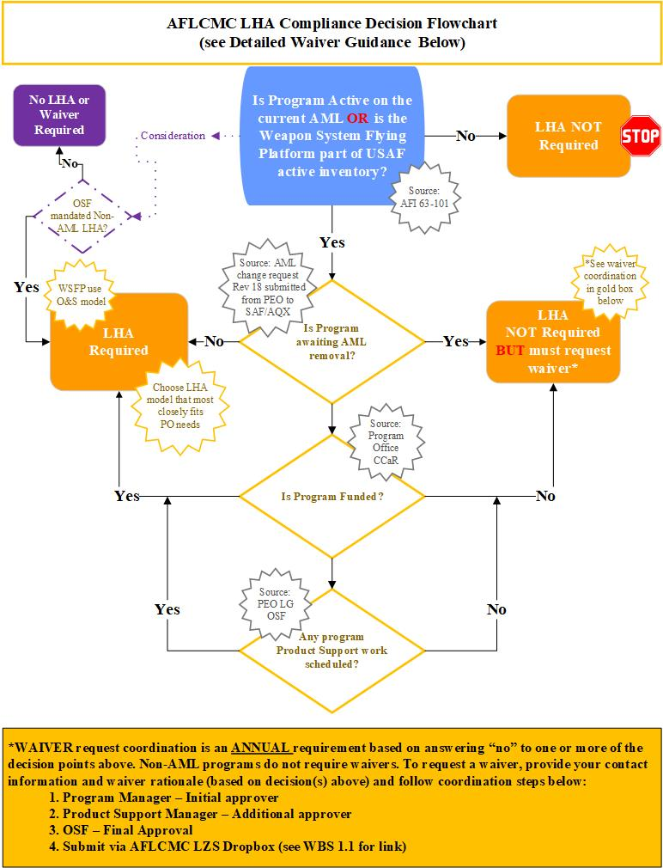

Acronyms
ACAT – Acquisition Category Programs
AFI – Air Force Instruction
AFLCMC – Air Force Life Cycle Management Center
AFMC – Air Force Materiel Command
AML – Acquisition Master List
DoD – Department of Defense
DoDI – Department of Defense Instruction
ESOH – Environment Safety and Occupational Health
GCE – Government Cost Estimating
ILA – Independent Logistics Assessment
IPT – Integrated Product Team
LCSP – Life Cycle Sustainment Plan
LHA – Logistics Health Assessment
MDA – Milestone Decision Authority
MDAP – Major Defense Acquisition Program
O&S – Operations & Support
OSF – Organizational Senior Functional
PEO – Program Executive Officer
PM – Program Manager
PO – Process Owner
PoR – Program of Record
PSE(s) – Product Support Element
PSM – Product Support Manager
PSS – Product Support Strategy
SA – Self Assessment
SEP – Systems Engineering Plan
SIPOC – Supplier, Input, Process, Output, Customer
SMART – Specific, Measurable, Action Oriented, Realistic, Time Bound
SOW – Statement of Work
SP – Standard Process
SPG – Standard Process Guide
SP&P – Standard Processes and Products
TEMP – Test and Evaluation Master Plan
WBS – Work Breakdown Structure
- References to Law, Policy, Instructions or Guidance. Process standardization is required by both Air Force Materiel Center (AFMC) and AFLCMC Strategic Plans. References that relate to this process include the following:

  - DoD Logistics Assessment Guidebook, 5 October 2022. Link (may require DAU log in): https://www.dau.edu/tools/t/Logistics-Assessment-Guidebook
  - DoD Product Support Managers (PSM) Guidebook, 17 November 2022. Link: https://www.dau.edu/tools/t/Product-Support-Manager-(PSM)-Guidebook
  - DAU Integrated Product Support Element Guidebook, 31 May 2022. Link (may require DAU log in): https://www.dau.edu/tools/t/Integrated-Product-Support-(IPS)-Element-Guidebook-
  - AFI 63-101/20-101, Integrated Life Cycle Management, 30 June 2020 (Incorporating Change 1, 23 November 2021). Link: http://static.e-publishing.af.mil/production/1/saf_aq/publication/afi63-101_20-101/afi63-101_20-101.pdf
  - AFLCMC/LG-LZ Memorandum, “Logistics Health Assessment (LHA) Process Change for AFLCMC Programs,” 15 August 2017. Link: LHA Memo for Annual Assessment_15 Aug 17.pdf

List of Attachments
Attachment 1: LHA Business Rules

