Air Force Life Cycle Management Center
Standard Process
For
Designation of Lead Developmental Test and Evaluation Organization (LDTO)

Process Owner: AFLCMC/AZT
Date: 15 Oct 2020
Version: 4.0

Record of Changes
Version | Effective Date | Summary
1.0 | 5 Dec 2013 | Standard process approved by S&P Board on 21 Nov 2013.  This standard process supersedes process approved by AFLCMC/AQT (CTA-WPAFB) and posted as Process Guide T126, dated 19 Sep 2012.
2.0 | 10 Jun 2016 | Updated to include AFMC/A3 8 Dec 2014 Interim Guidance Memorandum. Major changes: LDTO designation memorandum option removed IAW AFMC guidance and added introduction of new AFMC LDTO Designation Form 42, added a Change Management Plan and added note from AFMC/A3 that A&AS contractors cannot sign the Form 42.
3.0 | 18 Aug 2017 | Updated to include AFI 99-103 changes for “Alternate- LDTO” guidance. Updated attachment 2, Business Rules with enhanced AFMC Form 42 coordination/completion instructions. Administratively approved by S&P Board in June 2017.
3.1 | 16 Aug 2018 | Updated tools share-point links, added new training references, minor update to attachment 2 and various administrative fixes. Approved by S&P Board 16 Aug 2018.
4.0 | 15 Oct 2020 | Updated to include AFI 99-103 with AFMC Supplement changes for LDTO approval authority, Alternate-LDTO guidance and deletion of LDTO “blanket” designations. Improved process flowchart and WBS. Updated references and attachments. Approved by S&P Board 15 Oct 2020.

LDTO Designation Standard Process
- Description
  - The LDTO Designation Process facilitates the selection of the best suited and available test organization that can plan and execute Developmental Test & Evaluation (DT&E) activities for a project/program. The Program Manager (PM) is responsible for ensuring an LDTO is selected and designated as early as possible or after Material Development Decision (MDD) approval. The process is initiated by the program’s Integrated Test Team (ITT) that nominates a selected LDTO to the PM to begin approval coordination using the AFMC Form 42. The process concludes when an LDTO (or Alternate LDTO) is approved by AFMC/A3.
1.1.1 The Chief Developmental Tester (CDT), required for Major Defense Acquisition/Major Automated Information System programs or the Test Manager (TM) for other programs, co-chairs the ITT in executing this process. If no CDT or TM is appointed, the PM or other designee will need to complete the process. The PM may request support from the Directorate T&E Organizational Senior Functional (OSF) and the Center Test Authority (CTA) until a CDT or TM has been assigned/appointed.
  - Applicability: Acquisition or sustainment programs/projects that have a phase of Developmental Test and Evaluation (DT&E) require an LDTO that conducts/executes the DT&E and/or is responsible to oversee a group of organizations (including any contractor efforts) conducting DT&E for a program/project. Note: DT&E may include testing of commercial-off-the shelf and non-developmental items to validate the product or capability integrates into the intended environment and meets requirements and performance standards. See AFI 99-103 for Acquisition Category (ACAT) or other Acquisition Process Model applicability, LDTO responsibilities and types of DT&E. For low risk programs or projects, an Alternate LDTO option may be the best course of action for the PM (see paragraph 2.3).
  - Administration: After AFMC/A3F coordination, the completed form is returned to the Program Office (PO)/PM and copied to the weapon or system Program Element Monitor (PEM) if applicable and to the CTA. The PM (or CDT/TM) will forward a copy of the signed form to the LDTO/Executing Test Organization (ETO). The PM should reference this LDTO decision in the program Acquisition Strategy Plan (ASP) and Test and Evaluation Master Plan (TEMP) or equivalent documentation. See paragraph 3.4.
- Purpose
  - Proper selection: Execution of this process will ensure that the DT&E organization(s) with the most capable resources (including availability and cost considerations) is/are nominated and selected as the LDTO to support any given acquisition/sustainment project or program.
  - Single organization: No matter how many test organizations participate in DT&E activities, only one can/will be designated as the LDTO. Some LDTO organizations (e.g., AFTC and AFLCMC/CTA) may designate an ETO to carry out the duties of the LDTO directly with the program. The ETO should be known at the time of designation and noted on the AFMC Form 42.
  - Allows option: Per AFI 99-103, if an ACAT III program (or equivalent) is considered “low risk,” an Alternate LDTO option may be considered as a course of action for certain programmatic situations. For example, an LDTO may not be available or qualified to meet program/project DT&E requirements. In this case the ITT should fully investigate the viability and impact of not using an LDTO to address the testing and capability needs of the program/project or user/customer. In such cases, an alternate organization may be designated in lieu of an LDTO to perform and/or oversee the functions and responsibilities described in AFI 99-103. Justification must be provided to the PM that the Alternate LDTO option is best to meet cost, schedule, and performance interests. Also note that a trained and qualified CDT/TM must be appointed prior to nominating a PO as an Alternate LDTO. Use of a Participating Test Organization (PTO) may also be considered with LDTO or Alternate LDTO option.
- Entry/Exit Criteria
  - Entry Criteria: ITT nominates a selected LDTO or Alternate LDTO to the PM to begin approval coordination using the AFMC Form 42; designation process initiated.
  - Exit Criteria: AFMC/A3 signs AFMC LDTO Designation Form.
  - Inputs: Direction from the Directorate T&E Organizational Senior Functional (OSF) and/or program Chief Developmental Tester (CDT) or Test Manager (TM), early ASP discussions, consultation with local CTA office, and a copy of AFMC/A3 approved LDTO list, and communication with candidate LDTOs that include a description of the capabilities (technologies) the program is looking to develop/evaluate.
  - Outputs: AFMC/A3F signed AFMC LDTO Designation Form returned to the PM or PO and copy forwarded to the PEM (if applicable) and CTA.
- Process Workflow and Activities
  - Suppliers, Inputs, Process, Outputs & Customers (SIPOC), Table 1.
Table 1. SIPOC
Supplier | Inputs | Process | Outputs | Customer
Integrated Test Team (ITT) | Early T&E Strategy discussions | Initiate selection of an LDTO in conjunction with TEMP development | Selection Initiation | ITT, CDT/TM
AFMC/A3, Candidate LDTOs | AFMC/A3 approved LDTO list, discussions with candidate LDTOs | Research and analyze potential LDTO capabilities and resource availability | Comparison of TEMP LDTO capabilities and resource availability | ITT, CDT/TM
ITT | Analysis of candidate LDTO capabilities and resource availability vs. TEMP | Recommend LDTO candidate or Alternate LDTO option to the PEO for selection coordination | LDTO Recommendation or Alternate LDTO Option via AFMC Form 42 | PM
ITT | LDTO/Alternate LDTO Option Recommendation | AFMC/A3 Review/Approve recommended LDTO or Alternate LDTO Option | Signed AFMC LDTO Designation Form 42 | PM, PEO and LDTO
  - Process Flowchart. The process flowchart below, Figure 1, represents the LDTO Designation Process. The activities are further defined below and in Para 4.3, WBS.

Figure 1. LDTO Designation Process Flowchart
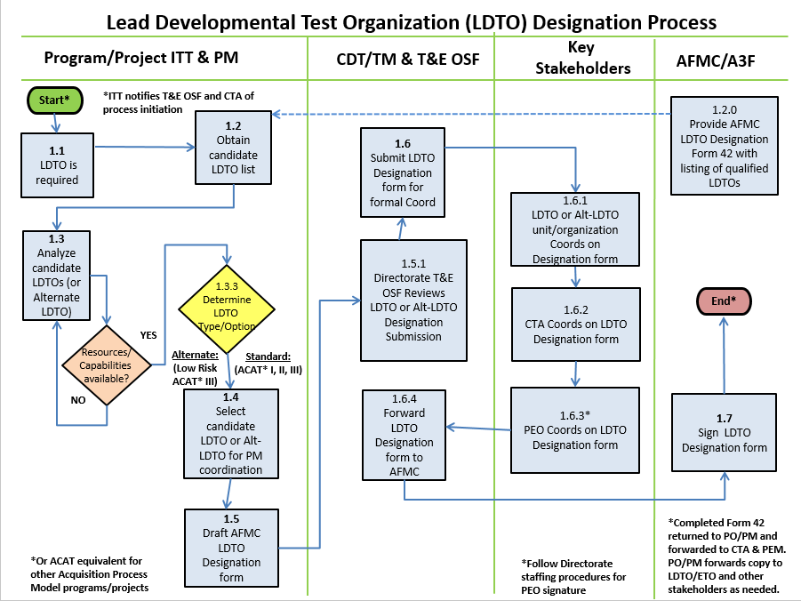

    - The CDT/TM (or PM designee) initiates the process with the ITT when an agenda item is open at an ITT forum/meeting to discuss designation of an LDTO for the project/program. The CDT/TM (or PM) should notify the Directorate T&E OSF and CTA that the process has been initiated.
    - The ITT, CDT/TM and PM can obtain/download a copy of the AFMC Form 42 for LDTO designation from the Air Force E-publications website. This form also contains the latest AFMC/A3 candidate listing of qualified LDTOs and their platform or system areas of expertise.
    - The ITT will contact and evaluate candidate LDTOs/ETOs and discuss with them the project/program’s information (capabilities and technologies that are to be developed) to determine if the candidates have the right DT&E skill sets and the human and capital resources to support project/program needs.
    - The ITT will analyze the candidate LDTO’s/ETO’s capabilities and resources and determine the “best fit” candidate for the project/program and appropriate ETO if applicable.
    - If an ACAT III program/project is determined to be “low risk” the ITT may recommend an Alternate LDTO Option if justified, to the PM. See Attachment 2, Business Rules paragraph 4.5 for additional information.
    - With the ITT’s determination, the CDT/TM (or PM designee) will draft the LDTO designation form for the PM concurrence and, after other stakeholder concurrence, forward to the PEO for coordination.
    - The LDTO designation form is also reviewed by the Directorate T&E OSF (as applicable) and coordinated thru the LDTO, CTA and PEO before forwarding to the AFMC/A3 for approval. See Attachment 2 for email workflow addresses.
4.3 Work Breakdown Structure (WBS). Attachment 1 provides a MS Excel version of the WBS with additional detail for all process activity steps and each activity box in Figure 1 flowchart.
- Process Measurement
  - Process Results
    - The overall LDTO designation process cycle time varies greatly based on the size and/or complexity of the program. Therefore the metric for this process will only measure the time it takes for an LDTO Designation Form 42 to complete the staffing/coordination process; the start is defined as the date the CDT/TM signs the LDTO Designation Form 42 and ends on the date the AFMC/A3 signs the form.
    - The measurement baseline for this metric is 45 business days.
  - Process Evaluation
    - AFMC/A3F should forward a copy of the approved form to the originating PO (or CDT/TM/PM) and CTA no later than 14 business days after final signature. CTA will track form start/end dates.
    - The CTA will monitor metric data for trends and for any indications that the current measurement standard may require an efficiency change or adjustment.
    - Process data may be briefed to the S&P Board by exception if negative trends are present/noted. Attachment 4 depicts the SMART metric attributes for this standard process.
- Roles and Responsibilities
  - Process Owner: AFLCMC/AZT, Center Test Authority (CTA)
    - Maintains and coordinates any changes to this process including responsibility for leading efforts on process improvement.
    - Secures approval for process changes via the Standards and Process Board.
    - The CTA chief concurs (or non-concurs) on LDTO recommendations.
  - Program Executive Officers (PEOs). Assist the PM, CDT or TM and ITT as needed in identifying key government DT&E execution organizations as LDTO candidates.
6.2.1 Concurs (or non-concurs) on LDTO designations to AFMC/A3.
  - Program Managers (PMs)
    - Ensures LDTO or Alternate LDTO option is selected (as appropriate), as early as possible or following program MDD or project equivalent.
    - Ensures the LDTO designation form is completed and forwarded to the selected LDTO for coordination before submission to the CTA and PEO.
  - T&E Organization Senior Functional (OSF). Executes all T&E functional policies, processes, and force development plans within their organizations. Reviews organization’s T&E plans documentation to include LDTO or Alternate LDTO submissions.
  - Chief Developmental Testers (CDT)/Test Managers (TM). Co-chairs the ITT and submits the LDTO designation form to the PM to begin coordination for approval.
  - Integrated Test Teams (ITT)
    - Begin the LDTO consideration/designation process after program/project initiation or start.
    - Communicate with candidate LDTOs and analyze their capabilities and resources to determine the test organization best-suited to accomplish the project’s or program’s DT&E activities/requirements.
    - Recommend LDTO candidate or Alternate LDTO option to the PM.
  - Candidate LDTOs.
    - Communicate with program or project ITTs to provide the test organizations capabilities and resource availability to plan and execute DT&E for the program/project.
    - Selected LDTO Concurs (or non-concurs) on PM’s recommendation.
  - HQ AFMC/A3.
    - Maintain, update and provide access to AFMC listing of qualified LDTOs for CDT/TM, PM, ITT and CTA reference.
    - Approves (or disapproves) LDTO selection after all stakeholders coordination.
- Tools/Resources
  - CTA Community SharePoint: https://usaf.dps.mil/teams/21435/cta/default.aspx
- Delivery Approach
  - Training
    - AFIT Course SYS 153 – Early Tester Involvement
    - AFIT Course SYS 154 – Test Planning, Execution and Reporting
    - AFIT Course SYS 253 – Early Test and Evaluation Influence in Acquisition
    - DAU Course TST 102 – Fundamentals of Test and Evaluation
    - DAU Course CLL 015 – Product Support Business Case Analysis
    - CTA Focus Week classes / CTA Test Manager orientation class/meeting
  - Change Management Plan. The Change Management Plan is located at Attachment 3 and describes the approach and methods used for implementing and institutionalizing this Standard Process.
- Definitions, Guiding Principles, Ground Rules, Assumptions and Acronyms. N/A
- References to Law, Policy, Instructions or Guidance
  - DoDI 5000.02 and DoDI 5000.02T
  - AFI 63-101 / 20-101
  - AFI 99-103 and AFMC Supplement
  - Air Force T&E Guidebook
  - Defense Acquisition Guidebook, Chapter 8
  - AFMC Form 42 (see AF publications website, MAJCOM section for current version)
- Attachments.

Attachment 1: MS Excel Version of WBS
Attachment 2: Business Rule Guidelines
Attachment 3: Change Management Plan
Attachment 4: Smart Metric Attributes

