Air Force Life Cycle Management Center
Standard Process
For
Intelligence Supportability Analysis (ISA)

Process Owner: AFLCMC/IN
Date: 18 November 2021
Version: 3.0

Record of Changes
Version | Effective Date | Summary
1.0 | 18 October 2013 | Standard process reviewed by Standards & Process (S&P) Board on 19 Sep 2013. Requested revisions were made and process was sent out to S&P Board members. Final approval granted at S&P Board on 17 Oct 2013.
1.1 | 6 November 2013 | Added minor clarifications to SIPOC, Para 4.1
1.2 | 1 February 2015 | Modified section 5 (Measurement) to better capture meaningful data/metrics for the AFLCMC/IN. Approved in S&P Board on 19 Mar 2015.
1.3 | 21 September 2016 | Incorporated terminology and guidance updates. Submission of new metric for approval.
2.0 | 19 September 2019 | Merges Intelligence Sensitivity Determination (ISD) and ISA Process Specifications into a single S&P process nested under the overarching ISA standard process. Incorporates additional administrative and guidance changes, and updates to references and links.
2.1 | 15 October 2020 | Annual update includes language changes stressing importance of threat informed acquisition and processes enabling rapid and tailored ISA support, link and reference updates, and updates to Section 8.0 Training courses. Approved by SP&P Group on 15 Oct 20
3.0 | 18 November 2021 | Annual update includes replacing the current metric, removing references to the Acquisition Intelligence Guidebook v3.0 and replacing with the MIE Manual, updating links and references. Future updates will need to include updated processes for measuring the new metric, as well as updating references currently in draft. Approved at 18 Nov 21 SP&P Group.

Intelligence Supportability Analysis (ISA) Standard Process

- Description
  - Intelligence Supportability Analysis (ISA) is the process by which the USAF intelligence, acquisition, and requirement communities collaborate to identify, document, and plan for intelligence requirements and supporting infrastructure necessary to successfully acquire and employ USAF capabilities, thereby ensuring intelligence integration and supportability. The goal of the ISA process is the identification of Derived Intelligence Requirements (DIRs) and gaps/deficiencies, along with associated risks to both acquisition and operational capability if the required intelligence is not provided. This collaborative effort should be initiated as early as possible and engaged throughout a program/effort/initiative’s (used interchangeably throughout this document) life-cycle in a phased and tailored approach to minimize risks to cost, schedule, and/or performance specifications. The results of the ISA process provide stakeholders with essential information needed to compare a capability’s stated or derived intelligence support requirements (data and infrastructure) with the intelligence community’s ability to deliver intelligence support across the capability’s lifecycle. The ISA process documents intelligence requirements, identifies intelligence gaps, and supports program risks assessments and mitigation strategies. (Note: Materiel Intelligence Enterprise (MIE) best practices can be found in the MIE Manual.)
  - Ensuring ISA inputs are incorporated into the programmatic documents listed below is critical to identifying, solving, and/or mitigating intelligence related shortfalls, issues, and concerns discovered during the analytic process. It is important to note that all ISA process elements can be tailored to best support each unique acquisition effort and the needs of the requirement owner and the Air Force. Key ISA activities and documentation includes:
    - The Intelligence Health Assessment (IHA) is the primary document summarizing the status or results of the ISA process. The IHA also documents DIRs and their mitigation strategies as they relate to cost, schedule, and performance which may or may not be accepted as part of the overall risk assessment of a program.
    - The Intelligence Sensitivity Determination (ISD) Memorandum for Record (MFR)
    - DIRs. Examples of DIRs include: threat data, geospatial information, PCPAD requirements and issues related to DOTMLPF
    - Community On-Line Intelligence System for End Users and Managers (COLISEUM) Production Requirements (PRs)
    - Intelligence inputs within programmatic documents such as the Intelligence Appendix to the Information Support Plan (ISP), Lifecycle Mission Data Plan (LMDP), Acquisition Strategy (AS), and the Systems Engineering Plan (SEP)
    - The Validated On-Line Life-Cycle Threat (VOLT) and other tailored products identifying the threat. The VOLT is the primary source for regulatory system threat assessments in the acquisition process for ACAT 1A/IAM/II/III programs. The authoritative threat assessment tailored for and normally focused on one specific MDAP and authorized for use in the Defense Acquisition Management Process (MDID)
  - The articles/documentation resulting from the ISA process are provided to the program office. Secret documents are stored in the GLADIATOR acquisition intelligence database (located on SIPRNET, reference 7.3). VOLTs are stored in the Defense Intelligence Threat Library. NOTE: Future tools are in development that may replace current online databases/tools, to include Joint Acquisition Intelligence for Mission Integration (JAIMI). Also, some programs may be required to reside on specific networks due to classification.
- Purpose
  - Intelligence integration in support of USAF and Joint systems development has never been more important or challenging than in today’s environment. Increasing threats from near peer adversaries, next generation weapon system Intelligence Mission Data (IMD) needs, and increasing Doctrine, Organization, Training, Materiel, Leadership, Personnel, and Facilities (DOTMLPF) related intelligence support requirements, demand early integration of intelligence and acquisition. When intelligence is not fully integrated into the acquisition lifecycle processes, the results often include scheduling delays, costly work-arounds, and unplanned adjustments to operations and maintenance and pre-planned product improvements. As future systems become more intelligence-dependent, it is imperative intelligence requirements are integrated as early as possible in the life-cycle to avoid prohibitive costs.
  - The desired effect of the intelligence function as a whole is to provide qualitative and quantitative improvements in survivability, performance, and capability and to reduce acquisition time and cost.
  - The ISA process provides the following elements necessary to effectively integrate intelligence into the effort’s acquisition life-cycle process:
    - A common understanding of effort’s intelligence needs across the intelligence, operations, requirements, and acquisition communities.
    - A working familiarity of intelligence infrastructure and threat analysis among acquisition/operational authority’s products or customer-funded alternatives.
    - Integration of IC stakeholders into planning, programming, and decision activities to weigh costs/benefits/tradeoffs.
    - An ability to analyze and compare a variety of intelligence requirements and deficiencies across numerous efforts to in order to recommend and advocate prioritized, efficient solutions at reasonable cost.
- Entry/Exit Criteria and Inputs/Outputs
  - Entry Criteria. Each Director of Intelligence (DOI)/Senior Intelligence Office (SIO) is responsible for identification of new work efforts that fall within their supported portfolio. Discovery of a new work effort could occur through one of the following methods:
    - Notification or request by the Program Manager (PM), Program Executive Officer (PEO), System Program Manager (SPM) to the intelligence division (DOI/SIO) for assistance in identifying a program’s intelligence supportability needs. AFLCMC/IN can be contacted (DSN 713-0619, Comm (937) 713-0619, AFLCMC/IN Workflow [aflcmc.in@us.af.mil]) to help identify supporting intelligence personnel assigned to each PEO.
    - Discovery or notification of new work effort on an acquisition master listing (i.e. Workload Master List (WML), Acquisition Master List (AML), Investment Master List (IML), or the Director Operational Test and Evaluation (DOT&E) Master List).
    - Approval of a new work effort through the AFLCMC corporate process (i.e. via the Project Management Resource Tools (PMRT) Requirements Identification Tool (RIT) new work approval process).
    - Discovery of new work effort through the formal/informal coordination of the Joint Capabilities Integration and Development System (JCIDS) requirements documentation such as the Capabilities Based Analysis (CBA) or the Initial Capabilities Document (ICD).
    - Discovery of a new work effort through the formal/informal coordination of DoDI 5000.02, “Operation of the Defense Acquisition System” activities/documentation such as the Analysis of Alternatives (AoA) Study Plan, or the Capabilities Development Document (CDD).
    - MAJCOM requested activity, program, or project.
    - Discovery of new work effort through formal/informal coordination with the Air Force Warfighting Integration Capability (AFWIC).
    - If there is a significant programmatic change in an effort (that is already being assessed for ISA) that impacts a program’s intelligence requirements, the effort will require an ISD reassessment, which will restart the ISA process.
    - If threat environment changes with the potential to significantly impact a program’s intelligence sensitivity determination, the effort will require an ISD reassessment, which would also restart the ISA process.
  - Exit Criteria
    - An effort is determined to be non-intelligence sensitive.
    - An effort’s intelligence needs are documented and supportable across the system’s life-cycle.
    - Intelligence shortfalls and gaps are addressed, solutions are planned, mitigation plans are developed and/or risks are accepted by all stakeholders.
    - Program, project, effort, or study is terminated or retired by the USAF or owning agency.
  - Inputs
    - Acquisition program master listings (for example the WML, AML, IML, or DOT&E Oversight List) and division-level portfolios.
    - Requirement process documentation such as the CBA and ICD.
    - Program documentation such as the Acquisition Strategy (AS), AoA, CDD, AF Form 1067 Modification Proposal, Transition Support Plan (TSP), and program staffing actions/packages.
    - Operational Plan (OPLAN), Concept of Operations (CONOPS), and DOTMLPF studies.
    - Joint Capabilities Technology Demonstration (JCTD), Urgent Operational Needs (UON), Joint Urgent Operational Needs (JUON), Joint Emergent Operational Needs (JEON), Quick Reaction Capability (QRCs), and roadmaps.
    - ISA process documentation such as the ISD Memo, Intelligence Sensitivity Survey (ISS), Intelligence Sensitivity Tier Matrix (ISTM), DIRs, PRs, Critical Intelligence Parameters (CIPs), intelligence Request for Information (RFI), VOLTs, and DOTMLPF study results.
    - Intelligence Community (IC) All-Source production documents
    - National Intelligence Program (NIP) (including General Defense Intelligence Program (GDIP) and Consolidated Cryptologic Program (CCP)), and Military Intelligence Program (MIP) documents.
    - Threat Working Groups (TWGs), Program Management Reviews (PMRs), Lifecycle Management Process (LCMP) reviews, and other programmatic meetings.
  - Outputs
    - ISD Memo/MFR to PM.
      - Usually the first ISA product produced to support the program, it informs the PM of the intelligence sensitivity of the assessed effort.
      - Provides initial assessment of the program to ensure intelligence requirements and any gaps are identified and mitigation plans are incorporated into the Acquisition Strategy as appropriate. It may also drive an Acquisition Decision Memorandum (ADM) and require the System Program Office (SPO) to identify/allocate capacity to address the effort’s intelligence needs.
      - May drive requirement for additional ISA and documentation by the program’s supporting Acquisition Intelligence Analyst (AIA).
      - Provides the PM information on general intelligence support considerations not specific to acquisition intelligence (e.g. current intelligence and threat briefings, Force Protection, Special Security Office (SSO) support for clearances and Joint Worldwide Intelligence Communication System (JWICS) IT support).
    - DIR documentation (including identification of potential gaps) supports program objectives and identifies any unique program requirements. DIRs document the results of ISA and requirements analysis into the applicable format/community standard. This may include an MFR, inputs in the Test and Evaluation Master Plan (TEMP), an Intelligence Appendix to the ISP, or Requirements Analysis Workbook (RAW) checklist, etc.
    - Listing of IMD requirements to support program objectives and identification of any IMD gaps. IMD elements identified via ISA will be submitted utilizing the most current tool of record (e.g. AIRViEW, spreadsheets, etc.). IMD shortfalls and gaps should be identified in the LMDP along with program courses of action to mitigate associated risks.
    - ISA outputs should also be documented in JCIDS (a requirement owner responsibility), programmatic, and product support documents such as the ICD, AoA, CDD, SEP, Acquisition Strategy, TEMP, LMDP, Program Protection Plan (PPP), and Lifecycle Sustainment Plan (LSP) depending on the level of IC involvement in the effort/program in relation to its current point in the life-cycle.
    - IC All-Source production documents
    - Identification and documentation of program DOTMLPF intelligence and/or intelligence infrastructure needs to meet program life-cycle requirements.
    - Associated intelligence supportability cost estimate to satisfy individual DIRs, and/or provide input to program office life-cycle cost estimate.
    - In addition to the ISD Memo, the IHA is the primary document summarizing the status or results of the ISA process. The IHA is an authoritative document created by an intelligence support working group, and approved by the DOI-SIO. It assesses the intelligence supportability of a capability based on nine intelligence support categories identified by JCIDS.
    - Other documentation reflecting the provision and/or method for long-term intelligence support is or will be established.
- Process Workflow and Activities
  - Suppliers, Inputs, Process, Outputs, Customers (SIPOC), Table 1.

Table 1. SIPOC

Suppliers  Providers of the required resources | Inputs  Resources required to execute the process | Process  Description of the activity | Outputs  Deliverable from the process | Customers  Anyone who receives outputs of the process
Director of Intelligence (DOI) / Acquisition Intelligence Analyst (AIA)  (Supporting Intelligence Division)/Program managers (PM) / project leads and Senior Intelligence Officer (SIO) / | New Acquisition program notification and documentation | Determine Intelligence Sensitivity of the new effort | Intelligence Sensitivity Determination (ISD) MFR/Memo | PM / project lead and SIO / DOI / AIA
SIO / DOI / AIA | ISD MFR/Memo and Program documentation | Prioritize Intelligence sensitive programs within the portfolio for allocation of low density high-demand intelligence resources to support the ISA effort | Intelligence Sensitivity Prioritization and COAs for the provision of ISA support (documentation to proceed to Intelligence Supportability Analysis if intelligence sensitive) | PM / project lead / PEO and SIO / DOI / AIA
PM / project lead and SIO / DOI / AIA | ISD MFR/Memo, Prioritization, ISA COAs, and Program documentation | Conduct Requirements Analysis | Identification of intelligence dependencies and/or requirements (e.g. DIRs, PRs, other JCIDS, programmatic, & product support documents) | PM / project lead / PEO, SIO / DOI / AIA, and the Intelligence Community (IC)
Intelligence Community | Program documentation, and ISA articles identifying intelligence dependencies/ requirements | Requirement analysis and analysis of available intelligence/ sources | Identification of Threat (e.g. VOLT and tailored threat documentation) and available intelligence resources and intelligence gaps (e.g. COLISEUM , various intelligence products) | PM / project lead / PEO, SIO / DOI / AIA
PM / project lead and SIO / DOI / AIA, and IC | Program documentation, DIRs, ISA articles identifying intelligence dependencies/ requirements, Intelligence gaps, IC all-source threat production | Identify Deficiencies and Conduct Risk Assessment | Plan to mitigate/resolve deficiencies / address intelligence gaps/shortfalls  (e.g. LMDP) | PM / project lead / PEO, SIO / DOI / AIA, and IC
PM / project lead,  SIO / DOI / AIA, and IC | All ISA data from all sub-processes | Compile, combine and disseminate all data to Program Office and supporting Intelligence Division | Data filed for record by the Program Office and stored in the GLADIATOR Acquisition Intelligence database on SIPRNET | PM / project lead / PEO, SIO / DOI / AIA, and IC

  - Process flowchart. The process flowchart below, Figures 1 & 2, represents the ISA process. These activities are further defined in Para 4.3 Work Breakdown Structure (WBS).

Figure 1. ISA Process Flowchart (Intelligence Sensitivity Determination)
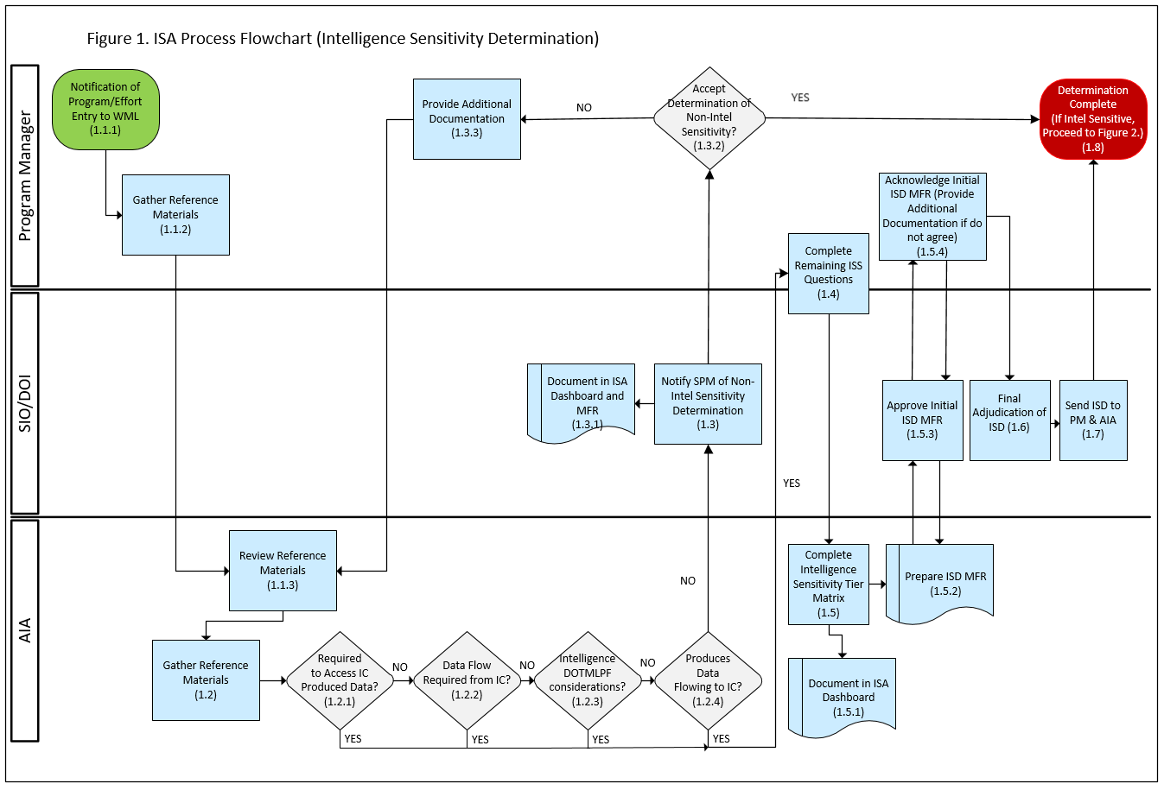
Figure 2. ISA Process Flowchart (Intelligence Supportability Analysis) [continued]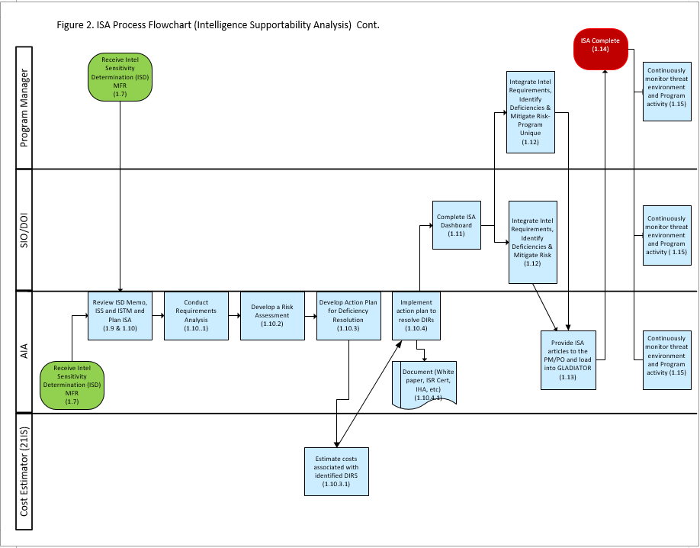

  - Work Breakdown Structure (WBS). The below WBS, Table 2, provides additional detail for the activity boxes in the above flowchart. The MS Excel version of this WBS with more detail is at Attachment 1. Note: References within Attachment 1 are currently in flux and will need updating at the next annual review. AFI 14-111 and AFMC Sup 1 to 14-111 are no longer valid and will be replaced with the (currently in draft/routing) AFMC Sup to AFI63-101/20-101, the MIE Manual, and the AFLCMC Annex to the MIE Manual.

Table 2. ISA WBS

Work Breakdown Structure
Process Name: ISA WBS
Process Owner: AFLCMC/IN
Level | WBS | Activity Name | Activity Description | OPR
1 | 1.0 | Intelligence Supportability Analysis (ISA) | This applies to all phases of Acquisition lifecycle (pre-Milestone (MS) A to post-MS C), including both major milestone and significant decision events. | Program Manager (PM)
2 | 1.1 | Create Intelligence Sensitivity Determination | Acquisition Intelligence Analyst (AIA) will create the Intelligence Sensitivity Determination (ISD), ISS long form, and the Intelligence Sensitivity Tier Matrix. The ISS associated checklist items should be reviewed with the program office to determine specific requirements. The ISD should be reviewed and updated as needed at each MS or major program change. (e.g. Developmental Planning kick-off, AF Form 1067, etc.) | SIO-DOI, PM, and AIA
3 | 1.1.1 | Notification of Program Entry to WML | PM works with the requirements community to create a program of record. Notification of success of program creation and budget allocation. | PM
3 | 1.1.2 | Gather Reference Materials | PM works with the requirements community to create a program documentation. | PM
3 | 1.1.3 | Review Reference Materials | AIA reviews program documentation provided by the program office | PM
2 | 1.2 | Gather Reference Materials | AIA researches program history and similar systems, threats, etc. | AIA
3 | 1.2.1 | Required to Access IC Produced Data? | Evaluation of Data created by IC needed for the system to operate (Intelligence Mission Data (IMD)) | AIA
3 | 1.2.2 | Data Flow Required from IC? | Evaluation of Data flow to an Intelligence, Surveillance, and Reconnaissance (ISR) sensor from Intelligence entities | AIA
3 | 1.2.3 | Intelligence DOTMLPF considerations? | Evaluation of the need for intelligence Doctrine, Organization, Training, Materiel, Leadership, Personnel, or Facility needs? | AIA
3  3 | 1.2.4  1.2.5 | Produces Data Flowing to IC?  Requires Threat Support | Evaluation of Data flow from an ISR sensor to Intelligence entities  Evaluation of required threat support to make programmatic decisions | AIA  AIA
2 | 1.3 | Notify SPM of Non-Intelligence Sensitivity Determination | Acquisition Intelligence Analyst (AIA) will review the Intelligence Sensitivity Survey (ISS). The ISS associated checklist items should be reviewed with the program office to determine specific requirements. The ISD should be reviewed and updated as needed at each MS or major program change. (e.g. Developmental Planning kick-off, AF Form 1067, etc.) The AIA will document a non-sensitivity rating for the SIO if none of the 1.2 questions are "yes". | AIA
3 | 1.3.1 | Document in Dashboard and MFR | Acquisition Intelligence Analyst (AIA) will draft an MFR identifying the program as non-intelligence sensitive and record the results of the ISD in a program entry on the Dashboard. | SIO-DOI
3 | 1.3.2 | Accept Determination of Non-Intelligence Sensitivity | The SPM or PM will either accept or reject statement of Non-Intelligence sensitivity. | PM
3 | 1.3.3 | Provide Additional Documentation | If Non-Intelligence sensitivity determination is rejected, the PM will need to provide additional reference documentation to the SIO-DOI-AIA for re-evaluation. | PM
2 | 1.4 | Complete Remaining ISS Questions | The ISS has initial questions to make a quick sensitive/non-sensitive determination. Completing the ISS allows the AIA analyst to be more specific about what some of the programs intelligence needs will be. | AIA, SIO-DOI, and PM
2 | 1.5 | Complete Intelligence Sensitivity Tier Matrix (ISTM) | The AIA will complete the tiering process using the Intelligence Sensitivity Survey and the units Tiering methodology | AIA
3 | 1.5.1 | Document in Dashboard | The AIA will document the result of the tiering process in the Dashboard. | AIA
3 | 1.5.2 | Prepare ISD MFR | The AIA will document the requirements, the result of the tiering process, the support that will be provided, and will not be provided in the ISD MFR | AIA
3 | 1.5.3 | Approve Initial ISD MFR | The SIO-DOI approves the documentation of the requirements, the result of the tiering process, the support that will be provided, and will not be provided | SIO-DOI
3 | 1.5.4 | Acknowledge Initial ISD MFR (Provide Additional Documentation if do not agree.) | The PM will acknowledge the documented requirements, the result of the tiering process, the support that will be provided, and will not be provided | PM
2 | 1.6 | Final Adjudication of ISD | The SIO-DOI will adjudicate between the PM and AIA to finalize the intelligence sensitivity and level of intelligence support | SIO-DOI
2 | 1.7 | Send ISD to PM and AIA | The SIO-DOI will send the final Adjudication of ISD to both the PM and AIA | SIO-DOI
2 | 1.8 | Send ISD to PM & AIA | The ISA process stops for Non-Intelligence sensitive programs. The memos generated in step 1.7 lead to more steps for Intelligence sensitive projects. | SIO-DOI
2 | 1.9 | Review Intelligence Sensitivity Determination | Acquisition Intelligence Analyst (AIA) will review the Intelligence Sensitivity Determination (ISD), ISS long form, and the Intelligence Sensitivity Tier Matrix. The ISS associated checklist items should be reviewed with the program office to determine specific requirements. The ISD should be reviewed and updated as needed at each MS or major program change. (e.g. Developmental Planning kick-off, AF Form 1067, etc.) | AIA and PM
2 | 1.10 | Plan ISA | Determine top-level estimate of resources needed to conduct ISA. PM, working with the AIA/Intelligence Division, develops an estimate for the scope of work needed for ISA. Determine program top-level ISA deliverables and deliverable dates; intelligence data requirements and program skill set requirements as identified in the ISS long form checklist. | AIA
3 | 1.10.1 | Conduct Requirements Analysis of efforts intelligence data requirements | Review program requirements and determine intelligence data needs to support program. (PM and AIA will review requirements throughout lifecycle of program) | AIA
3 | 1.10.2 | Develop a Risk Assessment | After a DIR is assessed as a deficiency, the next step is to determine the risk to the program if the deficiency is not satisfied. Program stakeholders of the effort need to understand the impact of not satisfying the deficiency in order to make resource prioritization decisions. Additionally, the IC needs to understand the impact so they can prioritize their support based on customer needs. Risk is analyzed from cost, performance, and schedule perspectives over the lifecycle of the program. Depending on the risk, Acquisition and Operations stakeholders may decide to assume the risk, employ more resources to reduce the risk, employ a different tactic or product design, or find another way to mitigate the risk. (quantify the impact to the performance and operational effectiveness of the capability of missing/degraded intelligence) | AIA
3 | 1.10.3 | Develop Action Plan for Deficiency Resolution | Depending on the action plan, implementation documentation may include producing a white paper, advocacy briefing, an ISR-CART input, IHA, intelligence support shortfall (in the impacted program’s CDD Paragraph 9), ISP (Issues' section or, if necessary, Intelligence Appendix), and/or other programmatic products (such as a Test and Evaluation Master Plan (TEMP), Acquisition Strategy Panel (ASP) briefing, etc.) type of document. | AIA
4 | 1.10.3.1 | Estimate costs associated with identified DIRs | AFLCMC’s 21st Intelligence Squadron cost estimators, in coordination with PM and SPC/IPC will support and/or develop cost estimates of intelligence supportability requirements, for inclusion in PM life cycle cost estimate; IMD and related Planning and Direction, Collection, Processing and Exploitation, Analysis and Dissemination (PCPAD) costs will be determined by the IMD producer (DIA, NASIC, etc.) | 21 IS costers
2 | 1.10.4 | Implement action plan to resolve DIRs | Once an action plan is developed, agreed upon by OPRs and documented, support the PO and Operational MAJCOM to inform the applicable intelligence, acquisition, test, and operational communities’ leadership and obtain approval on the resolution plan; support the PO, Operational MAJCOM and other mitigation OPR/OCR/POCs to implement the action plan. | AIA
4 | 1.10.4.1 | Document (White paper, ISR- Cart, IHA, etc.) | Document requirements and deficiencies to include associated risks. | AIA
2 | 1.11 | Complete Dashboard | Document level of support and status of support in the Dashboard on GLADIATOR | SIO-DOI and AIA
2 | 1.12 | Integrate Intelligence Requirements, Identify Deficiencies, and Mitigate Risk | Once a resolution is agreed upon to satisfy the shortfall, the decision needs to be acted on by the PM if the shortfall is unique to the program. If the shortfall falls within several programs then the SIO-DOI will coordinate with the 21 IS/INX for cross program analysis. In this situation, the PM needs to be informed of the plans and kept apprised of the status. | PM and SIO-DOI
2 | 1.13 | Provide ISA articles to the PM/PO and load into GLADIATOR | Once all ISA steps have been attempted/completed, AIA will compile all ISA data (ISD memo, ISS, ISTM, DIR, CIP, PR, DOTMLPF, IHA, memos, schedules, meeting minutes, PSR reviews, etc.) and place in Acquisition Intelligence centralized database (GLADIATOR). | PM and/or SIO-DOI
2 | 1.14 | ISA complete | Determines process is complete for this iteration | PM
2 | 1.15 | Continuously monitor threat environment and program activity | Assigned / applicable intelligence support organizations stay involved in program activity, as authorized by PO and/or Operational MAJCOM. Intelligence support organizations continue to review the foreign threat environment, key program documentation deadlines and status of program intelligence deficiencies, providing updates to stakeholders as required and resourced. If significant modification/upgrade to program, must go back to the ISS WBS. | PM, SIO-DOI, and/or AIA

  - Work Guidance Package
    - MIE Manual. [Access Controlled: Contact AFLCMC/IN, DSN 713-0619, aflcmc.in@us.af.mil]
    - AFLCMC/IN Toolset
https://intelshare.intelink.sgov.gov/sites/acqintel/ (SIPRNet)

- Process measurement
  - Process Results
    - The goal is to have a current (dated within the last 24 months) Intelligence Health Assessment (IHA) for all (100%) of intelligence sensitive programs. Eighty percent (80%) of all Intelligence sensitive programs assessed for ISA is considered the minimal acceptable threshold for metric reporting. When determining priority of work, DOIs/AIAs should take into account PEO and SML priorities. NOTE: the MIE Manual currently states IHAs should be current within 24 months; however, it is acknowledged that with the immergence of the Adaptive Acquisition Framework (AAF), 24 months may not be applicable to all pathways. Actions are underway to re-evaluate the impact of the AAF on the IHA template and timelines and will be addressed in the next update to this Standard Process.
  - Intelligence sensitive Process Evaluation
    - Metric data will be collected on programs once they are determined to be intelligence sensitive. The supporting DOI or AIA will build an entry for the program on the Dashboard (located in the GLADIATOR Acquisition Intelligence Database on SIPRNET, reference 7.3) based on a program’s discovery.
    - The Dashboard provides a visual snapshot of the status of ISA support for each intelligence sensitive program within a PEO’s portfolio. The supporting AIA will update the Dashboard as ISA articles are produced for the program and review program entries monthly. Metric data is collected and reviewed quarterly for process analysis.
  - Process Metric
    - The process metric will reflect the number of intelligence sensitive programs with a current (within 24 months) Intelligence Health Assessment (IHA) (as a percentage) out of all intelligence sensitive programs identified. The metric will be tracked on a quarterly basis by AFLCMC/IN in the following format (see Figure 3 and 4 below). The metric (Figure 3) will show percentages by PEO. Metric updates will be provided to the S&P Board annually or by exception once the minimum threshold (80%) is reached for four consecutive quarters by AFLCMC/IN.

Figure 3. Intelligence sensitive Programs Supported Metric

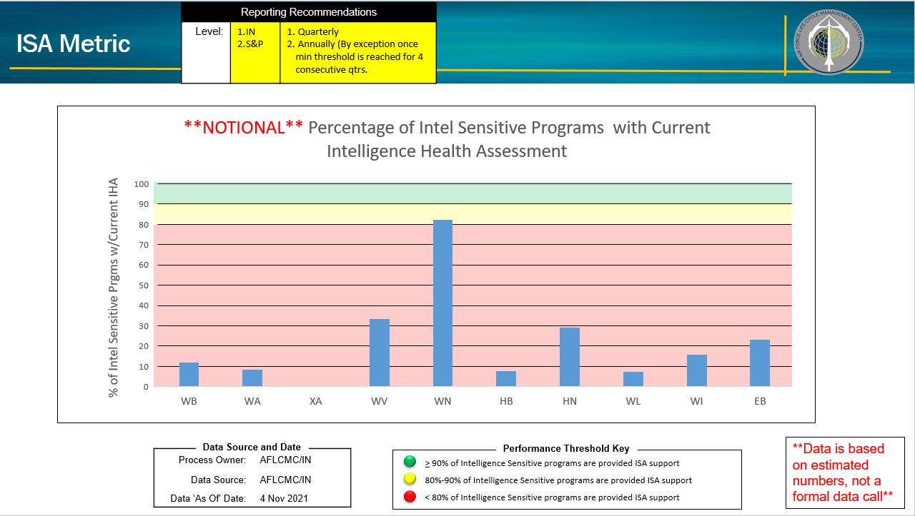
Figure 4. Intelligence sensitive Programs Metric Attribute Chart

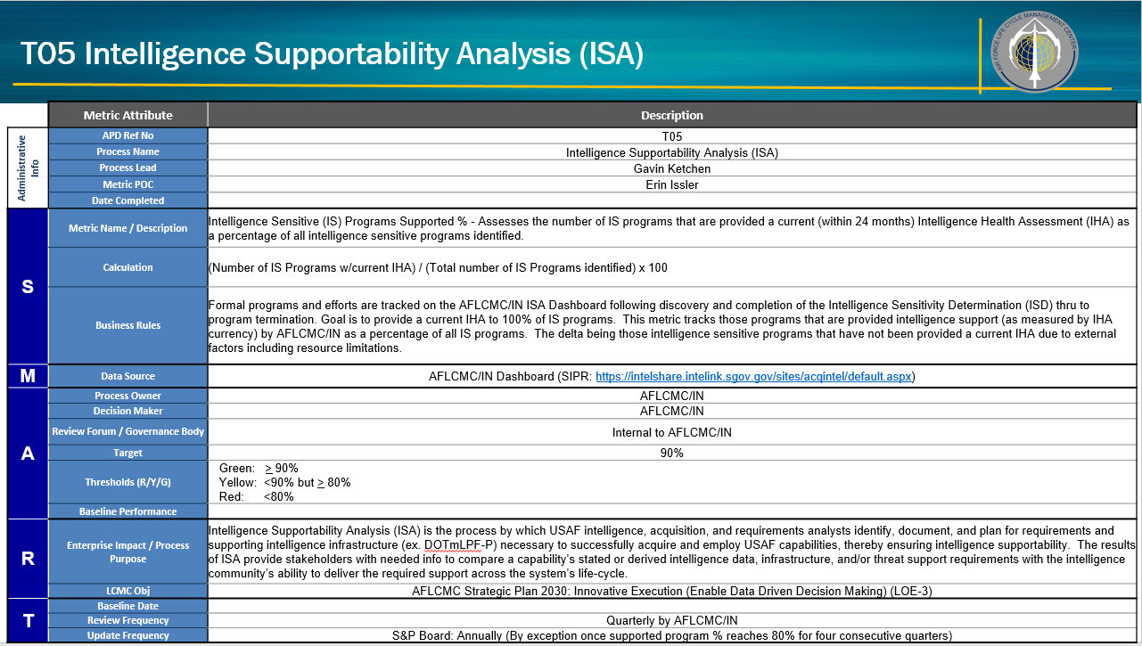
- Roles and Responsibilities
  - Process Owner AFLCMC/IN
    - Maintains and coordinates any changes to this process.
    - Leads and/or assigns personnel to work on process improvement and change events related to this process as required.
    - Secures approval for changes to this process with the Standards and Process Board.
  - Program Executive Officers (PEOs)and Senior Materiel Leaders (SMLs)
    - Ensures intelligence supportability considerations are integrated into all relevant acquisition programs in the PEO’s portfolio.
    - Ensures PMs request sufficient acquisition intelligence support throughout the lifecycle of the program.
    - Ensures new programs, or programs that have significant changes to key performance parameters or key system attributes, are appropriately identified to the supporting acquisition intelligence division for ISD assessment and ISA support.
    - Acknowledges intelligence supportability requirements of assigned programs, as determined by the Director of Intelligence.
    - Establishes program support mission priorities within their portfolio and informs their Organization Senior Functionals’ apportionment of functional resources accordingly.
  - Program Manager (PM)
    - Notifies the DOI/SIO/AIA of new program or programs that have significant changes to key performance parameters or key system attributes for ISD (re)assessment and request ISA support as required.
    - Provides program reference materials to the DOI/SIO/AIA for review and analysis in support of the ISA process.
    - Schedule ISD and complete an ISS in consultation with the supporting AIA.
    - Initiates the ISA process once a program has been identified as intelligence dependent (reference the ISD Memorandum for Record). (Ideally intelligence support to an effort/idea began during the JCIDS process and transitioned through to the Acquisition chain as the effort matured into a program. However, it is the PM’s responsibility to ensure intelligence requirements needed to support the program across the life-cycle have been identified and documented.)
    - Partners with the DOI/SIO/AIA to identify the program’s intelligence requirements and support ISA analytic efforts for their programs.
    - Ensures the DOI/SIO/AIA receives notification of any capability changes to programs which will affect intelligence dependencies.
    - Coordinates with the DOI/SIO/AIA to identify intelligence requirement gaps, develop mitigation plans and strategies, resolve deficiencies, and provide intelligence inputs to programmatic documents as applicable.
    - Ensures ISA is considered prior to each program milestone or significant decision event.
    - Receives the ISD MFR.
    - Integrates intelligence supportability considerations into all relevant acquisition programs in the PEO’s portfolio.
    - Requests sufficient acquisition intelligence support throughout the life-cycle of the program
  - Director of Intelligence (DOI)/Senior Intelligence Officer (SIO)
    - Responsible for providing rapid and tailored ISA support to meet programmatic requirements.
    - Reviews the ISD/ISS/ISTM and plans ISA.
    - Makes final adjudication of the ISD; approves and signs the ISD MFR/memo.
    - Prioritizes ISA support required within the supported portfolio; directs the initiation of ISA support as applicable.
    - Advocates to the Intelligence, Acquisition, and Requirement communities to assist in solving program DIRs.
    - Assesses overall intelligence health of a supported program and signs/approves the IHA.
    - Ensures Cross Program Analysis (CPA) is conducted on programs within the portfolio and coordinates with Intelligence Center of Excellence (ICE) (21 IS) for portfolio and cross-PEO CPA support.
    - Ensures ISA documentation is loaded in GLADIATOR and the Dashboard is updated with the latest status of ISA support to the program.
    - Responsible for ensuring tailored support is provided to programs within the PEO portfolio.
  - Acquisition Intelligence Analyst (AIA)
    - Reviews program reference materials to support the ISA process.
    - Provides rapid and tailored ISA support to meet programmatic requirements.
    - Schedules ISD and complete an ISS in consultation with the PM.
    - Completes ISTM if/as needed.
    - Prepares initial ISD MFR for DOI/SIO approval.
    - Plans and initiates follow-on ISA activities as applicable. Conducts requirements analysis; identify and document intelligence requirements in the appropriate format. Uploads DIRs into GLADIATOR.
    - Develops an IHA.
    - Develops an action plan for deficiency resolution in coordination with OPR.
    - Implements the action plan to resolve DIRs and document (white paper, ISR certification, IHA, etc.).
    - Initiates CPA when intelligence gaps are identified and coordinates with the ICE (21 IS) for more in-depth CPA analysis and identification of gaps in the ISR Capabilities and Requirements Tool (ISR-CART) as required.
    - Ensures ISA documentation is disseminated to the PM and loaded in GLADIATOR.
    - Updates the Dashboard with the latest status of ISA support to the program.
    - Provides or coordinates with the IC to provide the PM with timely and tailored intelligence to support key programmatic decisions.
    - Reassesses a program for ISD and restarts the ISA process if a programmatic or threat environment change impacts the intelligence sensitivity or supportability of a supported effort.
- Tools
  - AFLCMC/IN SharePoint Site (NIPRNET): https://usaf.dps.mil/sites/AFLCMC-IN/default.aspx [Access Controlled: Contact AFLCMC/IN, DSN 713-0619, aflcmc.in@us.af.mil]
  - AFLCMC/IN SharePoint (SIPRNET): https://intelshare.intelink.sgov.gov/sites/acqintel/default.apsx
  - GLADIATOR (SIPRNET): https://intelshare.intelink.sgov.gov/sites/acqintel/default.aspx
7.4 AFMC/A5 Sharepoint (SIPRNET) – List Requirement Documents for Programs meeting Air Force and DoD review boards. https://intelshare.intelink.sgov.gov/sites/afmc_requirements/AF_Requirements_Docs/Forms/AllItems.aspx
7.5 ISR Capabilities and Requirements Tool (ISR-CART) (SIPRNET)
7.6 AIRViEW (SIPRNET) – List of IMD requirements which supports the program’s LMDP. Note: TLA-2 has stated/required all IMD requirements will be captured within excel documents as opposed to AIRViEW as the tool is likely going to sunset. Acquisition Intelligence Requirements Enterprise System (AIRES) is a tool currently in development that may provide the capability to ingest IMD requirements in the future.
- Training
  - AFLCMC/IN Workforce Development/Directorate Master Training Plan (MTP), AFLCMC/IN SharePoint [Access Controlled: Contact AFLCMC/IN, DSN 713-0619, aflcmc.in@us.af.mil]
  - Acquisition Intelligence Formal Training Unit (IFTU) (In-residence; Administered by 21 IS for AFMC/A2) (Mandatory for SIOs and AIAs)
  - Fundamentals of Acquisition Intelligence (ACQ 110), DAU Training Courses and Schedules Link (Mandatory for SIOs and AIAs)
  - Introduction to the Joint Capabilities Integration & Development System (CLR 101), DAU Training Courses and Schedules Link (Mandatory for SIOs and AIAs)
  - Core Concepts for Requirements Managers (RQM 110), DAU Training Courses and Schedules Link (Mandatory for SIOs and AIAs)
  - Fundamentals of Systems Acquisition Management (ACQ 1010), DAU Training Courses and Schedules Link (Mandatory for SIOs and AIAs)

- Definitions, Acronyms, Guiding Principles and/or Ground Rules and Assumptions
  - Definitions
9.1.1 Acquisition Intelligence Analyst (AIA): Acquisition and Intelligence trained personnel who provide intelligence support to intelligence sensitive programs across the weapon system’s life-cycle. AIAs collaborate with the intelligence, acquisition, and requirement communities to identify, document, and plan for intelligence requirements and supporting infrastructure necessary to successfully acquire and employ USAF capabilities, thereby ensuring intelligence supportability.
9.1.2 Cross Program Analysis (CPA): CPA involves an analytical effort designed to “look across” all intelligence-sensitive efforts and the related intelligence deficiencies. The purpose of CPA is to identify common requirements and achieve synergies within resulting common solutions. Synergies between efforts and cost savings are realized when solutions are identified that support multiple programs. An additional aspect of CPA is to identify program integration issues. In addition, linkage of documented requirements with multiple customer sets serves to strengthen AF requirements forwarded to the larger IC for action.
9.1.3 Intelligence Community (IC): The federation of executive branch agencies and organizations that conduct foreign and/or counter-intelligence activities necessary for conduct of foreign relations and protection of national security. IC members include the Service intelligence organizations National Ground Intelligence Center (NGIC), Office of Naval Intelligence (ONI), National Air and Space Intelligence Center (NASIC), Marine Corps Intelligence Activity (MCIA), and Service intelligence staff/support units, the National Security Agency (NSA), the Central Intelligence Agency (CIA), the Federal Bureau of Investigations (FBI), The Defense Intelligence Agency (DIA) including The Missile and Space Intelligence Center (MSIC) and the Armed Forces Medical Intelligence Center (AFMIC), the National Reconnaissance Office (NRO), the National Geospatial-Intelligence Agency (NGA), as well as the intelligence components of the US Coast Guard, Department of Energy, Department of Homeland Security, Department of State, Department of Commerce, and Department of Treasury.
9.1.4 Intelligence Integration: The act or process of incorporating and coordinating intelligence across the acquisition and requirements communities to address critical organizational and programmatic challenges requiring enhanced intelligence support to design, produce, field, and support advanced military capabilities. It encompasses accurate threat information, identification of intelligence support requirements, and intelligence supportability assessments.
9.1.5 Intelligence sensitive: An assessment that a program has intelligence dependencies if at any point in its life-cycle it (1) produces, consumes, processes, or handles intelligence information, (2) requires Doctrine, Organization, Training, Materiel, Leadership and Education, Personnel, Facilities and Policy (DOTMLPF-P) or Planning and Direction, Collection, Processing, Analysis and Production, and Dissemination (PCPAD) intelligence support, or (3) requires threat support to make programmatic decisions.
9.1.6 Intelligence Supportability Analysis: ISA is the process by which AF intelligence plans for and documents the requirements and supporting intelligence infrastructure necessary to successfully acquire and employ future Air Force capabilities. ISA should begin as early as possible and continue during all phases of the acquisition lifecycle for intelligence sensitive efforts. As a minimum, ISA should identify as specifically and completely as possible, projected requirements for intelligence products, information, or services to include required performance, descriptive, or qualitative attributes.
9.1.7 Intelligence, Surveillance, and Reconnaissance Capabilities, Planning and Analysis (CP&A): The ISR CP&A outlines how the AF will create ISR capabilities to meet the demands of today and into the future. It incorporates guidance from the current AF Strategic Plan, AF ISR Strategy and the AF ISR Operational Concept and defines how ISR development will progress, including end to end management for ISR capabilities and weapon systems. The ISR CP&A is the foundational process to guide execution of the AF ISR Strategy.
9.1.8 ISR Capabilities Analysis Requirements Tool (ISR-CART): A database and searchable repository of intelligence requirements, ISR programs and capabilities, and ISR capability needs, gaps, and solutions. The tool resides on both SIPRNET and the Joint Worldwide Intelligence Communications System (JWICS).
9.1.9 Intelligence Support Category Descriptions (per JCIDS Manual, 31 Aug 18):
9.1.9.1 Intelligence Manpower Support: This category should be addressed if the capability solution will require intelligence personnel for development, testing, training, and/or operational employment.
9.1.9.2 Intelligence Funding Support: This category should be addressed if the capability solution or supporting efforts will require, or depend upon, intelligence funding.
9.1.9.3 Intelligence Planning and Operations Support: This category includes support requirements related to the six interrelated categories of the Joint Intelligence (PCPAD) Process, and support requirements from the various intelligence disciplines.
9.1.9.4 Intelligence Interoperability: This category is defined as the ability to receive, produce, store, and/or share intelligence data, products, services, and/or processes with similarly compatible systems; and to render that data, product, service, and/or process to other applicable systems in a readily available format.
9.1.9.5 Targeting Support: Targeting is the process of selecting and prioritizing targets and matching the appropriate response to them, considering the commander’s guidance and objectives, planning requirements at all warfare levels, and operational requirements and capabilities.
9.1.9.6 Intelligence Mission Data Support: DoD intelligence used for programming platform mission systems, including but not limited to, the functional areas of:
- Signatures
- Electronic Warfare Integrated Reprogramming (EWIR)
- Order of Battle (OOB)
- Characteristics and Performance (C&P)
- Geospatial Intelligence (GEOINT)

9.1.9.7 Space Intelligence Support: Refers to requirements for space-based capability solutions, other capability solutions relying upon space-derived capabilities, and platforms that perform space control or space support.
9.1.9.8 Counterintelligence Support: Refers to the process of gathering information on, and activities conducted to counter, adversary or other collection activities directed against U.S./allied forces, other intelligence activities, sabotage or terrorism conducted by, or on behalf of, foreign governments, foreign organizations, foreign persons or international terrorist entities.
9.1.9.9 Intelligence Training Support: Capability solutions that may require intelligence personnel to provide specialized training to support part or all of a given capability solution’s life cycle.
9.1.10 Planning and direction, Collection, Processing and exploitation, Analysis and production, and Dissemination (PCPAD):
9.1.10.1 Planning and direction — In intelligence usage, the determination of intelligence requirements, development of appropriate intelligence architecture, preparation of a collection plan, and issuance of orders and requests to information collection agencies. (JP 2-01)
9.1.10.2 Collection — In intelligence usage, the acquisition of information and the provision of this information to processing elements. (JP 2-01)
9.1.10.3 Processing and exploitation — In intelligence usage, the conversion of collected information into forms suitable to the production of intelligence. (JP 2-01)
9.1.10.4 Analysis and production — In intelligence usage, the conversion of processed information into intelligence through the integration, evaluation, analysis, and interpretation of all source data and the preparation of intelligence products in support of known or anticipated user requirements. (JP 2-01)
9.1.10.5 Dissemination and integration — In intelligence usage, the delivery of intelligence to users in a suitable form and the application of the intelligence to appropriate missions, tasks, and functions. (JP 2-01).
9.1.10.6 Evaluation and Feedback — In intelligence usage, continuous assessment of intelligence operations throughout the intelligence process to ensure that the commander’s intelligence requirements are being met. (JP 2-01).
9.1.11 Program Manager (PM): Designated individual with responsibility for and authority to accomplish program objectives for development, production, and sustainment to meet the user’s operational needs. The PM shall be accountable for credible cost, schedule, and performance reporting to the Milestone Decision Authority (MDA). (DoDD 5000.1)
9.1.12 Threat: The intention and capability of an adversary to undertake actions that would be detrimental to the interest of the United States. The sum of the potential strengths, capabilities, and strategic objectives of any adversary which can limit or negate mission accomplishment or reduce force, system, or equipment effectiveness.
  - Ground Rules and Assumptions
    - Upon discovery of new effort, PMs and AIA mutually agree that ISD is required as the first step in the process to comply with AFI 63-101/20-101, para 4.16 requirements for providing Intelligence Supportability.
    - PMs are partnering with AIAs from the supporting intelligence division for advice and counsel on how to conduct ISA.
    - PM, single manager, product director, technology director, team leader, or initiative lead are working closely with SIO / DOI / AIA or their designated representatives to identify intelligence requirements.
    - It is ultimately the PM’s responsibility to ensure intelligence requirements needed to support the program across the life-cycle have been identified and documented.
  - Acronyms
ACAT Acquisition Category
ADM Acquisition Decision Memorandum
AFI Air Force Instruction
AFLCMC Air Force Life Cycle Management Center
AFMC Air Force Materiel Command
AFMIC Armed Forces Medical Intelligence Center
AFWIC Air Force Warfighting Integration Capability
AIA Acquisition Intelligence Analyst
AIG Acquisition Intelligence Guidebook
AML Acquisition Master List
AoA Analysis of Alternatives
AS Acquisition Strategy
ASP Acquisition Strategy Panel
CBA Capabilities-Based Assessment
CCP Consolidated Cryptologic Program
CDD Capability Development Document
CIP Critical Intelligence Parameter
COLISEUM Community On-Line Intelligence System for End Users and Managers
CONOPS Concept of Operations
CP&A Capabilities, Planning and Analysis
CPA Cross Program Analysis
COA Course(s) of Action
C&P Characteristics and Performance
DIA Defense Intelligence Agency
DIR Derived Intelligence Requirements
DOI Director of Intelligence
DOTMLPF Doctrine, Organization, Training, Materiel, Leadership, Personnel, Facilities
DOT&E Director of Operational Test and Evaluation
EWIR Electronic Warfare Integrated Reprogramming (EWIR)
GEOINT Geospatial Intelligence
GDIP General Defense Intelligence Program
IC Intelligence Community
ICD Initial Capabilities Document
IFTU Intelligence Formal Training Unit
IHA Intelligence Health Assessment
IMD Intelligence Mission Data
IMD-PR Intelligence Mission Data Production Requirement
IML Investment Master List
IPC Intelligence Production Center
IS Intelligence Squadron
ISA Intelligence Supportability Analysis
ISD Intelligence sensitive Determination
ISP Information Support Plan
ISR Intelligence, Surveillance, and Reconnaissance
ISR-CART ISR Capabilities and Requirements Tool
ISS Intelligence Sensitivity Survey
ISTM Intelligence Sensitivity Tier Matrix
JEON Joint Emergent Operational Need
JCIDS Joint Capabilities Integration and Development System
JCTD Joint Capability Technology Demonstration
JUON Joint Urgent Operational Need
JWICS Joint Worldwide Intelligence Communication System
LMDP Lifecycle Mission Data Plan
LSP Lifecycle Sustainment Plan
MAJCOM Major Command
MCIA Marine Corps Intelligence Activity
MDA Milestone Decision Authority
MFR Memorandum For Record
MIE Materiel Intelligence Enterprise
MIP Military Intelligence Program
MS Milestone
NASIC National Air and Space Intelligence Center
NGIC National Ground Intelligence Center
NIP National Intelligence Program
ONI Office of Naval Intelligence
OOB Order of Battle
OPLAN Operational Plan
PCPAD Planning and Direction, Collection, Processing and Exploitation, Analysis and Dissemination
PEO Program Executive Officer
PM Program Manager
PMRT Project Management Resource Tools
PO Program Office
POC Point of Contact
PPP Program Protection Plan
PR Production Requirement
PSR Program Status Review
RAW Requirements Analysis Workbook
RFI Request for Information
RIT Requirements Identification Tool
QRC Quick Reaction Capability
SEP Systems Engineering Plan
SIO Senior Intelligence Officer
SIPOC Suppliers, Inputs, Process, Outputs, Customers
SPM System Program Manager
SPO System Program Office
SSO Special Security Office(r)
STAR System Threat Assessment
S&P Standards and Process
TEMP Test and Evaluation Master Plan
TSP Transition Support Plan
UON Urgent Operational Need
VOLT Validated On-Line Life-Cycle Threat
WBS Work Breakdown Structure
WML Workload Master List
- References to Law, Policy, Instructions or Guidance

AFI 10-601 Operational Capability Requirements Development
AFI 63-101/20-101 Integrated Life Cycle Management
AFI 99-103 Capabilities-Based Test and Evaluation
AFMAN 14-401 Intelligence Analysis and Targeting Tradecraft/Data Standards
AFPAM 63-128 Integrated Life Cycle Management
CJCSI 5123.01H Charter of the JROC and Implementation of the Joint Capabilities Integration and Development System (JCIDS)
DAG Defense Acquisition Guidebook
DoDI 8330.01 Interoperability of Information Technology (IT), Including National Security Systems (NSS)
DoDI 5000.02 Operation of the Adaptive Acquisition Framework
DoDI 5000.85 Major Capability Acquisition
DoDI 5000.86 Acquisition Intelligence
DoDI 5200.39 Critical Program Information (CPI) Identification and Protection within Research, Development, Test, and Evaluation (RDT&E)
DoDD 5250.01 Management of Intelligence Mission Data (IMD) in DoD Acquisition
MIE Manual Materiel Intelligence Enterprise Manual
Attachment 1: MS Excel version of WBS
Attachment 2: Change Management Plan

