Air Force Life Cycle Management Center
Standard Process
for
Implementing a Modular Open Systems Approach

Process Owner: AFLCMC/EZA
Date: 17 Feb 2022
Version: 1.4

Record of Changes.

Record of Changes
Version | Effective Date | Summary
1.0 | 17 March 2017 | Basic Document; Approved by S&P Board.
1.1 | 19 April 2018 | Editorial changes; updated terms, references, and links. Moved all examples to the appendix.  Approved by S&P Board on 19 Apr 2018.
1.2 | Apr 2019 | Editorial changes; updated terms, references, and links.  Approved by S&P Board on 2019
1.3 | 18 Feb 2021 | SP Name change from Open System Architecture to Implementing a Modular Open Systems Approach. Revised to reflect AFLCMC/XA organization stand-up and OAMO realignment. Updated language from “Architecture” to “Approach” wrt MOSA. Updated other language to begin to reflect impact of Digital Transformation with GRAs and Digital Models. Updated with 2021 NDAA language, added language for Modular System identification in the Acquisition Strategy. Added terminology for Modular System Interface per 2021 NDAA and removed Major System Interface. Updated links and references. Added language to Measurements section to clarify intent of measurement. Updated all figures / tables. Approved by SP&P Group on 18 Feb 2021
1.4 | 17 Feb 2022 | Administrative changes. Disclaimer added that this SP is in work to reflect more agile acquisition approaches as well as Digital Engineering tenets. Other service document and best practices are in review to incorporate. Approved at 17 Feb 2022 SP&P Group.

Disclaimer. This Standard Process does not yet address agile acquisition methods. It also is in transition to address more directly the use of Model Based Systems Engineering and Digital Engineering tenets. In review are other Service documents and best practices.

Contents
1.0 Description. 4
2.0 Purpose and Applicability. 5
2.1 Purpose. 5
2.2 Applicability. 6
3.0 Entry/Exit Criteria and Inputs/Outputs. 6
3.1 Acquisition Strategy. 6
3.2 Request for Proposal. 6
3.3 Systems Requirements Review (SRR)/Systems Functional Review (SFR). 7
3.4 Preliminary Design Review (PDR) 7
3.5 Critical Design Review (CDR) 8
4.0 Process Workflow and Activities. 8
5.0 Measurement. 12
6.0 Roles and Responsibilities. 13
6.1 Program Managers & Chief Engineers 13
6.2 Process Owner (AFLCMC/EZA) 13
6.3 AFLCMC/PK-PZ 13
6.4 AFLCMC/FZC 14
6.5 Digital Enterprise Launch Team for Acquisition (DELTA) 14
6.6 Open Architecture Management Office (OAMO, AFLCMC/XA) 14
7.0 Tools - Guides. 14
8.0 Training. 14
9.0 Definitions. 14
10.0 Acronyms. 17
11.0 References to Law, Policy, Instructions or Guidance. 18
Appendix A. SOW/PWS Examples 20

Implementing a Modular Open Systems Approach (MOSA)

Description.
A Modular Open Systems Approach (MOSA) is defined as an integrated business and technical strategy that:
(1) employs a modular design that uses modular system interfaces between major systems, major system components and modular systems;
(2) is subjected to verification to ensure that relevant modular system interfaces
(i) comply with, if available and suitable, widely supported and consensus-based standards; or
(ii) are delivered pursuant to the requirements established in subsection (a)(2)(B) of section 804 of the William M. (Mac) Thornberry National Defense Authorization Act for Fiscal Year 2021, including the delivery of—
(I) software-defined interface syntax and properties, specifically governing how values are validly passed and received between major subsystems and components, in machine readable format;
(II) a machine-readable definition of the relationship between the delivered interface and existing common standards or interfaces available in Department interface repositories; and
(III) documentation with functional descriptions of software-defined interfaces, conveying semantic meaning of interface elements, such as the function of a given interface field;
(3) uses a system architecture that allows severable major system components and modular systems at the appropriate level to be incrementally added, removed, or replaced throughout the life cycle of a major system platform to afford opportunities for enhanced competition and innovation while yielding:
(i) significant cost savings or avoidance;
(ii) schedule reduction;
(iii) opportunities for technical upgrades;
(iv) increased interoperability, including system of systems interoperability and mission integration; or
(v) other benefits during the sustainment phase of a major weapon system; and
(4) complies with the technical data rights set forth in section 2320 of the US Code.
MOSA is required by law in the National Defense Authorization Act (NDAA), for Major Defense Acquisition Programs, legacy programs and other relevant acquisition programs, including in the acquisition and sustainment of weapon systems, platforms, and components for which no common interface standard has been established. It has been a requirement in the Department of Defense since November 1994 and documents referencing MOSA are DoDD 5000.01, DoDI 5000.88, Defense Acquisition Guide (DAG) Chapter 3, and DoD Open Systems Architecture Contract Guidebook for Program Managers 1.1. Additionally, MOSA is required in AFI 63-101/20-101 (para 5.4.16) and per the Assistant Secretary of the Air Force for Acquisition, Technology, and Logistics, Dr Roper, SAF/AQ memo dated 9 Oct 2018 and titled, "Use of Open Mission Systems/Universal Command and Control Interface," requires all USAF programs to use a Modular Open Systems Approach (MOSA) by implementing Open Mission Systems (OMS)/Universal Command and Control Interface (UCI) to the maximum extent possible. While acquisition personnel are aware of the general tenets of MOSA, this standard process will aid MOSA implementation by providing clarifying details and defined MOSA properties.
1.1 MOSA Properties. Software Engineering Institute Carnegie Mellon University has produced for AFLCMC/EZAC a document titled, Model Open System Architecture Requirements, which describes Open System Architecture (OSA) properties (See Section 11.12). The properties described agree well with other literature and are generally understood across the acquisition community as fundamental characteristics of an open system. These properties outline the Technical Strategy of a MOSA. They are:
- Modularity. The system is modular in the sense that it exhibits:
- Good Abstraction. It implements a single function or concept. Layers of abstraction should be clearly understood to enable interoperability and also enable key services, components, and/or functionality to be independent of any particular platform.
- High Cohesion. All of the internals of a system are needed to implement that system’s single function or concept. The system does not implement any unrelated requirements. In other words, the system’s internals are necessary and sufficient.
- Low Coupling. It has few interfaces with other systems and these interfaces are relatively simple. Modular Systems do not interface with other systems unless the interface is necessary for the systems to meet their requirements.
- Encapsulation. Modular Systems hide their internals and do not permit other components to bypass their visible interfaces. Similarly, Modular Systems do not bypass the visible interfaces of other systems to access their hidden internals.
- Key Interfaces. The key interfaces or Modular System Interfaces are:
- Well-Documented. All key interfaces are documented in sufficient detail to support the substitution of one variant of the associated Modular System with another by an organization other than its original developer.
- Open Interface Standards. All key interfaces conform to open rather than proprietary interface standards. See Section 9.8 for a definition of Open Standards.
- Verified. The conformance of key interfaces to their associated open standards has been verified via conformance or compliance testing.

Purpose and Applicability.
  - Purpose. The purpose of the MOSA Standard Process is to integrate and implement MOSA strategy with existing AFLCMC processes for Acquisition Strategy, Request for Proposal, Contract Award, and early Systems Engineering activities and Technical Reviews. As a result, Air Force programs will have sufficient capability to deliver timely, agile, and cost effective systems and solutions while avoiding predicaments such as Vendor Lock (see Section 9.12). The products that result from using this MOSA standard process will mature as the program matures.
Note, this MOSA Standard Process does not include all necessary guidelines to address security assessments. Individual Open System Architecture approaches have accounted for security concerns within their control. Proper system engineering will need to occur during the entire lifecycle to address cybersecurity. The security determination will be assessed during a cyber vulnerability assessment as part of the Authority To Operate determination process.
  - Applicability. This Standard Process applies to all AFLCMC programs. Programs should tailor the activities described in this process to yield the benefits of MOSA within the program-specific acquisition strategy. Tailoring should be accomplished to align with the program’s acquisition strategy and be justified to the Program Executive Officer (PEO) for concurrence. The reviews used in this Standard Process follow the traditional systems engineering technical review process because that process is well defined and understood. However, if other development approaches are used such as Agile, then a program must determine where to check for proper MOSA implementation in the Development Cycle using the same principles as outlined in this Standard Process. The initial steps during an Acquisition Strategy and RFP should be applicable regardless of development process. AFLCMC/EZAC and AFLCMC/XA have subject matter experts who are available to assist programs as they develop and implement their MOSA strategies (see Section 9.0).

Entry/Exit Criteria and Inputs/Outputs.

Acquisition Strategy.
    - Entry. The program manager will consider open systems architecture principles at the start of the program as soon as the PEO provides direction via the Acquisition Decision Memorandum (ADM), or similar document that establishes program objectives, resources, and assigns authority and accountability. Furthermore, based on the SAF/AQ memo dated 9 Oct 2018 on "Use of OMS/UCI,” the following direction is provided: “PEOs shall ensure that all milestone reviews, especially the Acq Strategy Panel, include documentation to show how OMS/UCI will be used in the program. All requests for an exception to the use of OMS/UCI shall be handled by the AF Standardization Executive (SE) and will require SAE approval…”
    - Exit. Documented use of MOSA, specifically addressing use of existing/mandated open standards and applicable Government Reference Architectures (GRAs) under the technical/engineering section and technical data rights strategy section of the written acquisition strategy. Specifically, the written acquisition strategy will contain language which address the program’s MOSA requirements, identify relevant modular systems, identify the relevant modular system interfaces and the data rights strategy addressing the relevant modular system interface data.

Request for Proposal.
    - Entry. Approved acquisition strategy addressing MOSA, identifying relevant modular systems, and including data rights.
    - Exit. 1. Draft System Engineering Plan (SEP) including MOSA.
2. Documented approach on use of open architectures (see Digital Guidebook reference 11.10) as system requirements in the Statement of Work (SOW)/Performance Work Statement (PWS) and System Requirements Document (SRD). Exemplar language is included in Appendix A.
3. Note, a best practice is to ask the contractor to deliver an Open System Management Plan (OSMP) as part of the proposal (See Section 7.4).

Systems Requirements Review (SRR)/Systems Functional Review (SFR).
    - Entry. 1. Approved Information Support Plan (ISP) or SEP that addresses MOSA, applicable GRAs, use of digital engineering and data rights.
2. Approved SRD that addresses MOSA standards and requirements.
3. Approved SOW/PWS that addresses MOSA standards and requirements.
4. Approved Modular Systems are identified and documented to support MOSA.
    - Exit. 1. Modular System Interfaces identified and documented.
2. Identified GRAs used and MOSA standard(s) applied at each Modular System Interface, as appropriate.
3. Identified test methodologies to verify compliance with MOSA standard(s).
4. Note, a best practice is to have the contractor deliver an update to the SEP and digital model at each review or significant event (if using agile development practices).

Preliminary Design Review (PDR)
    - Entry. Identified Modular System Interfaces along with MOSA standard(s) required at each Modular System Interface.
    - Exit. 1. Defined Interface Control Documents (ICD)/Application
Programming Interfaces (API) for Modular System Interface(s).
2. Completed appropriate draft documentation or digital model for ICDs/APIs. For example, if OMS is the standard at the Modular System Interface, then the documentation would include such items as the mission package, service contract, the platform description document, etc.
3. Test plan and artifacts were presented, where applicable, that show MOSA implementation is compliant or conformant with the standard chosen and briefed at SRR/SFR.
4. Note, a best practice is to have the contractor deliver an update to the SEP and digital model at each review or significant event (if using agile development practices).

Critical Design Review (CDR)
    - Entry. Completed ICDs/APIs for Modular System Interface(s).
    - Exit. 1. Completed ICD/API documentation.
2. Completed test artifacts, where applicable, showing MOSA implementation is compliant with the standard(s) chosen and briefed at PDR.
3. Note, a best practice is to have the contractor deliver an update to the SEP and digital model at each review or significant event (if using agile development practices).

Process Workflow and Activities.
  - Suppliers, Inputs, Process, Outputs and Customers (SIPOC), Table 1.
Table 1. SIPOC
Suppliers | Input | Process | Output | Customers
Warfighter, Program Office, Contractor(s) | ICD, CDD, Market Analysis and Policy | Acq Strategy Development (includes MOSA strategy) | Acquisition Strategy Panel (ASP) Brief, SEP, SRD, PWS (includes MOSA strategy) | Decision Authority
Program Office | ASP Brief, Policy | RFP Development (includes MOSA strategy) | RFP (includes MOSA language in documents such as PWS and SRD), SEP, TEMP | Contractor
Contractor, Government Proposal Review Team | Proposal | Proposal Evaluation (appropriate consideration for MOSA) | Technical Evaluation (includes consideration for MOSA) | Government Proposal Review Team/PCO & Price Analyst
Program Office, Contractor | PWS/SRD | SRR/SFR | Approval to progress to PDR (includes MOSA evaluation) | Program Office
Program Office, Contractor | SRR/SFR | PDR | Approval to progress to CDR (includes MOSA evaluation) | Program Office
Program Office, Contractor | PDR | CDR | Approval to progress to M/S C (includes MOSA evaluation) | Program Office

  - Process Flow Chart. Figure 1 represents the MOSA process at a high level while Figure 2 provides more detail.

1.1 Strategy Development
1.2 PWS/SOW/SOO Development
1.3 PWS/SOW/SOO Review
2.1 Specific OSA reqmts included in
RFP
3.1 Proposal Review
3.2 Proposal Evaluation
3.3 Award
4.1 Addresses modular system interfaces and
standards

5.1/6.1 Addresses modular system interfaces and
standards

7.1 Addresses modular system interfaces and
standards

Figure 1. Top Level MOSA Process

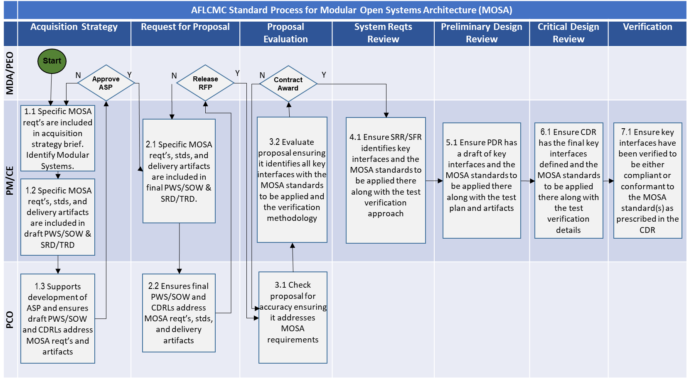Figure 2. MOSA Process
  - Work Breakdown Structure (WBS). The WBS provides additional detail to describe, define, and provide references for the activities in the process flowchart. The WBS is provided in Table 2.

Table 2. MOSA Work Breakdown Structure
WBS | Activity | Description | OPR
1.0 | Acq Strategy Development
1.1 | MOSA Strategy | System Engineers (SE) develop MOSA Strategy, determine key architectural principles, assess available GRAs and open standards, determine min procurable modules, and modular system interfaces. | PM/CE
1.2 | Acquisition Strategy | PM/CE ensure that the acquisition strategy documents the requirement for MOSA standards with the appropriate Data Rights and use of Digital Engineering. | PM/CE
1.3 | Draft SOO/SOW/PWS and SRD/TRD MOSA requirement | PM/CE ensure that the draft RFP documents the requirement for specific GRAs and MOSA standards such as OMS. See section 11.0 for reference to policy and guidance. | PM/CE
1.4 | Review of draft contractual documents | Contracting reviews the governments RFP (SOO/SOW/PWS/CDRLs) to ensure that all sections (e.g., L and M) contain the appropriate language and artifacts to support the government's requirements in the RFP. | PCO
2.0 | RFP Development
2.1 | Final PWS/SOW and SRD/TRD MOSA requirement | PM/CE ensure that the final RFP documents the requirement for specific GRAs and MOSA standards such as OMS. See section 11.0 for reference to policy and guidance. | PM/CE
2.2 | Review of final contractual documents | Contracting reviews the governments RFP (SOO/SOW/PWS/CDRLs) to ensure that all sections (e.g., L and M) contain the appropriate language and artifacts to support the government's requirements in the RFP. | PCO
3.0 | Proposal Evaluation
3.1 | Check for Accuracy | Government receives the contractor's proposal and checks the proposal to ensure it contains the appropriate artifacts to support the government's requirements in the RFP. | PCO
3.2 | Evaluation | Government team reviews the entire proposal and evaluates how well the contractor addressed open systems architecture requirements in the RFP to include modular system interfaces, MOSA standards, and verification. On competitive acquisition, provide appropriate MOSA evaluation criteria for Section M (if MOSA is determined to be a source selection discriminator). | PM/CE
4.0 | SRR/SFR
4.1 | Key Interfaces, standards, and verification | At the SRR/SFR, the government team reviews the contractor's presentations to ensure that modular system interfaces were identified along with the MOSA standards to be used at the modular system interfaces. In addition, the government team reviews the contractor’s preliminary MOSA verification plans for adequacy. | PM/CE
5.0 | PDR
5.1 | Key Interfaces, standards, and verification | At the PDR, the government team reviews the contractor's presentations to ensure that ICDs for modular system interfaces were drafted. In addition, the government team reviews the contractors MOSA verification plans for adequacy. | PM/CE
6.0 | CDR
6.1 | Key Interfaces, standards, and verification | At the CDR, the government team reviews the contractor's presentations to ensure that ICDs for modular system interfaces were complete. In addition, the government team reviews the contractors MOSA verification plans for completeness. | PM/CE
7.0 | Verification
7.1 | Testing and reporting | As a result of the verification process, the contractor delivers the appropriate documents that show the modular system interfaces conform or comply with the open architecture standard. | PM/CE

Measurement.
  - Standard Process results: Measure ACAT programs implementing MOSA as part of their Acquisition Strategies and SEPs. Initial measurement will be accomplished by generating status data from Program Offices asking if MOSA is part of Acquisition Strategies and SEPs. Follow-on measurements may be accomplished against further details of the MOSA, identified Modular Systems, and level of re-use of Modular System Interfaces (i.e. OMS/UCI, Weapon Open System Architecture (WOSA), etc.).
  - Compliance and Product Support Risk Metric. Figure 3 depicts the Specific, Measurable, Actionable, Relevant, Time Based (SMART) attributes for the MOSA metric.
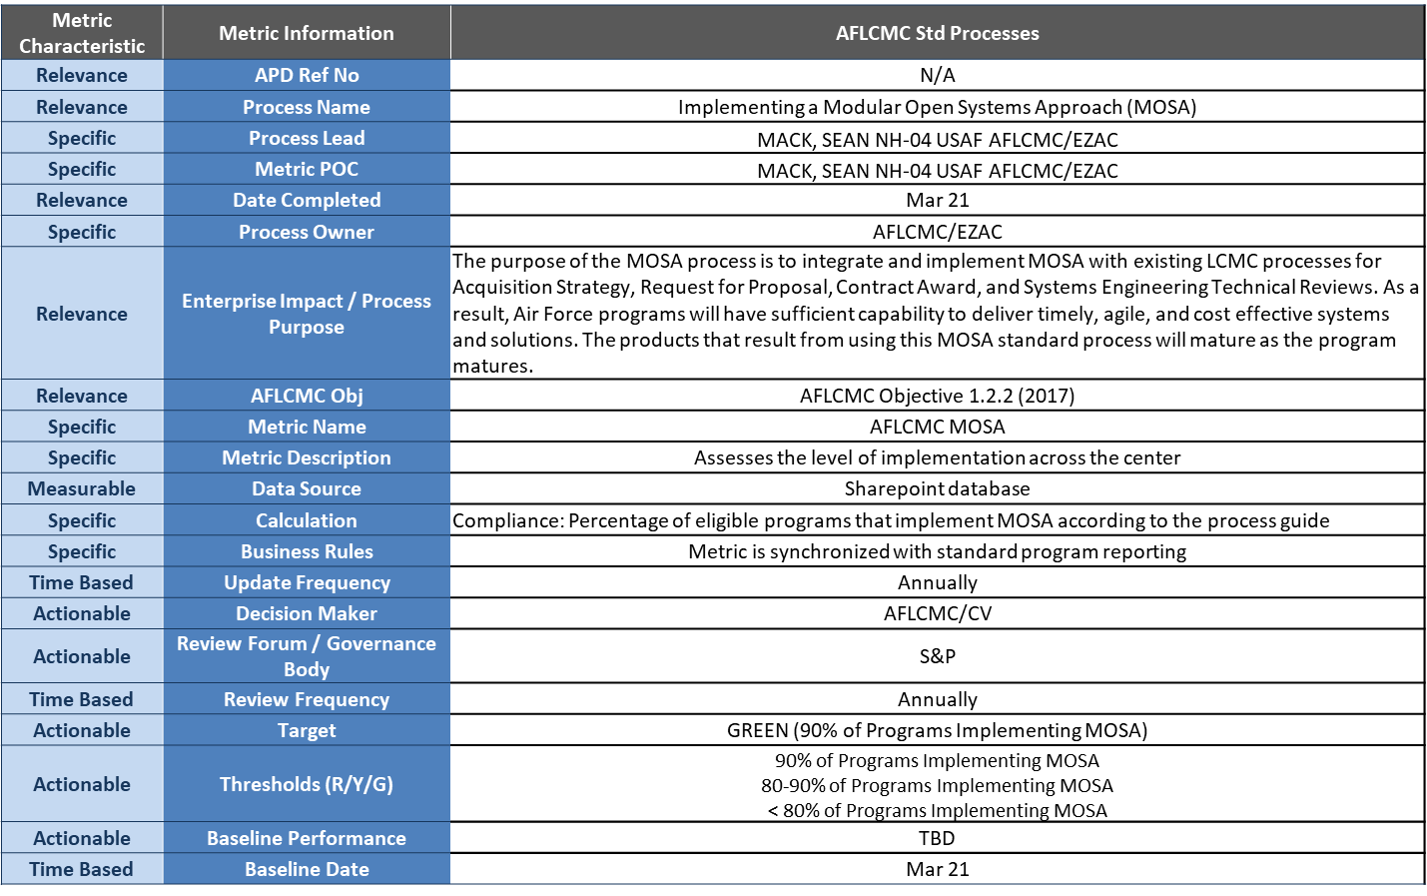
Figure 3. MOSA SMART Attributes

Roles and Responsibilities.

Program Managers & Chief Engineers
    - Develop the MOSA strategy to be included with the Acquisition Strategy by reviewing existing GRAs and Open Standards from the list of existing GRAs.
    - Include the appropriate Open Standard (i.e. OMS, WOSA, etc.) and GRAs to support the MOSA strategy in the RFP, PWS, SOW, and SRD.
    - Ensure contractor provides required MOSA standard artifacts as a part of the program engineering review process (i.e. SRR, SFR, PDR, CDR).
    - On competitive acquisition, provide appropriate MOSA criteria for RFP Section M (if MOSA is determined to be a source selection discriminator). If MOSA criteria are included in the solicitation, ensure corresponding instructions are included in RFP Section L. Work with AFLCMC/PK-PZ to ensure suitable language is written into the contract.
    - Respond to periodic SOCCER Taskers with detail on implementing a MOSA.

Process Owner (AFLCMC/EZA)
    - Maintains and coordinates changes to this process.
    - Leads process improvement and change events related to this process.
    - Provides training during AFLCMC Focus Week and upon request.

AFLCMC/PK-PZ
    - Ensure contract sufficiently addresses MOSA artifacts (especially data rights strategy) to support the program MOSA strategy (e.g. SOW, Section L, and M).
    - Include the necessary CDRLs as approved by the program office.
    - Based on the MOSA requirement, and working with legal counsel, incorporate the appropriate data right/software contract clauses into the contract.

AFLCMC/FZC
    - Provide guidance for program office estimates to support the MOSA strategy.
    - Understand life cycle cost benefits of MOSA for a Program of Record (POR).

Digital Enterprise Launch Team for Acquisition (DELTA)
    - Provides multi-functional support from the AFLCMC Acquisition Center of Excellence (ACE) as well as AFLCMC Engineering Subject Matter Experts from the Digital Engineering Advisory Group (DE AG) for programs considering Digital Acquisition, including MOSA.
    - Helps guide program teams through consideration of Digital Acquisition strategies, processes, and tools, including MOSA.
    - Supports program teams to critically think through applicability and implementation of Air Force Digital Acquisition policies/guidance/best practices into their acquisition programs, including MOSA.

Open Architecture Management Office (OAMO, AFLCMC/XA)
    - Provide guidance on acquisition strategies for using MOSA.
    - Consult and assist program offices with their MOSA implementations including RFP, SOW, and PWS development along with program review (e.g. SRR, SFR, PDR, etc.) evaluations.
    - Help program offices understand risks associated with MOSA.
    - Provide just in time training to program offices on considering MOSA.

Tools - Guides.
  - Open Mission Systems (OMS) Acquisition Guide (send a request to the OAMO org box – AFLCMC/XA OAMO)
    - Latest version of OMS Documentation and Documentation available upon request.
    - Numerous Templates (e.g., Platform Description Document (PDD), Subsystems Description Document (SDD), Mission Package Description Document (MPDD)).
  - Future Airborne Capability Environment (FACE) Contract Guide
  - DoD Open Systems Architecture Contract Guidebook for Program Managers V1.1
  - Data Item Description – Open Systems Management Plan
  - USAF Digital Guide Book
  - DoD Automatic Test Systems (ATS) Open Systems Interfaces
  - Sensor Open Systems Architecture (SOSA) Business Guide

Training.
  - OMS Training: Call AFLCMC/XA (send a request to the OAMO org box – AFLCMC/XA OAMO)
  - MOSA Principles Training: Email AFLCMC/EZAC (Architectures), sean.mack@us.af.mil
  - WOSA Training: Call AFLCMC/RWWG, 850-883-2713 or jonathan.shaver.1@us.af.mil

Definitions.
  - Design Disclosure means making data related to the design of a component, subsystem, or system available to qualified recipients, with a goal of establishing and maintaining a process that will provide “early and often” design disclosure directly to the Government or to third party contractors via Government-established access and the ability to download artifacts. This data is sufficient to allow the third party to develop and produce a competitive alternative. Design Disclosure can be enabled through a variety of mechanisms including keeping data, code, and design artifacts in a repository either maintained by or overseen by the Government; providing the artifacts electronically upon requests made via the Government; or allowing requesting parties to obtain them directly from the source firm through a process involving review and approval from the Government. In addition, the Government can require that contractors allow the program to have continuous, real-time visibility and access to the development environment with access and the ability to download artifacts. Each program has the flexibility to establish the most appropriate mechanism for its specific needs; with a goal of establishing a process that is both cost-effective and responsive to requests. [DOD Open System Architecture Contract Guidebook for Program Managers: https://www.acqnotes.com/Attachments/Open%20System%20Architecture%20%28OSA%29%20Contract%20Guidebook%20for%20Program%20Managers%20June%2013.pdf]
  - Digital Model or Digital System Model is a digital representation of a defense system, generated by all stakeholders that integrates the authoritative technical data and associated artifacts which define all aspects of the system for the specific activities throughout the system lifecycle. [https://www.dau.edu/glossary/Pages/Glossary.aspx]
  - Key Interfaces are those interfaces that are of special interest to the Government for a variety of reasons such as: rapid changes in technology; rapid changes in threat systems; exists in multiple variants; has multiple, long term, viable sources; rapid changes in requirements; provides something critical; or isolates US-only systems. All Modular System Interfaces are Key Interfaces. [Derived from NDAA 2021 and Model Open Systems Architecture (OSA) Requirements, Software Engineering Institute, Carnegie Mellon University see Section 11.12]
  - Modular System refers to a weapon system or weapon system component that—
- is able to execute without requiring coincident execution of other specific weapon systems or components;
- can communicate across component boundaries and through interfaces; and
- functions as a module that can be separated, recombined, and connected with other weapon systems or weapon system components in order to achieve various effects, missions, or capabilities. [NDAA 2021]
  - Modular System Interface means a shared boundary between major systems, major system components, or modular systems, defined by various physical, logical, and functional characteristics, such as electrical, mechanical, fluidic, optical, radio frequency, data, networking, or software elements. [NDAA 2021]
  - Modular Open Systems Approach is the business and technical strategies of DoD’s implementation of Modular Open Systems, as specified in Section 1. Within the MOSA context, programs should design their system based on adherence to the following five MOSA principles: Establish an Enabling Environment; Employ Modular Design; Designate Key (Modular System) Interfaces; Use Open Standards; and Certify Conformance. [Integrating Business and Engineering Strategy Through Modular Open Systems Approach, Defense AT&L: January-February 2005]
  - Open Interface is a public standard for connecting hardware to hardware and software to software. With regard to hardware, it implies that there is more than one brand of product that can be hooked up to the device with the open interface. In the case of software, it implies that more than one program exists to interface with the application that has the open interface or that a program can be readily written to communicate with it. See open system and open standard. [Source is PC Magazine Encyclopedia.]
  - Open Standards means widely accepted and supported standards set by recognized standards organizations or the marketplace. These standards support interoperability, portability, and scalable [tailored: Glossary of Defense Acquisition Acronyms & Terms, 13th Edition, November 2009]
  - Open System A system whose technical architecture adopts open standards and supports a modular, loosely coupled, and highly cohesive system structure. This modular open architecture includes publishing of key interfaces within the system and relevant design disclosure. [DAU Glossary]
  - Open Systems Approach means an integrated business and technical strategy that employs a design that, where appropriate, defines key interfaces using widely supported, consensus-based standards that are published and maintained by a recognized industry standards organization. [DoD Open System Architecture Contract Guidebook for Program Managers v1.1]
  - Open System Architecture is a system that employs modular design, uses widely supported and consensus-based standards for its key interfaces, and has been subjected to successful validation and verification tests to ensure the openness of its key interfaces. [DoD Open System Architecture Contract Guidebook for Program Managers v1.1]

  - Vendor lock is the situation in which customers are dependent on a single manufacturer or supplier for some product and cannot move to another vendor without substantial costs and/or inconvenience. This dependency is typically a result of standards that are controlled by the vendor. It can grant the vendor some extent of monopoly power and can thus be much more profitable than would be the absence of such dependency. [http://www.linfo.org/vendor_lockin.html and http://dodcio.defense.gov/Open-Source-Software-FAQ].

Acronyms.
ACAT Acquisition Category
ADM Acquisition Decision Memorandum
AFLCMC Air Force Life Cycle Management Center
API Application Programming Interface
ASB Avionics Service Bus
ASP Acquisition Strategy Panel
ATS Automatic Test Systems
CDD Capability Development Document
CDR Critical Design Review
CDRL Contract Data Requirements List
CE Chief Engineer
FACE Future Airborne Capability Environment
GRA Government Reference Architecture
ICD Interface Control Document
ICD Initial Capabilities Document
ISP Information Support Plan
MOSA Modular Open Systems Approach
M/S Milestone
OAMO Open Architecture Management Office
OCE Open Computing Environment
OMS Open Missions System
OSA Open Systems Architecture
PCO Procuring Contracting Officer
PEO Program Executive Officer
PDR Preliminary Design Review
PM Program Manager
POR Program of Record
PWS Performance Work Statement
RFP Request for Proposal
SEP System Engineering Plan
SFR Systems Functional Review
SOO Statement of Objectives
SOW Statement of Work
SRD System Requirements Document
SRR System Requirements Review
TRD Technical Requirements Document
UCI Universal Command and Control Interface
WOSA Weapon Open System Architecture

References to Law, Policy, Instructions or Guidance.
  - NATIONAL DEFENSE AUTHORIZATION ACT FOR FISCAL YEAR 2017, Pub. L. No. 114-328; https://www.congress.gov/114/plaws/publ328/PLAW-114publ328.pdf
  - Defense Acquisition University Modular Open Systems Architecture Website
  - DoD Open System Architecture Contract Guidebook for Program Managers v1.1
  - Future Airborne Capability Environment (FACE) - www.opengroup.org/face including the Open Group FACE™ Contract Guide (requires registration to download document)
  - SAF/AQ Memo “Assistant Secretary of the Air Force (Acquisition, Technology & Logistics) Chief Architect” 18 Oct 2018
  - SAF/AQ Memo "Use of Open Mission Systems/Universal Command and Control Interface" 9 Oct 2018
  - Tri-Service Service Acquisition Executives Joint Memo “MOSA for Weapon Systems is a Warfighting Imperative,” 7 Jan 2019
  - AFLCMC/CC Memo "Sensor Open Systems Architecture (SOSA) Consortium”, 2 Apr 2018
  - NDIA, Model Open Systems Approach – Considerations Impacting Both Acquirer and Supplier Adoption, July 2020 [https://www.incose.org/docs/default-source/midwest-gateway/events/ndia_mosa_whitepaper_final_20200701.pdf]
  - Digital Guide Book List of Government Reference Architectures, 2020, https://usaf.dps.mil/teams/afmcde/SitePages/Government-Reference-Architecture.aspx
  - Comprehensive Architecture Strategy, US Army Combat Capabilities Development Command, https://apps.dtic.mil/sti/pdfs/AD1103295.pdf
  - Model Open Systems Architecture (OSA) Requirements, Software Engineering Institute, Carnegie Mellon University, Oct 2015

  - NATIONAL DEFENSE AUTHORIZATION ACT FOR FISCAL YEAR 2021, Pub. L. No. 116-283 ; https://www.congress.gov/bill/116th-congress/house-bill/6395/text/enr

Appendix A. SOW/PWS Examples
“System X shall incorporate an open system, service oriented architecture that utilizes non-proprietary government, commercial, or industry interfaces and standards. The architecture shall include a Tier Y compliant Mission Package and Tier Y compliant Platform in accordance with the Open Mission Systems (OMS) Definition and Documentation (D&D) V1.2. The architecture will be layered or decoupled and flexible/scalable to enable affordable, efficient, competitive capability upgrades and technical refresh with minimum flight or mission software re-write and regression testing.”

“The Subsystem/Software Services shall be incorporated into an open system, service oriented architecture that utilizes non-proprietary government, commercial, or industry interfaces and standards. The Software Service/Component shall be integrated into the OMS reference implementation as a Tier Y compliant Software Service/Component in accordance with the Open Mission Systems (OMS) Definition and Documentation (D&D) V1.2.”

“The contractor shall develop and document all key OMS interfaces in the OMS Platform Description Document (PDD) in accordance with the GFE PDD Template. These interfaces shall be non-proprietary. The OMS documentation shall include:
a. Technical description of any computing environment that executes an OMS service
b. The OCE mission software resource life-cycle prioritization and resource allocation scheme
c. A step-wise description for how a 3rd party can add, modify, or remove OMS software services in the Open Computing Environment
d. Comprehensive, non-proprietary descriptions of mission system interfaces that received OMS exceptions/waivers
e. An OMS verification cross reference matrix (VCRM) tracing design elements back to the OMS D&D artifacts.”

“The contractor shall maintain an assessment of OMS Compliance to the required level as their mission systems architecture design and actual performance measures evolve. The contractor shall notify the government of any gaps or conflicts associated with achieving the required level of compliance. Notification shall include a detailed description of the gap or conflict and proposed resolution. Where applicable, the contractor shall propose changes to the OMS configuration control board IAW the OMS Governance Plan defined processes.”

“The contractor shall document the functional, logical and physical design aspects of the mission system architecture. The purpose of this documentation shall be to evaluate compliance at the key systems engineering reviews and document the final, as delivered, implementation of the OMS compliance mission system instantiation. The document shall be sufficient to facilitate and enable organic modernization activities, such as, adding new or replacing existing OMS mission system software and OMS subsystems.”

“The contractor shall support a demonstration of a third-party integrator who will integrate one new software service and one new subsystem into the adopting program (AP). The contractor shall enter into Associate Contractor Agreements with the Government-selected third-party integrator, software
service developer, and subsystem developer. The contractor shall provide OMS-related source code, OMS documentation, access to the AP SILs, and technical support to the third party integrator and developers. The contractor shall support design and planning reviews, provide answers to technical questions related to the AP and OMS documentation, and support the testing phase of the demonstration.”

“This development program shall utilize the Open Mission Systems (OMS) and XYZ standards to meet its OSA goals. The Government defines MOSA as a system for which major interfaces are collaboratively defined and maintained by an established community of interest (COI) for unconstrained usage.
“The contractor shall establish, develop and maintain interface control documents (ICDs) and or application programming interfaces (APIs) for the system and identified subsystems and configuration items. The ICDs shall document the functional, logical, and physical interfaces. ICDs are required for any hardware and/or software interface (including a detailed description of the physical and logical interfaces) including but not limited to: external interfaces, subsystem to subsystem interfaces, component-to-component interfaces within the subsystem and all proposed extensions or modifications to the standard (such as OMS messaging schema).”
“The contractor shall adhere to the FACE™ technical standard, ed 3.0, for the design of safety critical software modularity and interface definitions. Safety critical software components shall adhere to the FACE Safety-Base profile. Safety critical software components shall conform to the FACE Shared Data Model, ver 3.0.5.”

