

Air Force Life Cycle Management Center

Standard Process

For

*Financial Funds Flow &*

*Funds Control*

Process Owner: AFLCMC/FZA

Date: 18 Aug 22

Version: 1.9

***Financial Funds Flow & Funds Control***

|  |  |  |
| --- | --- | --- |
| **Record of Changes** | | |
| Version | Effective Date | Summary |
| 1.0 | 1 Aug 2013 | Initial standard process approved by S&P Board on 20 Jun 13. |
| 1.1 | 30 Apr 2014 | Revised and clarified Para 5.0 Measurements |
| 1.2 | 18 Aug 2014 | Clarified TLS measurements, roles and responsibilities |
| 1.3 | 1 May 2015 | Revised to include DEAMS information |
| 1.4 | 24 Dec 2015 | Added attributes chart to Section 5.0 |
| 1.5 | 23 May 2017 | Updated to reflect receipt of BA direct from SAF |
| 1.6 | 21 Jun 2018 | Clarified in Para 5.1.2.1 the start of the 2 day turnaround for program office, spelled out acronyms, made administrative changes; Approved by S&P Board on 21 Jun 2018. |
| 1.7 | 7 Nov 2018 | Removed Steps 1.8-1.9 from Table 2 (outdated information) |
| 1.8 | 17 Sep 2020 | Updated Figure 1 to include EFD, clarified process in Para 1.0 and 5.1.2.1, removed metrics from 5.2 that are no longer being tracked, made administrative changes. Approved at 17 Sep 20 S&P Board. |
| 1.9 | 18 Aug 2022 | Table 2 corrected to reflect 2 days processing time for program offices; updated reg reference; administrative changes. Approved at 18 Aug 22 SP&P Group. |

***Financial Funds Flow & Funds Control***

1. **Description.** The Standard Process for Financial Funds Flow & Funds Control provides the framework and the steps necessary to ensure that funds received by AFLCMC are properly loaded into the Air Force accounting systems in accordance with appropriate regulations and guidelines. The process encompasses all fund types executed by AFLCMC organizations not limited to, but including AF Investment, AF Operations & Maintenance, OSD appropriations, FMS Administrative Surcharge, and funds from other MAJCOMs. Centralized Asset Management (CAM) OAC 87 and FMS Case funding are not part of this process.
2. **Purpose.** The purpose of the AFLCMC Funds Flow and Funds Control Process is to ensure accountability and balancing of all funds received by AFLCMC organizations.
3. **Potential Entry/Exit Criteria and Inputs/Exits.**
   1. Entry Criteria
      1. Receipt of Budget Authority Document from higher headquarters.
      2. Request by Directorate or Division to realign Budget Authority to different line of accounting or location.
   2. Exit Criteria
      1. Issue and loading of Budget Authority Documents received from higher headquarters.
      2. Completion of requested realignments in the AF Accounting Systems.
      3. Balance Accounting Systems at end of month with authority received on Budget Authority Documents.
   3. Inputs
      1. Budget Authority Document from Higher Headquarters provided from various MAJCOMs and Agencies.
      2. AF1269 Target Load Sheet provided via Comprehensive Cost and Requirement System (CCaR) or manual AF1269 to AFLCMC/FZA mailbox from Directorate or Divisions.
      3. Directorate or Division Operating Budget Accounting Number (OBAN) execution forecast.
   4. Outputs
      1. Budget Authority Documents from AFLCMC to various locations (OBANs) or to Sub-allotted OBANs.
      2. Approved CCaR generated AF1269 Target Load Sheets are processed and saved in CCaR for historical reference.
      3. Manual AF1269 Target Load Sheets are processed in the General Accounting and Finance System (GAFS-BQ) and Defense Enterprise Accounting and Management System (DEAMS) and saved on the AFLCMC/FZA shared drive for historical reference.
4. **Process Workflow and Activities**.
   1. Supplier, Input, Process, Output, Customer (SIPOC). See **Table 1** below.

**Table 1. SIPOC**

|  |  |  |  |  |
| --- | --- | --- | --- | --- |
| **Suppliers** | **Inputs** | **Process** | **Outputs** | **Customer** |
| MAJCOM/ Agency | MAJCOM/Center receives Budget Authority Document from SAF / OSD | Change in Budget Authority from MAJCOM / Agency | Budget Authority Document from MAJCOM/SAF to Center/ Budget Authority Document from AFLCMC to OBAN / Target Load Sheet - AF 1269 | Directorates/ Division |
| Directorate/ Division | Request to Realign Funds to different OBAN | Realignments between OBANs of Budget Authority received | Budget Authority Document from AFLCMC to OBAN / Target Load Sheet - AF 1269 | Directorates/ Division |
| Directorate/ Division | Target Load Sheet - AF 1269 | Realignments between Lines of Accounting of Budget Authority received | Budget Authority realigned in the accounting system. | Directorates/ Division |
| MAJCOM/ Agency | Budget Authority Document & Target Load Sheet - AF 1269 | Funds Control / EOM Balancing | Accounting System balanced at EOM. | AFLCMC |

* 1. Process Flowchart. The process flowchart below, **Figure 1**, represents an overview of the SAF/AQ Financial Funds Flow and Funds Control Process. The AFLCMC Standard Process for Financial Funds Flow and Funds Control Process is represented by the flowchart shown in **Figure 2.** The flowchart shows the four possible entry points into the process which aligns with the four rows in the SIPOC, **Table 1**.
  2. Work Breakdown Structure (WBS). The WBS below, **Table 2**, provides additional detail for the activity boxes in the AFLCMC process flowchart, **Figure 2**.
  3. Additional work tables, figures, or checklists. N/A

**Figure 1.** Flowchart for SAF Financial Funds Flow and Funds Control Process

**Figure 2.** Flowchart for AFLCMC Financial Funds Flow and Funds Control Process

NOTE: In FY17, Investment funds previously distributed by AFMC began to flow directly from SAF to AFLCMC. BAs for FY16 and prior will continue to flow through AFMC for distribution to the Center.

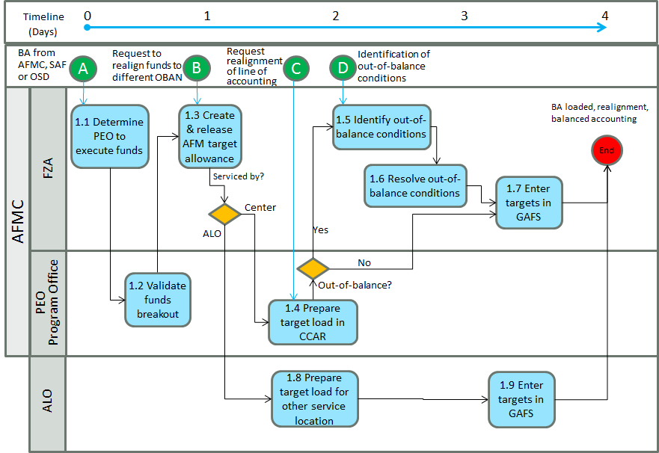

**Table 2.** WBS for AFLCMC Financial Funds Flow & Funds Control Process

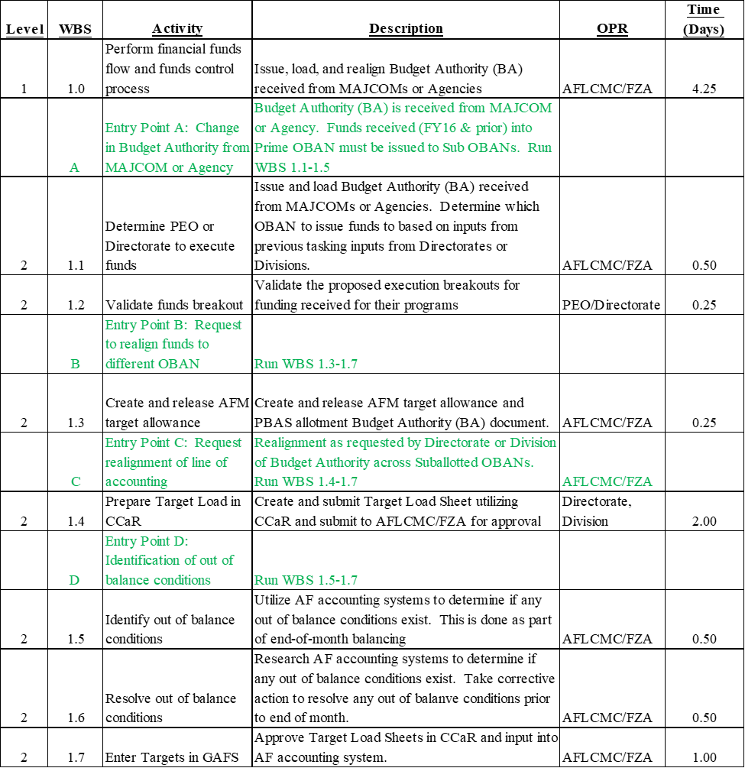

1. **Measurement.**
   1. Process Results
      1. Budget Authority Document (Timeliness & Quality)
         1. From a count of the total number of Budget Authority (BA) Documents received, AFLMC/FZA will determine the number properly loaded in AF Accounting system at end of each month. FZA will review and validate the BA documents received comparative to funds loaded in the accounting system.
         2. HQ AFMC collects the data monthly from the AF accounting systems using the end of month file and Selective Transaction History (STH) based on end of month data.
      2. Target Load Sheets (Timeliness & Quality)
         1. From a count of the total Target Load Sheets, AFLCMC/FZA will determine the number “Direct Authority Load” Target Load Sheets not properly processed within two full business days after BA issue date (weekends & holidays do not count) *Example: Issue date on Tuesday will not count. Programs will have two full business days of Wednesday and Thursday to have the TLS fully coordinated and be at the FZA Loader step by the close of business on the 2nd business day.* FZA will approve TLS and input to the GAFS or DEAMS accounting system within one business day of receipt.
         2. FZA utilizes an Access database to capture the data that they use to populate a spreadsheet and then present in chart format (monthly).
   2. Process Evaluation
      1. AFLCMC/FZA will track the following metrics internally:
         1. Customer satisfaction measured via feedback fromannual survey to Organizational Senior Functionals (OSFs).
         2. Number of Target Load Sheets not processed within two business days.
      2. AFLCMC/FZA will report timeliness of Target Load Sheet submission.
         1. Number of Target Load Sheets that Directorates or Division do not submit within two business days after receipt of BA document

**Figure 3.** AFLCMC Financial Funds Flow and Funds Control Metric Attribute Chart

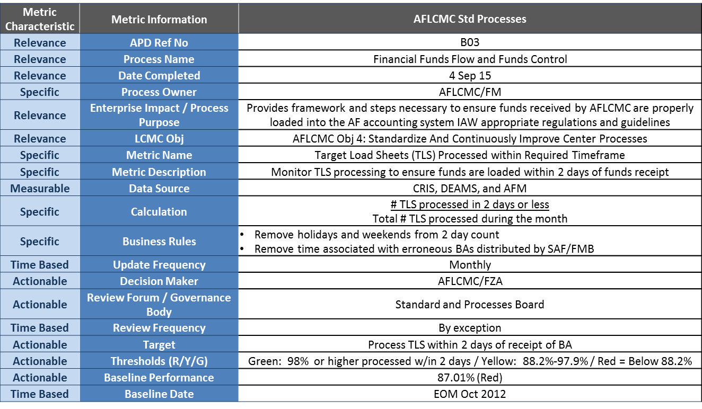

1. **Roles and Responsibilities.**
   1. AFLCMC/FZA
      1. Maintains and coordinates any changes to this process
      2. Leads and/or assigns personnel to work on any process improvement and change events related to this process
      3. Processes Target Load Sheets – AF 1269 in the AF Accounting System
      4. Process Budget Authority documents - AFLCMC/FZA will issue BA documents to Directorates within one business day of a receipt.
   2. MAJCOM or Agency. Process and Provide Budget Authority documents
   3. Directorate or Division. Process and Submit Target Load Sheets – AF 1269 within two full business days of BA receipt. To ensure FIAR compliance, please follow the process in the AFLCMC Comprehensive Cost and Requirement (CCaR) System guide (Ref No. B113)
2. **Tools.**
   1. Automated Funds Management (AFM)
   2. Comprehensive Cost and Requirements System (CCaR)
   3. General Accounting and Finance System (GAFS-BQ)
   4. Program Budget Accounting System (PBAS)
   5. Commander’s Resources Integration System (CRIS)
   6. Windows – General Accounting Microcomputer Processing System (WINGAMPS)
   7. Defense Enterprise Accounting and Management System (DEAMS)
3. **Training.** 
   1. Available Training. AFLCMC/FZA will provide training to any organization requesting funds flow training.
4. **Definitions, Guiding Principles and/or Ground Rules & Assumptions**.
   1. All documents must be in compliance with FIAR guidance.
   2. In order to properly balance two days prior to the end of month, AFLCMC/FZA will not process realignment requests unless an end of month emergency TLS is requested by the OSF and approved by AFLCMC/FZA.
   3. Per current AFMC/FM direction, the 88th Air Base Wing (ABW) and the 66th Air Base Group (ABG) will continue to receive direct Budget Authority from HQ AFMC/FMA.
5. **References to Law, Policy, Instructions or Guidance**.
   1. DAFMAN 65-605 Vol 1 Budget Guidance and Technical Procedures, Attachment 2, Paragraph A2.1.3 requires end of month balancing of Budget Authority.