

Air Force Life Cycle Management Center (AFLCMC)

Standard Process

to

Develop & Manage AFLCMC Standard Processes & Internal Process Guides

Process Owner: AFLCMC/OZT

Date: 18 Mar 2021

Version: 6.0

Record of Changes.

|  |  |  |
| --- | --- | --- |
| Record of Changes | | |
| Version | Effective Date | Summary |
| 1.0 | 21 Feb 2013 | Basic Document; Approved by Standards & Process (S&P) Board on 21 Feb 2013 |
| 1.1 | 10 Apr 2013 | Minor administrative changes and clarifications; added link to Excel WBS |
| 2.0 | 3 Jun 2013 | Expanded standardization process to include process management, Continuous Process Improvement (CPI) and management of AFLCMC Process Directory (APD). Approved by S&P Board on 30 May 2013. |
| 2.1 | 28 Oct 2013 | Added language regarding criteria to determine if processes should be Standard Processes (SP) overseen by the S&P Board. Updated formatting for template and added optional subparagraphs. |
| 3.0 | 23 Dec 2013 | Adds information regarding the AFLMC Process Maturity Model (PMM) and the Process Metrics Dashboard. |
| 3.1 | 8 Oct 2014 | Removed references to ABE as a requirement for standardization. Made Table 2 WBS into searchable words (rather than a picture). |
| 4.0 | 24 Feb 16 | Updated to include new SP template, SP vs IPG definition; PMM level; Change Mgt. Plan, update process flow and corresponding WBS. |
| 4.1 | 17 Nov 16 | Updated to add an area for cross reference to other SP and IPGs; and updated metric |
| 5.0 | 31 Jan 2019 | Draft update includes Board recommendation for review frequency based upon PMM level, PMM grading matrix updated, CPI activity update, updated attachments, revised process flow due to OZT process improvement, updated and revised Change Management Plan, and abbreviated process for interim changes. |
| 5.1 | 20 Feb 20 | Update includes minor administrative and AFI 38-401 (23 Aug 19) changes. Approved at 20 Feb 2020 S&P Board |
| 6.0 | 18 Mar 21 | Added FIAR and Digital Transformation Steps to WBS.  Added FIAR and Digital Transformation Guidelines and information. Updated Change Management Plan and communications plan. Approved by SP&P Group on 18 Mar 2021. |

1. **Description**.
   1. This process provides role responsibilities and describes activities to submit, coordinate, review, approve, publish, format, maintain and manage Standard Processes (SP) and Internal Process Guides (IPG) in a central repository, the AFLCMC Process Directory (APD) (<https://usaf.dps.mil/teams/21710/gov/SitePages/APD.aspx>). It provides templates and instructions for change management efforts and designates and follows the approved standard process standard format for SP variation reduction in alignment with Six Sigma Continuous Process Improvement (CPI) principles. The process outlines abbreviated and Interim Changes to facilitate lessons learned captured within standard processes. Finally, it outlines task frequencies for each of the activities outlined within this document. The SP and IPG Templates can be found at Attachment 1.
   2. The aforementioned APD contains a link to initiate a Change Request (CR) email to AFLCMC/OZT workflow and has links to existing SPs, IPGs, and Air Force Security Assistance and Cooperation (AFSAC) Directorate Process Desk Guides (PDGs).
   3. Standard Processes and Products (SP&P) Group chartered process teams, in collaboration with AFLCMC/OZT Certified CPI experts define, document, or update processes and deliver documents.
   4. AFLCMC Process Maturity Model (PMM)Template, at Attachment 2, describes the five (5) process maturity levels including entry criteria for each level, description of each level and requirements required to request a PMM level increase. PMMs are presented and reviewed during SP&P Group reviews and are a combination of the Process Owner (PO) and AFLCMC/OZT recommendations derived from evidence outlined in Attachment 2.
   5. Every PO shall ensure Financial Improvement and Audit Remediation (FIAR) is properly addressed in his/her Standard Process during the annual review. In order to meet the intent of Federal Manager’s Integrity Act of 1982 and other FIAR related legislation, review each process and capture the steps within the document which will demonstrate AFLCMC has established internal controls utilizing the appropriate financial systems for the subject process and provide reasonable assurance the following are achieved:

* Effective and efficient operations;
* Compliance with regulations and applicable laws; and
* Reliable/accurate financial reporting through the applicabale Accounting Property System of Record (APSR).
  1. Every SP document shall address Digital Transformation. For existing SPs this can be achieved during the annual/biennial review. The objective of digital transformation is to deliver capabilities at ever increasing speed and efficiency by designing, sustaining, and modernizing them in an integrated digital environment.
     1. The links below provide the latest information on this effort, including: SAF/AQ guidance; AFMC Digital Campaign Website and Digital Guidebook, which stores the definitions, training, and vision for the effort; and the beta link to Digital University, where employees can register and see the available training offered. Many of these links offer resources that are being regularly updated as this effort moves forward.
     + SAF/AQ – There is No Spoon: The New Digital Acquisition Reality: <https://usaf.dps.mil/teams/afmcde/Shared%20Documents/Vision/There%20Is%20No%20Spoon%20(Digital%20Acquisition)%207%20Oct%202020%20-%20digital%20version.pdf>
  + AFMC Digital Campaign Website: <https://www.afmc.af.mil/Digital/>
  + AFMC Digital Guidebook: <https://usaf.dps.mil/teams/afmcde>
  + Digital U: <https://digitalu.af.mil/>
  + ACE Homepage (includes information on Digital Acquisition and both sole source and competitive Gameboards): <https://cs2.eis.af.mil/sites/21596/default.aspx>
  1. Change Management Plans (CMP) are required for new or updated SP utilizing the template provided within Attachment 5. The CMP (including the Communication Plan) will be reviewed and approved at the SP&P Group.
  2. Interim Changes to Standard Processes are occasionally required out of the standard process review cycle due to regulatory changes, capturing of best practices, lessons learned or process improvement activities etc. The process for Interim Changes is outlined in Figure 1, Interim Change Process for Standard Processes.

**Figure 1. Process Flowchart – Interim Change Process for Standard Processes**

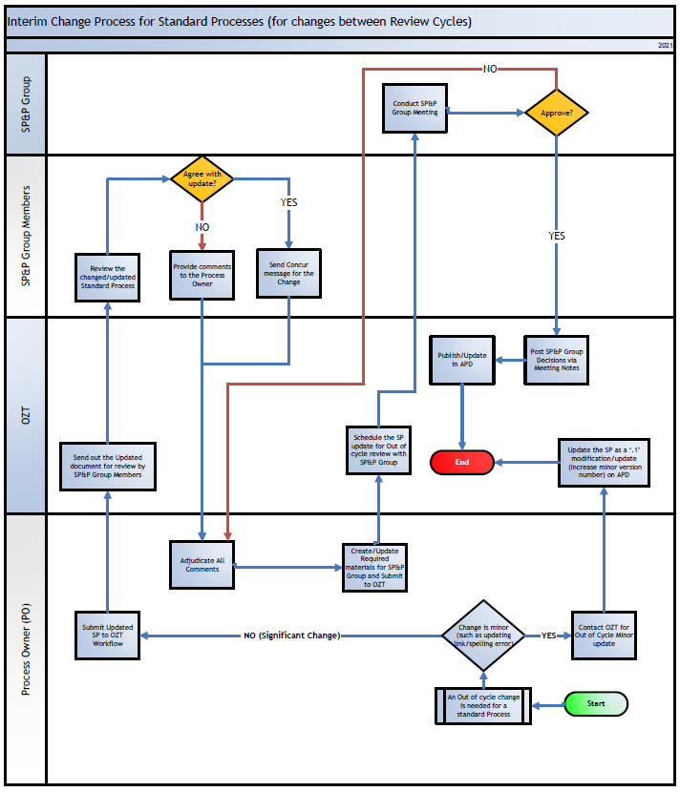

1. **Purpose**.
   1. The purpose of this document is to establish methodology to codify best practices, lessons learned, and process efficiencies derived from CPI efforts across AFLCMC. This Standard Process also outlines one method to interface between AFLCMC Commander’s CPI management responsibilities as outlined in AFI 1-2 *Commander’s Responsibilities*, AFI 38-401 *Continuous Process Improvement (CPI),* and the AFLCMC Directorates. Additionally, this process outlines data collection, metric reporting methodology, frequency, and improvement targets for AFLCMC SP&P Group oversight.
   2. The purpose of standardizing processes is to support consistent, efficient, and effective work outcomes and to reinforce desired cultural behavior. A SP provides the initial basis for CPI and application of best practices when appropriately maintained, routinely updated, and integrated with frequent user feedback.
2. **Entry/Exit Criteria.**
   1. Entry Criteria
      1. A new or undocumented process is submitted to AFLCMC/OZT workflow via APD.
      2. A change to an approved SP or IPG is submitted to AFLCMC/OZT workflow via APD.
      3. An SP&P Group change is tracked by AFLCMC/OZT into the workflow.
      4. An Interim Change to a process is submitted to AFLCMC/OZT workflow via APD.
   2. Exit Criteria
      1. PMM checklist (attachment 7) actions are complete.
      2. SP&P Group approves new or revised SP and PMM level.
      3. SP posted to APD.
      4. SP&P Group determines no change is required, or process should be an IPG.
      5. Interim Change is posted to APD awaiting regular review cycle.
3. **Process Workflow and Activities.**
   1. Suppliers, Inputs, Process, Outputs, Customers (SIPOC), Table 1.

**Table 1. SIPOC**

|  |  |  |  |  |
| --- | --- | --- | --- | --- |
| **S**uppliers | **I**nputs | **P**rocess | **O**utputs | **C**ustomers |
| Workforce, process users, POs, process improvement teams | Proposed process, revision to existing process, PMM level increase, new/revised policy | Fully define & document processes in a standard format using standard methodology | SP, IPG or a PMM level increase | SP&P Group |
| SP&P Group | SP, IPG or a PMM level increase | Conduct SP&P Group | SP&P Group decision rendered, meeting notes published & APD updated, as required | Workforce, process users, PO |

* 1. Process Flowchart. The process flowchart, Figure 1, Illustrates the Interim Change process for existing Standard Processes between formal reviews. Process flow in Figure 2, illustrates the process to develop and manage a SP/IPG.

**Figure 2. Process Flowchart – Develop and Manage AFLCMC SP/IPG**

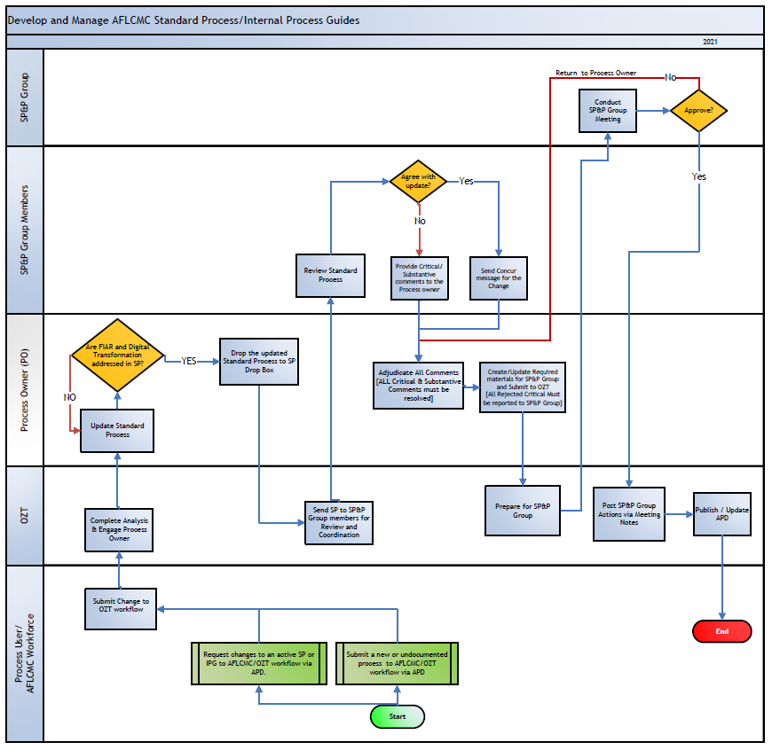

* 1. Work Breakdown Structure (WBS). The WBS, Table 2, provides additional detail in support of the Table 1’s activity boxes. The MS Excel version of the WBS is at Attachment 3.

**Table 2. WBS – Develop and Manage AFLCMC SP/IPGs**



1. **Measurement**.

5.1 AFLCMC/OZT collects PMM data from SP&P Group minutes. Table 3 provides metric detail for this SP.

5.2 This SP is rated as a PMM Level III. PMM rating checklist for this document is provided at Attachment 7.

**Table 3. AFLCMC Process Maturity – SMART Metric with Metric Attributes**

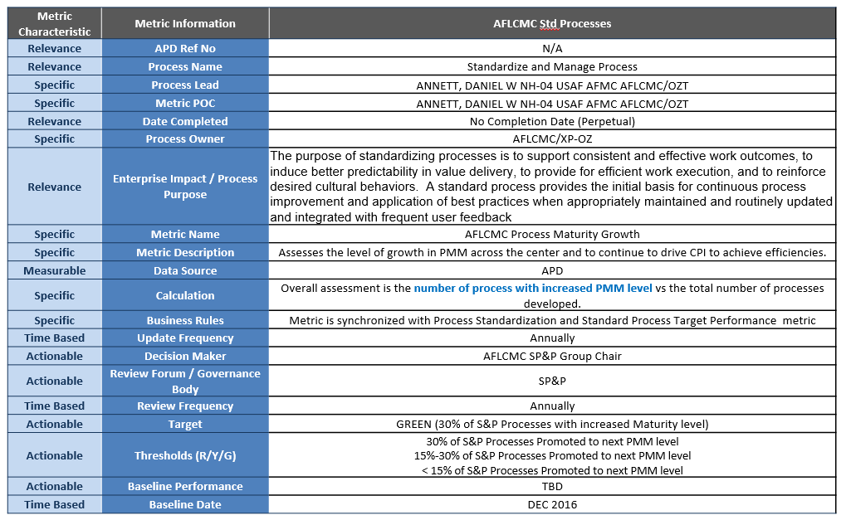

1. **Roles and Responsibilities**.
   1. AFLCMC/OZT will:
      1. Maintain and coordinate any changes to “Develop and Manage AFLCMC SPs/IPGs”.
      2. Assist PO and process teams to define, document and improve SP.
      3. Provide CPI project and supporting documentation completion assistance.
      4. Maintain and manage APD changes, to include posting interim standard process changes to APD.
      5. Ensure metric owner updates and report metrics as required for SP&P Group support.
      6. Manage the PMM and assist POs with PMM level evaluations.
      7. Ensure continuous training on both APD and CPI throughout AFLCMC.
      8. Perform SP&P Group secretariat role.
      9. Initiate and monitor taskers for SP&P Group related taskings.
      10. Maintain and manage SP&P Group SharePoint site residing within AFLCMC Governance SharePoint site.
      11. Post working/archived Comment Resolution Matrix (CRM) to APD so SP&P Group members will have access to other Directorate comments prior to SP&P Group meeting.
   2. PO will:
      1. Act as approval authority for IPG(s).
      2. Accept process ownership and oversight to a particular SP or IPG, assign process leads, metric owner and coordinate process documents.
      3. Ensure stakeholders are notified on process creation, modification, or deletion.
      4. Monitor and continuously improve processes by releasing updates to the SP on at least an annual basis, or on biennial basis if SP rated as a PMM level 4 or 5.
         1. The PO completes interim reviews and publishes SP as a ".1" revision.
         2. All SP&P Group comments are submitted to the PO via CRM. The PO will manage disposition of all comments and coordinate resolution with the submitting organization. The PO must resolve any rejected comments with the submitting organization for concurrence. If the concurrence is not met, then views of others will be presented at the SP&P Group for final decision and approval.
         3. Revised SP, SP Slides, and final CRM will be submitted to SP&P Group Drop Box on SP&P Group SharePoint site at least five (5) business days prior to scheduled SP&P Group.
         4. Ensure process metrics are being collected and reported using Specific, Measurable, Action oriented, Realistic, Time Bound (SMART) Metric. See template at Attachment 4, for SMART metric captured for this SP.
      5. On at least an annual basis, or biennial basis if SP is a PMM level 4 or 5, review all SP/IPGs, process metrics, and PMM level.
      6. Ensure Change Management Plan (CMP) (attachments 5 & 6) is drafted and executed.
   3. Process Lead will:
      1. Manage changes to documented processes, incorporate lessons learned and feedback into processes, monitor and continuously improve process performance and effectiveness.
      2. Create/update PMM Level questionnaire as required.
      3. Responsible for development and execution of CMP and CP.
   4. AFLCMC SP&P Group:
      1. The roles and responsibilities are documented within the AFLCMC Governance Charter located on the Governance SharePoint Site at: <https://usaf.dps.mil/teams/21710/gov/GDOCS/Forms/AllItems.aspx>
      2. Membership includes all Center Deputy Directors, Center Test Authority (AFLCMC/AZT) Chief, the Deputy Chief Information Officer, SMEs as necessary, and/or appropriate delegates.
      3. The SP&P Group will review past due SPs at every Group meeting and provide POs suspense date to correct overdue SPs.
      4. Upon request, the SP&P Group will determine if SP should be rescinded, changed to an IPG, or placed in abeyance.
      5. Direct specific CPI activity within Center as needed to achieve process performance targets.
2. **Tools**.
   1. APD is the repository for all AFLCMC SP and IPG. It is located at the following SharePoint site: <https://usaf.dps.mil/teams/21710/gov/SitePages/APD.aspx>
   2. Dashboard is a display of metrics collected in support of all AFLCMC SP, section 5.0. The dashboard may be utilized by anyone within AFLCMC to analyze process metrics or to report metrics status. The dashboard can be accessed from the APD: <https://usaf.dps.mil/teams/21710/gov/SitePages/APD.aspx>
3. **Delivery Approach**.
   1. Training:
      1. APD:
         1. AFLCMC/OZT provides an overview of process standardization, the SP templates, Dashboard, and APD demo as requested.
      2. CPI:
         1. AFLCMC/OZT CPI Team provides Green Belt and Black Belt training and mentoring, as requested.
         2. AFLCMC/OZT CPI Team provides tailored courses or tool specific training to support Lean, Six Sigma, Theory of Constraints, Business Process Engineering, Organizational Design and Development, Change Management, and Strategic Planning, Alignment, & Deployment activities.
   2. Change Management Plan. The Change Management Plan is located in Attachment 5 and describes the approach and methods used for implementing and institutionalizing this SP.
4. **Definitions, Guiding Principles, Ground Rules & Assumptions, and/or Acronyms**.
   1. Definitions:
      1. Activity - Any work performed to convert inputs into outputs.
      2. Continuous Process Improvement (CPI) Initiatives – CPI initiatives are projects to improve products, processes, organizational interfaces and cultural elements using activity specific improvement tools and the scientific method. These projects are led by either certified Green or Black Belts to support POs in developing or improving processes.
      3. Change Management Plan – The systematic approach and application of knowledge, tools and resources to enhance workforce adoption of changes. Change management defines corporate strategies, structures, procedures and technologies to encourage workforce adoption of external condition and business environment change.
      4. Communication Plan - Outlines the roles and responsibilities of project participants in the review, approval and dissemination of information about key project processes, events, documents and milestones.
      5. Internal Process Guides (IPG) - For AFLCMC, IPGs generally do not cross Directorates or functional areas, are recommended (vs mandatory), may be utilized to provide clarification for laws, regulations, etc., and no measurements are required. IPGs define the specific instructions necessary to perform a task or part of a Process.  IPG can take the form of a work instruction, a desk top procedure, a quick reference guide, or a more detailed process guide.  IPGs are structured by subject and address only a single task.  It should detail who performs the task or a part of a process, what steps are performed, when the steps are performed, and how it is performed.

NOTE: Current IPGs may be in a legacy format. As IPGs are updated or newly developed, users shall utilize the new SP format.

* + 1. Metric Owner - Manages all aspects of process measurements including updates to the PMD; appointed by the PO.
    2. Process - A defined sequence of related activities and decisions (or gateways) that together achieve a particular result of value (to customers).
    3. Process Lead - Forms and leads a multifunctional team to define and document a process utilizing the Standardize and Manage AFLCMC Process; appointed by PO.
    4. PO - A designated directorate that provides oversight to a particular IPG or SP, normally resides within a Center Functional Office.
    5. Process Team - Multifunctional team that assists POs and process leads in defining and documenting a process.
    6. Return on Investment (ROI) - The impact and benefit of what the standard process brings back to the Center.
    7. Standard Process (SP) - For AFLCMC, SPs generally cross Directorates or functional areas or benefits the Center and are mandatory. Processes are related repeatable activities that produce a specific service or product (example, Procurement to Payment), continue to seek increase in PMM and are measurable. SPs indicate where there is a separation of responsibilities and control points (they are not task specific). They are also very helpful to identify (or expand upon current) Policy and Procedure requirements. Processes address why it is needed, who is responsible to perform the Process (department, division), what major functions are performed, when the function is triggered.

NOTE: If policy/procedure, such as an AFI, AFMAN, FAR, DFAR, or DoD directive, provides detailed instruction, then development of a SP/IPG may not be needed, but the decision should be made at the SP&P Group.

* + 1. SP&P Group - The governance body for AFLCMC CPI initiatives and cross organizational or high interest process capture and metric monitoring.
  1. Acronyms:

ACE – Acquisition Center of Excellence

AFI – Air Force Instruction

AFLCMC – Air Force Life Cycle Management Center

AFMC – Air Force Materiel Command

AFMAN – Air Force Manual

AFSAC – Air Force Security Assistance and Cooperation

APD – AFLCMC Process Directory

APSR – Accounting Property System of Record

CMP – Change Management Plan

CPI – Continuous Process Improvement

CR – Change Request

CRM – Comment Resolution Matrix

DFAR – Defense Federal Acquisition Regulation

DoD – Department of Defense

FAR – Federal Acquisition Regulation

FIAR – Financial Improvement and Audit Remediation

IPG – Internal Process Guide

PDG – Process Desk Guide

PMM – Process Maturity Model

PO – Process Owner

ROI – Return on Investment

SIPOC – Supplier, Input, Process, Output, Customer

SP&P – Standard Processes and Products

SMART – Specific, Measurable, Action Oriented, Realistic, Time Bound

SP – Standard Process

WBS- Work Breakdown Structure

1. **References to Law, Policy, Instructions or Guidance**.
   1. Related process references include the following:
      1. AFI 1-2 *Commander’s Responsibilities*, 8 May 2014
      2. AFI 63-101/20-101 *Integrated Life Cycle Management*, 30 Jun 2020
      3. AFI 38-401, *Continuous Process Improvement (CPI)*, 23 Aug 19
      4. AFLCMC Governance Charter, Nov 2020

**11.0 List of Corresponding SP/IPGs.**  The list of SPs and/or IPGs that relate to this process are referenced in our SP/IPG Central Repository, located in our APD per para 1.1.

**12.0 List of Attachments:**

|  |  |
| --- | --- |
| **Attachment 1: Standard** Process Template |  |
| **Attachment 2:** AFLCMC Process Maturity Model (PMM) Template |  |
| **Attachment 3:** MS Excel version of WBS |  |
| **Attachment 4: SMART Metric Template** |  |
| **Attachment 5: Change Management Plan Template** |  |
| **Attachment 6: Standard Process for Standard Processes Change Management Plan** |  |
| **Attachment 7: PMM for this document** |  |