

Air Force Life Cycle Management Center (AFLCMC)

Standard Process

for

*Annual Program Office Cost Estimate*

Process Owner: AFLCMC/FZC

Date: 18 March 2021

Version: 3.3

Record of Changes.

|  |  |  |
| --- | --- | --- |
| Record of Changes | | |
| Version | Effective Date | Summary |
| 1.0 | 29 May 2013 | Basic document approved by S&P Board on 16 May 2013 with minor edits made approved by S&P Board Champion. |
| 2.0 | 5 September 2014 | Revision to achieve Process Maturity Matrix Level 4. |
| 2.1 | 27 August 2015 | Annual update. Administrative changes to document. |
| 2.2 | 14 January 2016 | Annual update. Revision to reflect October 2015 S&P Board approved metric changes. |
| 3.0 | 23 March 2017 | Change Time-Based Metric to Compliance-Based Metric. Administrative changes to the document. |
| 3.1 | 29 March 2018 | Annual update. Administrative changes to document. |
| 3.2 | 21 March 2019 | Annual update. Administrative changes to document. Approved by S&P board on 21 MAR 2019. |
| 3.3 | 18 March 2021 | Change metric measurement from calendar year basis to fiscal year basis. Administrative changes to document. Approved at 18 March 2021 SP&P Group. |

*Annual Program Office Cost Estimate Process*

1. **Description**. An Annual Program Office Cost Estimate (POE) (also known as a Single Best Estimate or SBE) is a documented point in time of the estimated total life cycle cost of the directed acquisition program. Annual POEs are required each fiscal year after the program’s Initial POE is approved by the Center Cost Chief or delegate (see Paragraph 7.1 for waiver information). Annual POEs should include all Research Development Test and Evaluation (to include program specific direct cite Civilian Pay over and above Acquisition Workforce PE funding), Procurement, Military Construction (MILCON), Operations and Maintenance (O&M) and Military Personnel costs as well as all disposal and Restoration and Modernization costs associated with facility and infrastructure sustainment. Included are all resources associated with all of the applicable work breakdown structure elements (reference MIL-STD 881E for the typical WBS elements); all indirect elements; costs displayed by program phase consistent with acquisition program phases defined in DoDI 5000.02; a comprehensive risk/uncertainty analysis and a sensitivity analysis. The Annual Program Office Cost Estimate shall be consistent with the intent contained in AFI 65-508. The Cost Center Chief, or delegate at the location where a program is managed, shall approve all POEs.
2. **Purpose**.
   1. The Annual Program Office Cost Estimate and its development process provides leadership with the critical information for program decision making, establishes executable budgets, and proactively addresses financial issues. POEs are integral to all Milestone decisions and Planning, Programming, and Budgeting Execution (PPBE) formulation. The POE is the basis for the Independent Government Cost estimate for source selections, and supports program breach or program change decisions.
   2. Support strategic planning.
      1. Supports AFLCMC Objective 2.1, “Standardize Processes across AFLCMC regardless of location.”
3. **Potential Entry/Exit Criteria and Inputs/Outputs.**
   1. Entry Criteria
      1. The entry criteria for an Annual Program Office Cost Estimate Process is triggered by the Initial Program Office Cost Estimate. An Initial Program Office Cost Estimate is required within twelve months of the program being added to the Acquisition Master List (AML) (see Paragraph 7.1 for waiver information). An Annual Program Office Cost Estimate is initiated in each fiscal year following the program’s Initial POE approval by Center Cost Chief or delegate for as long as the program remains on the AML. The POE should be completed and approved by FZC prior to the Program Objective Memorandum (POM) submission with rare exception. If a program is proceeding to a milestone, the POE should be approved prior to any required reconciliation activities and prior to the milestone approval. The basis of the POM submission or milestone decision will be the FZC approved POE.
   2. Exit Criteria
      1. Initial or annual estimate is complete and approved by the Center Cost Chief or delegate, or a waiver (annual or permanent) is approved.
      2. Final documentation is provided to the AFLCMC/FZC Workflow inbox ([AFLCMC.FZC.workflow@us.af.mil](mailto:AFLCMC.FZC.workflow@us.af.mil)), made available by the managing locations’ SharePoint site or is provided to the FZC Independent Staff Analyst assigned to review the POE and placed in the official file.
   3. Inputs:
      1. Appropriately Defined Requirements (based on Program Phase): The defined requirements for the estimate include definition of the estimate scope, ground rules, assumptions, constraints, and alternative programs. Also, a well-defined programmatic and technical baseline must exist as well as a Program Work Breakdown Structure (WBS) which will be incorporated and documented as part of the Cost Analysis Requirements Document (CARD) for ACAT I programs and for ACAT II and III programs the technical content must align with the appropriate programmatic requirement documents and be reflected in the POE briefing charts. The requirements must be adequately defined to initiate the Annual Program Office Cost Estimate Process.
      2. Most Probable Schedule: This may be an Integrated Master Schedule or similar document that contains the critical linked tasks and durations of those tasks for the program.
      3. Defined Technical Parameters: Program technical parameters must be identified so they can be properly documented and utilized in the estimate formulation.
      4. Risk Assessment: Cost, schedule, and technical risks from the Integrated Risk Assessment (IRA) must be identified and quantified in the POE.
         1. A schedule analysis should be incorporated with the cost estimate to include the assessment of risk, identified opportunities and the uncertainty associated with schedule variability.
         2. A sensitivity analysis should be performed on key cost, schedule and technical parameters.
      5. Technology Readiness Assessment (TRA), Manufacturing Readiness Assessment (MRA), Systems Engineering Assessment (SEA), Test Assessment, Risk Identification, Integration & “Ilities” and Logistics Health Assessment (LHA) must be integrated into the estimate if the estimate will be part of a Program Sufficiency Review.
   4. Outputs:
      1. Approved Annual Life Cycle Program Office Cost Estimate model/s.
      2. Formal Briefing Presentation Chart Deck.
      3. Cost Estimate Documentation. (see AFI65-508 Chapter 6)
4. **Process Workflow and Activities.**
   1. Suppliers, Inputs, Process, Outputs, Customers (SIPOC), **Table 1**.
   2. Process Flowchart. The process flowchart below, **Figure 1**, represents the Annual Program Office Cost Estimate Process. The activities are further defined in the WBS at **Attachment 1**.
   3. Process Work Breakdown Structure (WBS). The Annual Program Office Cost Estimate Process WBS below, **Table 2**, provides additional detail for the activity boxes in the above Annual Program Office Cost Estimate process flowchart. The MS Excel version of the WBS with more detail is provided at **Attachment 1.**

**Table 1. SIPOC**

|  |  |  |  |  |
| --- | --- | --- | --- | --- |
| **Suppliers** | **Input** | **Process** | **Output** | **Customers** |
| Program Office  User | Documented Requirements Definition | 1.1 Estimate Planning | Approved Documented Requirements Definition  Cost Estimate Plan | Cost IPT  Program Office |
| Program Office  Cost Databases | Approved Documented Requirements Definition  Raw Program and Cost Data | 1.2 Research, Collection and Analysis | Normalized and Documented Cost Data  Cost Estimating Relationships | Cost IPT |
| Program Office  Cost IPT | Approved Documented Requirements Definition  Normalized and Documented Cost Data | 1.3 Formulate Estimate | Draft Program Office Estimate | Cost IPT |
| Cost IPT | Draft Program Office Estimate | 1.4 Formal Review  / Presentation | Approved Annual Program Office Cost Estimate  Approved Draft Documentation | Program Office |
| Cost IPT | Approved Draft Documentation | 1.5 Finalize Documentation | Signed and Approved Estimate Documentation | Program Office |

**Figure 1. Process Flowchart**

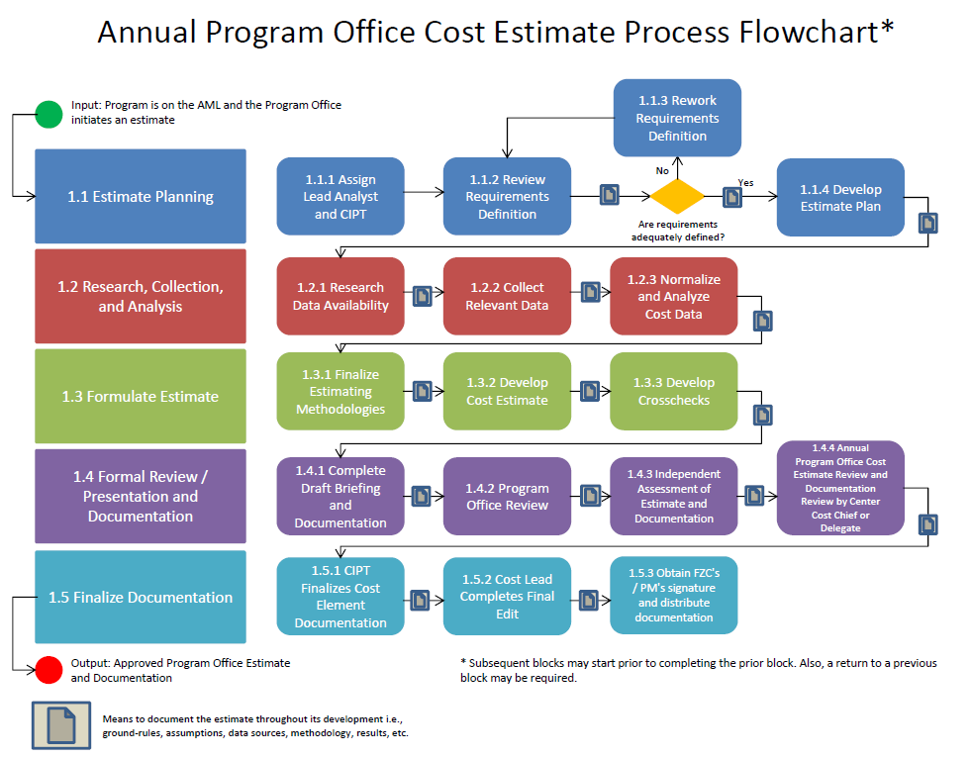

**Table 2. WBS for Annual Program Cost Estimate**



1. **Measurement**. This section outlines the process results and process evaluation for the Annual Program Office Cost Estimate process. An AML Baseline will be established in September of the previous fiscal year. All programs on the AML Baseline, regardless of whether the requirement is for an initial estimate or an annual estimate update will be tracked for compliance.
   1. Process Results: All ACAT programs on the Acquisition Master List (AML) as of 01 October of that fiscal year will be considered compliant if the program has a Center Approved POE, a Center Approved Annual POE Waiver, or a Center approved Permanent POE Waiver by 30 September of that fiscal year (see Paragraph 7.1 for waiver information). Programs that are taking action to be removed from the AML will not be tracked for compliance. See Metric Attribute below for more information.

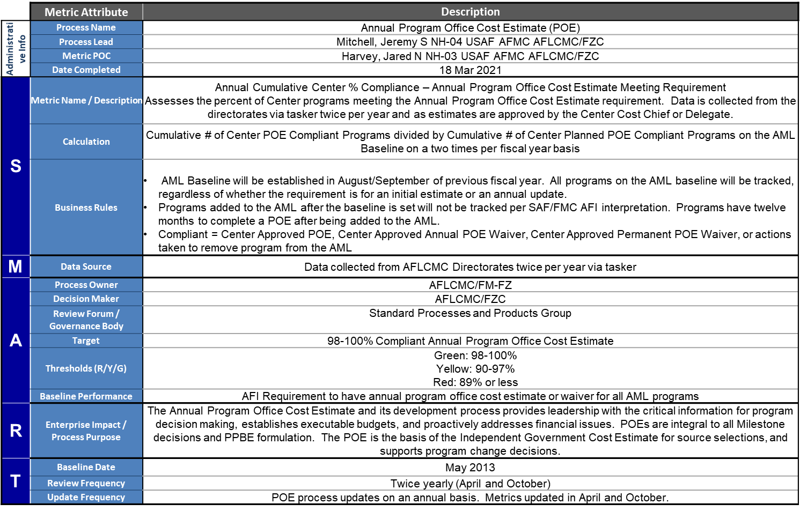

1. **Roles and Responsibilities**. Sections 6.1 through 6.6 provide a summary of roles and responsibilities and should not be viewed as the only guidance. The Annual Program Office Cost Estimate Work Breakdown Structure (WBS) referenced in para 4.3 and provided as Attachment 1 expands this summary with specific tasks and products for each OPR.
   1. AFLCMC/FM-FZ
      1. Review Acquisition Category I/II/III estimates as necessary.
   2. AFLCMC/FZC (Process Owner)
      1. Maintain and coordinate any changes to this process, “Annual Program Office Cost Estimate Process.”
      2. Maintain track of all annual program office cost estimates and waivers for AFLCMC ACAT programs on AML.
      3. Serve as arbitrator if there are unresolved issues between Center Cost Chief or delegate and PEO staff.
      4. Upload POE metrics to AFLCMC Dashboard.
      5. Brief POE metrics to the SP&P Group and other interested AFLCMC leadership groups as requested.
   3. Center Cost Chief or delegate (Center Cost Chief responsibilities have been delegated to the Staff cost chief at the location where the program is managed (see table below)). As per AFI 65-508, all ACAT I, II, III programs’ annual estimate must achieve the approval of the Center Cost Chief.

|  |  |
| --- | --- |
| Location | Office Symbol |
| Wright-Patterson AFB | AFLCMC/FZC |
| Eglin AFB | AFLCMC/EGOL/FZC |
| Gunter Annex | AFLCMC/FZC |
| Hanscom AFB | AFLCMC/HAOL/FZC |
| Tinker AFB | AFSC/FZC |
| Hill AFB | AFSC/FZC Hill |
| Robins AFB | AFSC/FZC Robins |
| Other Locations | AFLCMC/FZC |

* + 1. Determine lead and members for Cost Integrated Product Team (CIPT) for estimates resourced by Center Cost Staff. For ACAT I programs, the lead analyst must be Level III Business-Cost Estimating (BUS-CE) Certified and for ACAT II/III programs, lead analyst must be at least Level II BUS-CE Certified. The team may include stakeholder and customer personnel as well as Center Staff resources required to accomplish the estimate.
    2. Identify an FZC Staff Analyst to conduct an independent assessment of the estimate and documentation. This will be a sufficiency review of the estimate that will take place prior to the Annual Program Office Cost Estimate Review (CER) by the Center Cost Chief or delegate.
    3. Provide the approved Cost Estimate Review Briefing and Documentation to the AFLCMC/FZC Workflow inbox.
  1. Cost Integrated Product Team (CIPT)
     1. The CIPT is the cost team that will develop the Annual Program Office Cost Estimate. The CIPT requires the support of other Program Office functionals (e.g. financial management, program management, contracting, engineering, and logistics assets) as required to support the estimating activities.
     2. Document activities (plan, schedule, ground-rules/assumptions, data sources, methodologies, results, etc.) as estimate is developed.
     3. With inputs from the stakeholders and customer, review the requirements definition provided and determine if the content is adequate for cost estimating purposes, i.e., a costable programmatic and technical baseline has been developed. If not, the requirements are returned to the appropriate stakeholders for further definition or correction and/or the CIPT works with stakeholders to develop ground-rules and assumptions to fill in the gaps.
     4. Define Preliminary WBS, cost elements, data sources, estimating methodologies, tools, ground rules and assumptions, team member assignments, estimate scope and schedule, and briefing schedule. The team lead should coordinate these activities with the customer to determine if anything needs to be added or revised before proceeding.
     5. Research, collect, and analyze data to support proposed methodology.
     6. Formulate the estimate.
     7. Prepare briefing charts for reviews and present to program office, FZC independent staff analyst, Center Cost Chief or delegate for Cost Estimate Review (CER) and others as required.
     8. Document estimate throughout entire process such that the estimate could be replicated by an experienced cost analyst. Finalize documentation using the AFLCMC documentation checklist: <https://org2.eis.af.mil/sites/21114/AFLCMC.FZC/Briefings%20and%20Templates/Forms/AllItems.aspx?RootFolder=%2Fsites%2F21114%2FAFLCMC%2EFZC%2FBriefings%20and%20Templates%2FBriefing%20Information&FolderCTID=0x0120003146A7C86AD5094893FB3CA92AD08489&View=%7BC571F542%2D1BD5%2D4D17%2DBF12%2D6B2B85EE64F6%7D> (Links require SharePoint Access to FZC site)
  2. Stakeholder [e.g., Using Command, Program Executive Officer (PEO), Program Office/Manager, etc.]
     1. During the Estimate Planning step, provide a defined requirement such as a draft Cost Analysis Requirements Document (CARD) or similar document, the Most Probable Schedule (MPS), technical parameters and the Integrated Risk Assessment. The defined requirement for the estimate includes definition of the estimate scope, ground rules, assumptions, constraints, and alternative programs.
  3. Program Office/Program Manager.
     1. Review estimate prior to Cost Estimate Review by Center Cost Chief or delegate.
     2. Provide functional support (e.g., financial management, program management, contracting, engineering, and logistics assets) to the CIPT as required to support the estimating activities.
     3. Facilitate contact between CIPT and other sources of program information.
     4. Initiate estimating activity in a timely manner so that the estimate can be utilized for its intended purpose (in support of POM, in support of Milestone, in support of ASP, etc.).
  4. Directorate Chief Financial Officer.
     1. Poll programs within Directorate’s portfolio to determine which programs will accomplish an estimate and which will request a waiver during the fiscal year and provide summary info to AFLCMC/FZC.
     2. Request support from Center Cost Staff as needed to accomplish estimates.
     3. Review estimate prior to Annual Program Office Cost Estimate Review by Center Cost Chief or delegate.

1. **Tools**.
   1. AFLCMC Annual Program Office Cost Estimate Waiver Criteria are located at the following link:

<https://org2.eis.af.mil/sites/21114/AFLCMC.FZC/Briefings%20and%20Templates/Forms/AllItems.aspx?RootFolder=%2Fsites%2F21114%2FAFLCMC%2EFZC%2FBriefings%20and%20Templates%2FCurrent%20POE%20Waiver%20Criteria%20and%20Forms&FolderCTID=0x0120003146A7C86AD5094893FB3CA92AD08489&View=%7BC571F542%2D1BD5%2D4D17%2DBF12%2D6B2B85EE64F6%7D> (Link requires FZC SharePoint access)

* 1. Cost Models. Information for AFMC-funded cost models is located at the following link:

<https://org2.eis.af.mil/sites/21114/AFLCMC.FZC/Cost%20Software/Forms/AllItems.aspx>

* 1. AFLCMC FZC SharePoint Site. The AFLCMC/FZC SharePoint Site is located at the following location:

<https://org2.eis.af.mil/sites/21114/AFLCMC.FZC/default.aspx>

* 1. Specific tools related to the process are included in the WBS at **Attachment 1** with links to those tools.
  2. AFLCMC/FZC Research Data Request Workflow can be utilized to request cost data analysis or research services: AFLCMC.FZC.ResearchDataRequest@us.af.mil

1. **Training**.
   1. Training Plan.
      1. AFLCMC/FZC conducted numerous training sessions via telecom and local presentation before the standup of AFLCMC.
      2. AFLCMC/FZC presented a training session at the AFLCMC Cost Working Group meeting to articulate any differences between this Process Guide and the previous Process Guide input.
      3. AFLCMC/FZC trained the directorate Financial Management OSFs at the AFLCMC/FM Acquisition OSF monthly meeting.
   2. Available Training.
      1. AFLCMC/FZC will provide training to any organization requesting Annual Program Office Cost Estimate Process training.
      2. Other available training for cost estimate related topics can be found at the following link: <https://org2.eis.af.mil/sites/21114/AFLCMC.FZC/Courses%20and%20Training/Forms/Training.aspx> (Link requires FZC SharePoint access)
2. **Definitions, Guiding Principles or Ground Rules & Assumptions**.
   1. In accordance with AFI 65-508, 2.1.2.1.1: “”POEs (SBEs) are either developed by the Program Office or are the result of a collaborative effort between the Program Office and the Acquisition Center Cost Staff. The Acquisition Center Cost Staff Chief (or delegated representative) must approve all annual ACAT I, II and III POEs.
   2. Initial Program Office Cost Estimates should follow the same five-step process, and will be included in the compliance metric calculation if the program is on the AML Baseline on 01 October of the fiscal year.
3. **References to Law, Policy, Instructions or Guidance**.
   1. AFI 65-508 Cost Analysis Guidance and Procedures, 06 Dec 2018. POEs are governed by AFI 65-508 and are required for all ACAT I, II and III programs to be updated annually, unless waived.
   2. AFI 63-101 Integrated Life Cycle Management, 30 Jun 2020. The PM shall update life cycle cost estimates in accordance with AFPD 65-5, Cost and Economics, and AFMAN 65-506, Economic Analysis, and compare them to the program budget to assess program executability.
   3. Estimate documentation must be in compliance with AFI 65-508 and the AFLCMC documentation checklist.
   4. MIL-STD 881E. Prescribes work breakdown structure for programs.
   5. DoDI 5000.02. Defines acquisition categories, life cycle of acquisition programs and instructions for acquisition activities
   6. DoDI 5000.4-M. Provides guidance on the content and use of the Cost Analysis Requirements Document.
   7. OSD CAPE Operating and Support Cost Estimating Guide. Provides the O&S standard cost element structure to be used when presenting O&S cost estimates.

**Attachment 1 – Annual POE Process WBS Excel file**



**Attachment 2- Change Management Plan**

