Air Force Life Cycle Management Center (AFLCMC)
Standard Process
for
Pre-Award Acquisition Strategy (AS) and
Request for Proposal (RFP) Development

Process Owner: AFLCMC/AQ
Date: 17 November 2022
Version: 2.8

Record of Changes
Version | Effective Date | Summary
1.0 | 16 May 2013 | Basic document. AFLCMC Standards & Process (S&P) Board on 18 Apr 2013 directed revisions. Approved by AFLCMC S&P Board on 16 May 2013
1.1 | 14 Nov 2013 | Update to Work Breakdown Structure (WBS) numbering and diagram. Updated workdays to calendar days. Included reference to developed metrics tool.
1.2 | 27 Jan 2014 | Revised metrics. Revision approved by AFLCMC S&P Board on 23 Jan 2014
1.3 | 17 Mar 2014 | Updated links and modified some terms.
2.0 | 25 Nov 2014 | Revised cycle times for “Develop Acquisition Strategy (AS)” and “Develop Request for Proposal (RFP)” in Figure 1, Figure 2, and WBS. Changed standard process start date from the submittal of the Presidential Budget Request (PBR) to Milestone Decision Authority (MDA) signature date of the Program Charter, Acquisition Decision Memorandum (ADM), or similar document. Sample Program Charter included as attachment. Clarified process to be used for RFP changes after Standard Process completion.
2.1 | 25 Mar 2015 | Figure 1 – Top-Level Process Flowchart updated to include sub-process cycle times. Figure 2 – Process Flowchart updated to include PBR Submittal as potential program start date. Reference to Proposal Evaluation Team Plan (PETP) for sole source acquisitions included under Tools paragraph (7.8).
2.2 | 07 Mar 2016 | Updated to add SMART Metric attribute to paragraph 5.0
2.3 | 26 May 2016 | Updated links and modified Figure 2 – Process Flowchart and WBS 1.3 to reference AFLCMC Memo dated 8 Mar 2016 concerning the Multi-Function Independent Review Team (MIRT) for Critical Decision Point (CPD) 1
2.4 | 12 Jan 2018 | Updated links and removed Paragraph 7.3 Acquisition Documentation Development and Management (ADDM) Link. ADDM is no longer maintained. Added Paragraph 7.8 to include link for Incorporating T&E into DoD Acquisition Contract Guide.
2.5 | 19 Apr 2019 | Updated MIRT guidance per SAF/AQC Policy Memo 19-C-03, 12 Feb 19. Removed “with OSD oversight,” as it is not tied to the >/= $50M threshold. Approved by S&P Board on 19 Apr 2019.
2.6 | 20 Nov 2020 | Removed “total cycle time” metric per S&P Board guidance on 20 Aug 20. Updated graphics and WBS to remove metric. Updated links. Changed FedBizOpps references to System for Award Management (SAM.gov). Removed references to rescinded RAD process. Updated guidance on MIRTs. Added note about Class Deviation on Peer Reviews. Added link to DAU’s Adaptive Acquisition Framework (AAF) website. Added links to more Tools in 7.0. Approved by SP&P Group on 19 Nov 2020
2.7 | 18 Nov 2021 | Updated links. Added Section 1.3 to address the relationship between an Acquisition Strategy, an Acquisition Plan, and an Acquisition Strategy Panel. Removed references from Figure 2 Process Flowchart to the rescinded AFLCMC Center-Level Senior Acquisition Team (SAT) Process Guide. Updated Section 8.0 to align with current ACE training offerings. Added link to SAF/AQXE SharePoint. Added link to Product Support Contract Requirements Tool (PSCRT). Removed example program charter and replaced it with a link to a DAU Program Charter. Added Change Management Plan as Attachment 3. Approved at 18 Nov 21 SP&P Group.
2.8 | 17 Nov 2022 | Updated links and corrected admin errors. Updated file formats for attachments. Added Acquisition Process Model (APM) link to Tools section. Approved at 17 Nov 22 SP&P Group.

Acquisition Strategy (AS) Approval and Request for Proposal (RFP) Development
- Description.
  - The AS is the overall strategy for managing programs from initiation through post-production support. An AS is required for all acquisition programs regardless of the acquisition category (e.g., ACAT, SCAT, FMS, and Other Programs)/ acquisition pathway (Urgent Capability Acquisition, Middle Tier of Acquisition, Major Capability Acquisition, Software Acquisition, Defense Business Systems, and Acquisition of Services) utilized and must be approved by the Milestone Decision Authority (MDA)/Decision Authority (DA) (henceforth identified as MDA) under the advisement of the Acquisition Strategy Panel (ASP) (AFI 63-101/20-101). Acquisition planning should begin as soon as the agency need has been identified, but not later than the submittal of the Presidential Budget Request (PBR) Congressional Budget Item Justification documentation (p-doc, r-doc, etc.) for the program. For Foreign Military Sales (FMS) programs, acquisition planning should begin upon receipt of a validated Letter of Request (LOR), but no later than prior to submitting the LOA (or amendment) to the country (or countries) for signature.
  - In defining an AS, teams may need to select the most appropriate Adaptive Acquisition Framework (AAF) acquisition pathway given their unique program requirements (see DAU’s AAF website in Tools section below). The DoD transitioned from the Defense Acquisition System to the AAF to allow acquisition professionals more streamlined, flexible tools (pathways) to satisfy warfighter requirements. The focus of AAF is on “tailoring in” versus “tailoring out” program documentation requirements to help meet Air Force leadership’s intent to “accelerate change.” The AS may also need to address how Digital Acquisition will be addressed in their program, if applicable. Leadership’s vision for Digital Acquisition is a digitally empowered Air Force equipped with an agile workforce, state-of-the-art technologies, and intuitive processes that drive model-based enterprise decision-making, enable automation, institutionalize open architectures, and leverage authoritative models and data to ensure seamless stakeholder collaboration across the acquisition lifecycle. The AS also defines the approach to provide maximum practicable opportunities to small business, to maximize competition, and to promote use of commercial products and technologies.
  - Note that an AS is required for all acquisition programs regardless of acquisition category and must be approved by the MDA before formal RFP release. The Acquisition Plan (AP) (document) is used for services, commodities, and “Other Contracting efforts.” ASP (presentation) slides may be used for approval of the AS/AP if the slides contain all of the elements required to be included in a written AS/AP. The current trend for many ACAT II (or equivalent) and below programs in AFLCMC is for teams to request that the “ASP slides with approved meeting minutes serve as the AS.” Most ASP slide templates are built to include all of the requirements of the written AS/AP, but teams should verify that all requirements are met. FAR Part 7.105 and the DoD (DFARS SUBPART 207.1) and Air Force FAR supplements (AFFARS PART 5307) set forth the requirements for Contents of Written Acquisition Plans, including approval authorities.
  - As the AS begins to be identified, the RFP development process can begin. The RFP is a collaborative effort among government stakeholders to develop clear, concise, well-written government requirements to help industry respond to the government’s needs. Draft RFPs, or portions thereof, should be used to obtain industry feedback prior to issuance of the final RFP. This top-level standard process (Figure 1) describes the AS and RFP development for a supply or service-type acquisition program (either competitive or sole source) using a Federal Acquisition Regulation (FAR) based contract >$50M. A requirements approval process is used to identify and obtain approval of requirements as applicable (see AFI 63-101 and AFI 63-138 for guidance and exemptions).
- Purpose.
  - The purpose of the AS and RFP process is to consistently develop effective acquisition strategies along with clear, well-written RFPs to ensure that industry responds appropriately to government requirements and delivers systems or services that support Department of Defense (DoD) capabilities.
  - The intent of this process document is to be a top-level road map to train the acquisition team in the development of their AS and RFP.
- Potential Entry/Exit Criteria and Inputs/Outputs.
  - AS: The entry point for the AS is the acquisition planning start date as indicated by the MDA on the Program Charter, Acquisition Decision Memorandum (ADM), or similar document that initially establishes program objectives, resources, and assigns authority and accountability (Note: For investment-funded programs, the acquisition planning must start no later than the submittal of the PBR Congressional Budget Item Justification documentation (p-doc, r-doc, etc.) for the program). A sample Program Charter is available at a link below (see 10.1) and a template ADM is available at the SAF/AQXE SharePoint link (see Tools section below). The exit point is an approved AS and signed ASP minutes or ADM (See Figure 1). If the ASP determines that sufficient funding or requirements have not been provided to support the recommendation, it may either approve the AS contingent upon Program Manager (PM) follow-up actions or disapprove the recommended AS until further analysis can be completed.
  - RFP: The entry point for initiating development of the RFP (either sole source or competitive) is the same as the AS. The exit point is the RFP release. Note: In instances where the contracting activity is not co-located with the MDA, there needs to be close coordination with the cognizant Contracting Authority prior to release of an RFP package.
- Process Workflow and Activities.
  - Supplier Input Process Output and Customers (SIPOC), Table 1.

Table 1. SIPOC
Suppliers  Process Owner | Inputs  Inputs Required to Execute Process | Process  Process Description | Outputs  Standardized Process Training | Customers  Who Receives Output
PM and Stakeholders | Signed Program Charter, ADM, Transition Support Plan (TSP), or similar document, submitted PBR, signed LOA or LOA Amendment (if FMS). | Development of AS or Addendum to an Existing AS. | Signed AS Document and Signed ASP Minutes | Program Acquisition Team
PM and Stakeholders | Signed AS approving Sole-Source AS | Development of a Sole-Source RFP | Approved Justification and Approval (J&A) and Formal RFP | Program Acquisition Team and Industry
PM and Source Selection Evaluation Board (SSEB) Chair | Signed AS approving competitive AS | Development of a Competitive RFP and identify source selection team | Formal RFP  Signed SSP | Program Acquisition Team and Industry

  - Process Flowchart: The top-level process flowchart below, Figure 1, represents the essential tasks for the AS and RFP development process for both supply and service-type contracts. As you can see in Figure 1, development of the draft AS and RFP can be accomplished with some concurrency. This includes the concurrent requirements approval process for service-type contracts (Note: for services contracts, a requirements approval is not needed if there is an approved AS; see AFI 63-138 for guidance and exemptions). The top-level development activities are further defined in Figure 2 for both a sole-source acquisition and a competitive acquisition.
  - Work Breakdown Structure (WBS): The attached WBS provides additional detail for the activities shown in the process flowcharts. For an MS Excel version of the WBS, see Attachment 1. Extracts from the WBS are at Attachment 2 for both a sole-source acquisition and a competitive acquisition. WBS activities may be utilized to form the basis of the schedule or tailoring can be done to add columns of supporting information. Note: This Standard Process WBS is different from an acquisition program, MIL-STD-881-based WBS that a team may develop and include in their RFP.

Figure 1. Top–Level Process Flowchart
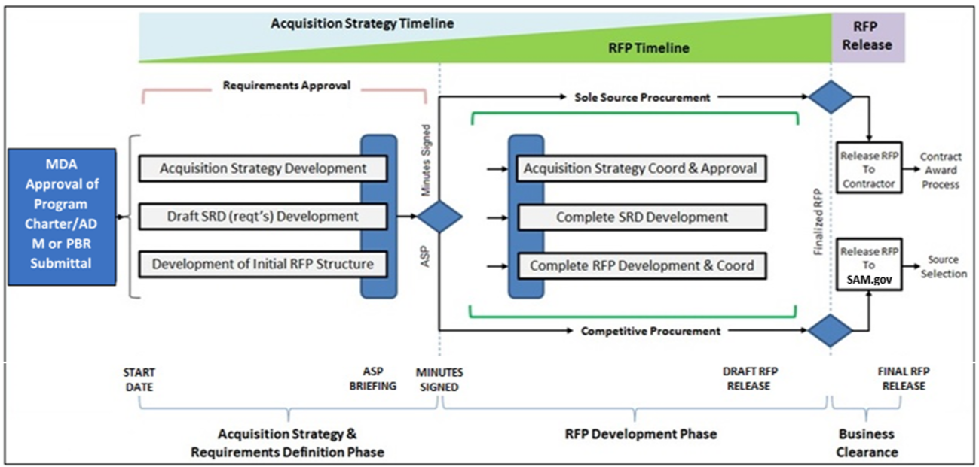
Note: The requirements approval process (see AFI 63-101 and AFI 63-138 for guidance and exemptions) is concurrent with the AS Development process and must be completed before the RFP can be released.
Figure 2. Process Flowchart
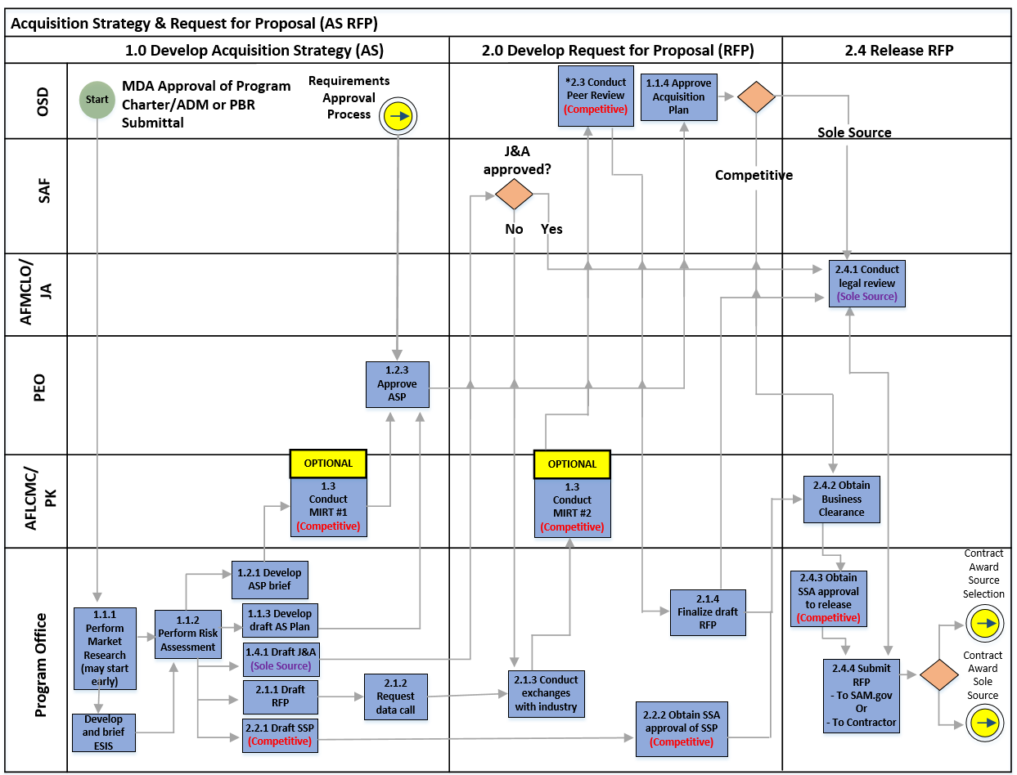
Note: Process is based on FAR-based Contracts >$50M.
*MIRTs reviews are considered a best practice, but are not mandatory (AF PGI 5301.9001(b))
*Approval level for J&A less than $100M may be lower than SAF (AFFAR 5306.304 Approval of the Justification)
*Regarding 2.3 Peer Review, Defense Pricing and Contracting will only conduct Peer Reviews for MDAPs above $1B for which USD (A&S) is the MDA and USD (A&S) special interest programs (USD (A&S) Memo Class Deviation - Peer Reviews of Contracts for Supplies and Services 2019-O0010 20 Aug 19)

- Measurement.
  - Acquisition timelines will be different depending on the unique circumstances of each program. Team formation (manning) timelines, budget approval timelines, and requirements stability/definition timelines are just three of several factors that may drive overall AS & RFP process timelines. Planned acquisition timelines are typically briefed at the ASP and approved by the MDA.
  - Per AFLCMC/CV initial guidance at the Apr 2019 S&P Board and confirmed at the Aug 2020 S&P Board, the “AS & RFP Development Total Cycle Time” metric (formerly 330 days) was determined to not support the standard process due to variation of MDA approved schedules based upon complexity and scope factors, so tracking was discontinued and a waiver was granted to the metric requirement.
  - After the RFP is released and prior to receipt of proposals, the PM will initiate a review with representatives from the Program Office, the Acquisition Center of Excellence (ACE), Contracting, Finance, etc. to capture lessons learned and identify possible areas for AS & RFP process improvements. Existing Lessons Learned and Best Practices can be found on the ACE Homepage.
- Roles and Responsibilities
  - AFLCMC/AQ (Process Owner) is responsible to:
    - Maintain and coordinate any changes to the “Pre-Award AS and RFP Process” in the AFLCMC Process Directory. AFLCMC/AQ will also solicit feedback from process users on an annual basis to assist in the identification of possible process improvements. AFLCMC/AQ will also take the lead to make timely revisions to the standard process and obtain AFLCMC Standard Processes and Products (SP&P) Group approval as required.
  - PM is responsible to:
    - Contact PEO Program Execution Group (PEG)/Director’s Action Group (DAG) to obtain the most current ASP Template for ACAT II & III programs (and equivalents). Utilize the SAF/AQX ASP template for ACAT I (and equivalent) programs (see link in the Tools section below). Coordinate with all stakeholders to solicit input and develop the ASP briefing and all supporting documentation to provide the ASP Chair with the best viable AS and identify any key program risks or issues.
- Tools. At this time, there are no mandated tools for the AS and RFP development process; however, the following list of websites may be useful to the PM.
  - Air Force Contracting Central:
https://usaf.dps.mil/sites/AFCC/SitePages/Home.aspx
  - ACE Homepage (includes information on both sole-source and competitive Gameboards as well as the ACE Lessons Learned and Best Practices Library):
https://usaf.dps.mil/sites/21596/SitePages/Home.aspx
  - Defense Acquisition University (DAU) Acquisition Resources: https://www.dau.edu/
  - DAU’s Adaptive Acquisition Framework (AAF) Website (includes information on the six acquisition pathways):
https://aaf.dau.edu/
  - DAU’s Service Acquisition Mall:
https://www.dau.edu/tools/Documents/SAM/home.html
  - AFLCMC Engineering Guide to Writing RFP Technical Content (Restricted Access):
https://usaf.dps.mil/teams/23230/RFPResource/SitePages/Home.aspx
  - Product Support Contract Requirements Tool (PSCRT)
https://usaf.dps.mil/sites/41289/Pages/SitePages/Product-Support-Contracts-Requirements-Tool.aspx
  - Proposal Evaluation Team Plan (PETP) is a tool used in Sole-Source Acquisitions to establish and execute a plan of action to develop an RFP and evaluate a contractor’s proposal in a timely and efficient manner. The template is located at:
https://usaf.dps.mil/sites/21596/Library/Acquisition_Planning/Templates/PETP%20Template%20for%20Sole%20Source%20Contract%20Award.xlsx?web=1
    - The PETP covers:
      - Activities needed to develop an RFP (including J&A), prepare for receipt of a proposal, proposal evaluation, and contract award (includes OPRs, start/end dates, inputs/outputs).
      - Team member expectations and responsibilities.
      - RFP Requirements/Ground Rules & Assumptions enables a common understanding of the RFP requirements and how the team will operate (includes distribution plans, ROEs, communication plans, battle rhythm meetings, evaluation framework, templates, Work-in-Process board use, file structure, etc.)
  - Incorporating Test & Evaluation (T&E) into DoD Acquisition Contract Guide: https://www.dau.edu/tools/t/Incorporating-Test-and-Evaluation-into-DoD-Acquisition-Contracts
  - AFLCMC Environmental, Safety, Occupational Health (ESOH) Central SharePoint is a repository of references, training, and documents that will assist in ensuring ESOH Risk Management, National Environmental Policy Act (NEPA), and National Aerospace Standard (NAS) 411 are incorporated into the AS and RFP:
https://usaf.dps.mil/teams/20608/ESOH/SitePages/Home.aspx
  - FAR Part 34 addresses Major System Acquisition and AS requirements:
https://www.acquisition.gov/far/part-34#FAR_34_004
  - Air Force Materiel Command (AFMC) Guiding Principles for Fair Opportunity Selection Under Federal Acquisition Regulation (FAR) 16.505(b)(1) provides detailed guidance on Fair Opportunity Ordering Procedures. These procedures offer flexibility and time savings utilizing less formal FAR 16.505 competitive contracting strategies: https://usaf.dps.mil/teams/PK-Central/afcc/afmc_pk_mp_ig/fairoo/forms/allitems.aspx
7.13 Services Acquisition Tool (DAU) helps the acquisition professional to understand the requirements for SAWs, the 7-Step process for service acquisitions, and the resources/training available to support service acquisitions:
https://www.dau.edu/tools/t/Services-Acquisition-Workshop-(SAW)Tool
7.14 SAF/AQX Secretariat SharePoint site with ASP Template for ACAT I (and equivalent) programs, as well as the ADM template:
https://usaf.dps.mil/sites/SAFAQ/dir/integration/execution/Templates/Forms/AllItems.aspx (Note: If folder appears empty, email stanley.armstead.ctr@us.af.mil to obtain access)
7.15 DoD Sole Source Streamlining Toolbox
https://www.dau.edu/tools/t/DoD-Sole-Source-Streamlining-Toolbox
7.16 Air Force Digital Guide includes many tools to support digital acquisition including strategic contract guidance, acquisition document templates, and the Acquisition and Sustainment Data Package (ASDP) tool.
https://usaf.dps.mil/teams/afmcde
7.17 Acquisition Process Model includes many references and guides that support acquisition processes.
https://www.afacpo.com/apm/
- Training. Contact your local ACE to access the following training.
  - ACE Orientation
  - Adaptive Acquisition Framework (AAF) Workshop
  - Rapid Acquisition Overview
  - ACE Phase I Training
    - Pre-Award Schedule Workshop
    - Market Research Training
    - Pre-Award Risk Workshop
    - Acquisition Strategy Workshop
    - Performance Work Statement (PWS) Training
    - RFP Sections L&M Training/Workshop
  - Contractor Incentives Training
  - Product Data Logistics Workshop
  - Digital Acquisition Training
- Definitions, Guiding Principles, or Ground Rules & Assumptions.
  - Process: While this standard process outlines the activities for an acquisition using a FAR-based contract >$50M (Figure 2), it will accommodate all types of acquisitions with minor adjustments for appropriate approval levels and Multi-Function Independent Review Team (MIRT)/Peer reviews, as required. While the requirements approval and System Requirements Document (SRD) processes have been identified in Figures 1 and 2, AFLCMC/AQ does not own these processes.
  - “As-Is” Process: While this initial “as-is” standard process is considered a baseline, it will be acceptable to make minor “fixes” as long as the process still complies with overarching policy and guidance. An assumption has also been made that the RFP developed under this process will be used to initiate the Standard Process for Contract Award (Sole Source) or the Standard Process for Contract Award (Source Selection). Once the RFP has been released, any changes to the competitive RFP will be addressed by formal amendments to the RFP. Changes to a sole-source RFP will be addressed through amendments to the RFP.
  - “To-Be” Process: Once the baseline “as-is” process is established, the next step is to optimize the “to-be” process. This process should also be reviewed annually to optimize the process and provide lessons learned.
- References to Law, Policy, Instructions or Guidance. Process standardization is required by the AFMC and AFLCMC Strategic Plans. References that relate to this process can be found below:
  - Program Charter DAU Guidance and Template:
https://www.dau.edu/tools/Documents/SAM/resources/Team_Charter.html
  - Attachment 1: Work Breakdown Structure (WBS) Excel
  - Attachment 2: Work Breakdown Structure (WBS)
  - Attachment 3: Change Management Plan (CMP) Template

Attachment 1: Work Breakdown Structure (WBS) Excel

Attachment 2: Work Breakdown Structure (WBS) 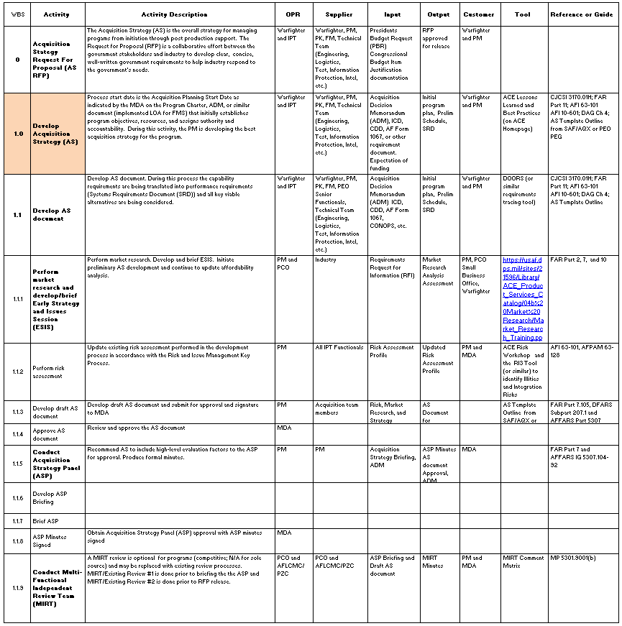

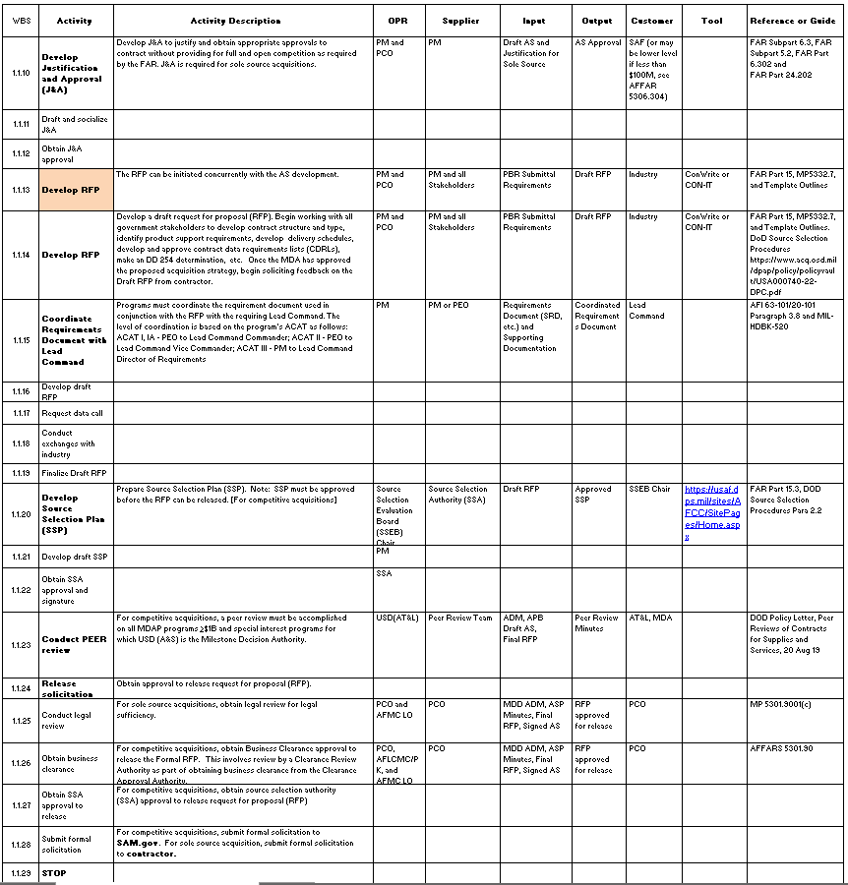
Attachment 3: Change Management Plan (CMP)

