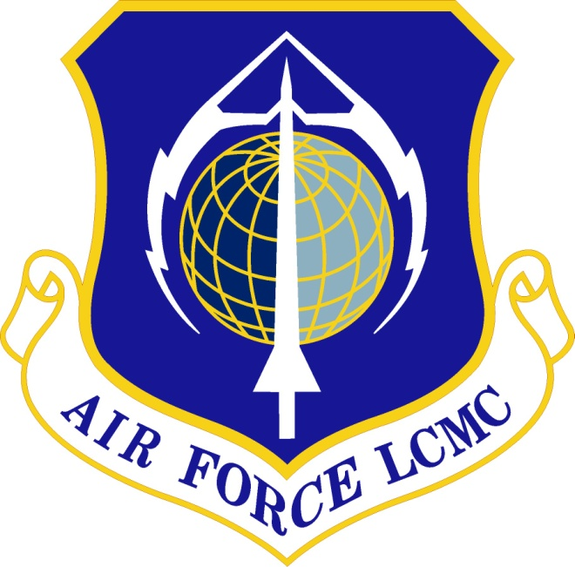

Air Force Life Cycle Management Center (AFLCMC)
Internal Process Guide
For
Operational Test & Evaluation (OT&E) Readiness Certification

Process Owner: AFLCMC/AZT
(Center Test Authority)
Date: 24 February 2016
Version: 1.0

Record of Changes
Version | Effective Date | Summary
1.0 | Mar 2016 | Process re-issued as an IPG as approved by S&P Board on 24 Feb 16. Major change; removed section 5 “measurements” paragraph that was associated with the former SP. Sharepoint Dashboard metric data was deleted. Includes administrative changes and business rule updates due to release of the new AFMAN 63-119 dated 19 Feb 2016.
Minor changes are annotated by changing the second digit, i.e., the first minor change after the basic document would be recorded as 1.1. Major changes are annotated by changing the first digit, i.e., the first major change after release of the basic document would be numbered as 2.0, etc.
Operational Test & Evaluation Readiness Certification
- Description. This Operational Test and Evaluation (OT&E) Readiness Certification process describes the AFLCMC process for obtaining OT&E readiness certification approvals in accordance with DoDI 5000.02, AFI 99-103, AFI 63-101/20-101, AFI 62-601 and AFMAN 63-119 guidance and instructions. The Air Force requires that a certifying official, usually the acquisition program’s Milestone Decision Authority (MDA), formally approve when systems or capabilities are ready to enter/start a dedicated phase of operational testing. This process applies when an MDA is to make an OT&E readiness certification approval decision. For ACAT I programs the MDA is the Defense Acquisition Executive (DAE) unless delegated lower. For ACAT II programs the MDA is the CAE (or SAE) unless delegated lower. For delegated ACAT I, II or III programs, the MDA is usually the PEO. The PEO may also delegate MDA for ACAT III programs to a Deputy PEO. See Attachment 2, paragraph 4.2 for more information on OT&E readiness approval delegations. This process will be used for all ACAT level programs within each AFLCMC PEO’s portfolio. The AFLCMC Center Test Authority (CTA) at WPAFB is the process owner with CTA Site Offices (SOs).
  - Applicability.
    - AFI 99-103 directs that the OT&E readiness certification guidance in AFMAN 63-119 is mandatory for reviewing all programs on the OSD T&E Oversight List and programs on the Air Force Acquisition Master List (AML). AFMAN 63-119 further directs use of the AF certification process to evaluate system readiness for operational testing in support of a full-rate production and/or fielding decision for all acquisition programs to include systems in sustainment utilizing Operations and Maintenance (O&M) funding for non-ACAT projects.
    - For programs without a dedicated OT&E phase, a certification is not normally required and this AFLCMC process would not apply/be used. However, for such programs of limited scope and complexity (i.e. form, fit, function type programs with no JCIDS/AFROC requirements or no new operational capability requirements) a MAJCOM Sufficiency of Operational Test Review (SOTR) in lieu of a certification may be conducted IAW AFI 99-103. See Attachment 2, paragraph 4.4 for more information.
  - AFMAN 63-119 “Certification of System Readiness for Dedicated Operational Testing,” provides a disciplined and structured certification process for acquisition programs to help ensure successful operational test outcomes. This continuous assessment process is used throughout the lifecycle of a program and is also used to effectively identify risk and document program development. Figure 1 illustrates the cycle.
  - This process mirrors existing procedures used for program decision reviews such as Acquisition Strategy Panels and milestone decision reviews. It also includes Senior Acquisition Team (SAT) involvement as determined by the PEO/MDA, AFLCMC CTA or CTA SOs. The SAT is a member based panel of senior level advisors that provide functional area expertise counsel at specific acquisition program decision briefings.
    - AFLCMC Process Guide A108, The Senior Acquisition Team outlines information on SAT structure and function. Changes to the SAT process may affect this process in future updates. Also see paragraph 6.7.
  - Enhanced process business rules located in Attachment 2 provides more detailed information on requirements, functional coordination, formats and special topics.
Figure 1. OT&E Readiness Certification Review Cycle

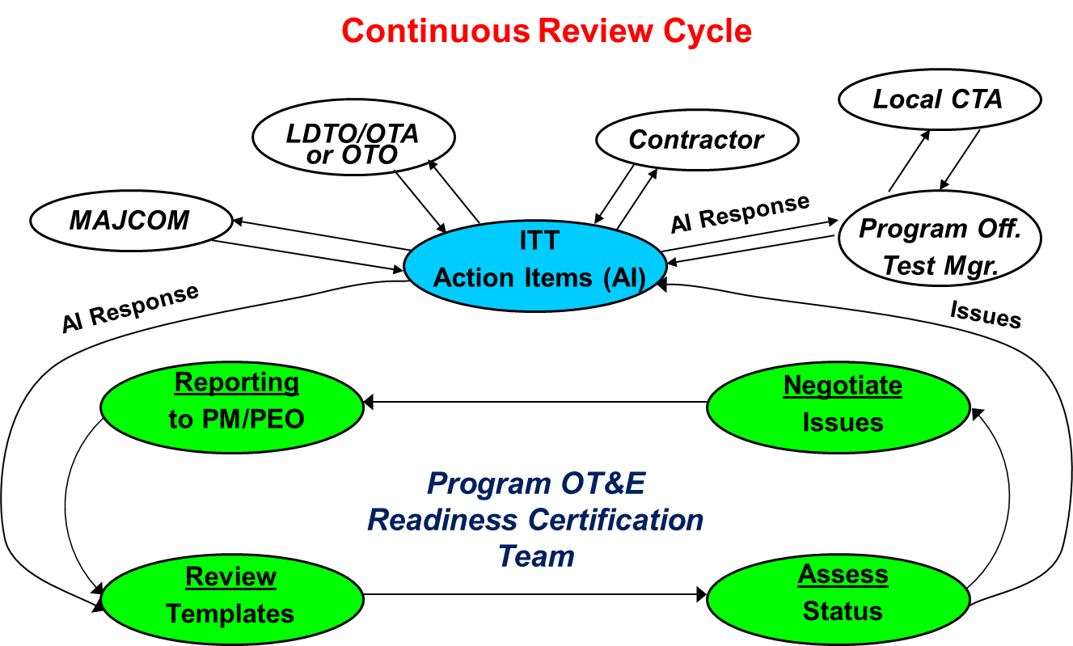

- Purpose
  - This process provides a single OT&E readiness certification process for the Center and ensures a comprehensive and in depth review is accomplished to best support the actual certification decision. It also provides a formal means for AFLCMC leadership and PEOs/MDAs to review readiness for dedicated operational testing. The products serve to support the approval decision to start dedicated operational testing. The formal OT&E readiness certification briefing addresses operational test posture and reviews actions of contributing agencies in preparation for OT&E start. The certification briefing (or package) includes AFMAN 63-119 certification templates, developmental test results, test plan updates, test team status (staffing and training), test capability status, and general confidence that the system is ready to begin operational testing.
  - The process is intended to assist certification approval certification decision makers in determining that:
    - DT&E results are understood and any corrective actions are either in work or already completed and any supportability issues are understood or have acceptable work-arounds.
    - The system is mature, stable, production representative and ready for operational testing with required system certifications, test resources and test personnel.
    - Known anomalies/deficiencies have not increased any technical risks associated with executing testing and that any operational limitations have been identified.
    - All reasonable efforts have been made to minimize or mitigate any program technical or readiness risk.
    - Assessment was completed of system progress against key performance parameters, key system attributes and critical technical parameters.
    - Expected test results will provide the appropriate inputs for the evaluation of the tested system’s/capability’s performance for production and/or fielding.
- Entry/Exit Criteria and Inputs/Outputs
  - Entry Criteria. OT&E entry criteria as specified in the TEMP and OT&E Readiness Certification reviews and assessments initiated by the program ITT or Test Manager.
  - Exit Criteria. MDA signs/approves OT&E Readiness Certification memorandum.
  - Inputs. Program status and reporting information, various assessment tools, functional area analysis including functional SME and T&E stakeholder reviews.
  - Outputs. Recurring OT&E Readiness Certification assessments culminating in the MDA’s certification approval memorandum forwarded to the Operational Test Agency (OTA) or Operational Test Organization (OTO).
- Process Workflow and Activities. This section provides a visual representation of the process with details of workflow and activities. It lays out the process from end-to-end and describes interaction between AFLCMC organizations, as well as external organizations integral to the process.
  - Suppliers, Inputs, Process, Outputs, Customers (SIPOC), Table 1.
Table 1. SIPOC
Suppliers | Inputs | Process | Outputs | Customers
- PM, CDT or TM  - Program ITT  - T&E Stakeholder SMEs  - LDTO  - OTA/OTO | - Program technical, validation, analysis, verification and other program status information/reports  - Integrated assessment tools and findings  - Recommendations and status updates from functional area SMEs and T&E stakeholders | - AFMAN 63-119 Certification of System Readiness for Dedicated Operational Testing process  - Assessment of 32 functional area attachments (templates) tailored to program req’s | - Recurring OT&E Readiness Assessments  - Pre-Brief/Review with CTA  - SAT participation if required or directed  - Final MDA Briefing  - OT&E Readiness Certification memo | - PEO/MDA  - OSFs  - AFOTEC or  - MAJCOM Operational Test Organization

  - Process Flowchart. The flowchart at Figure 2 represents the overall AFLCMC process. (Also see AFMAN 63-119 Figure 2.4 notional top level process flow for reference).
  - Work Breakdown Structure (WBS). The WBS provides additional detail for the activity boxes in the flowchart. Table 3, below, is an excerpt of the WBS. The MS Excel version of the WBS is included at Attachment 1.
  - Work guidance package or additional work tables, figures, or checklists.
    - CTA OT&E Readiness Certification Process Support/Coordination. The AFLCMC CTA with other CTA SOs are the points of contact for T&E technical/management support to AFLCMC program offices throughout this process’s management and execution. The AFLCMC CTA is located at Wright-Patterson AFB. Table 2, below, outlines CTA OT&E readiness certification support requirements:
Table 2. CTA OT&E Readiness Certification Support Requirements
AFLCMC Program Level | Provides T&E Technical/Management Support to Program Office | Conducts CTA OT&E Readiness Certification  Pre-briefing/Review | Attends OT&E Readiness Certification Final  Briefing to PEO/MDA
ACAT I, II &  Oversight | Local CTA by Geographic Location | AFLCMC  T&E Center Senior Functional (CSF)  (AFLCMC/AZT) | AFLCMC  T&E Center Senior Functional (CSF)  (AFLCMC/AZT)
ACAT II, III &  Non-Oversight | Local CTA by Geographic Location | CTA SO Site Senior Functional (SSF) | CTA SO Site Senior Functional (SSF)

    - Pre-briefings. OT&E readiness certification pre-briefs are necessary to understand and work programmatic issues. Programs will first schedule and accomplish a pre-briefing or review session with the CTA or CTA OL for initial feedback. Another pre-brief or dry-run is usually conducted at the Directorate level to the Deputy Director or Deputy PEO and is then followed by the final briefing to the appropriate certification authority (PEO/MDA). Senior Advisory Team (SAT) member or other SME functional participation at the final briefing may be recommended by the CTA or as directed by the PEO/MDA (see enhanced business rules in attachment 2).
      - Note: pre-briefings may include the participation of AFTC Representatives and AFOTEC Liaison officers that may be assigned to AFLCMC or co-located with some program offices.
      - Note: see Attachment 2, paragraph 4.1 for information on AFOTEC’s Readiness to Test (RTT) procedures.

Figure 2. Process Flowchart – Operational Test & Evaluation Readiness Certification Process

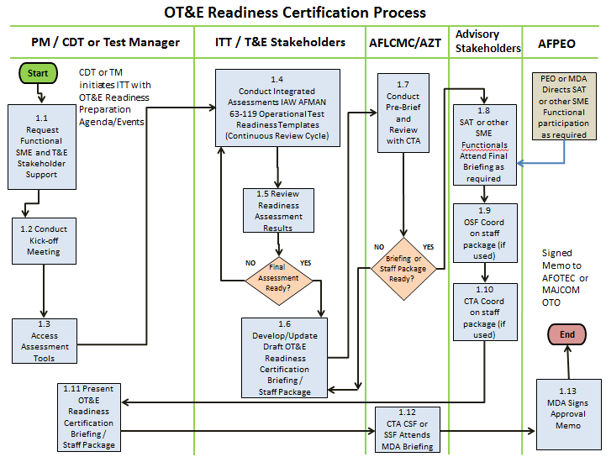
Table 3. WBS
Level
WBS
Activity
Description
OPR
Duration
(Days)
1
1.0
OT&E Readiness Certification
2
1.1
CDT or TM initiates ITT with
OT&E Readiness Preparation
Request and gather functional SME and T&E stakeholder
support.
PM
1
2
1.2
Conduct Kick-off Meeting
Self-explanatory
PM
1 to 2
2
1.3
Access Assessment Tools
Collect and make available office tools to support, track
and document assessment status.
PM
1 to 2
2
1.4
Conduct Integrated
Assessments IAW AFMAN 63-
119 Operational Test
Readiness Templates
Conduct assessments using disciplined reviews during
all stages of program acquisition and sustainment. T&E
stakeholders assist the PM in identifying risks, reaching
negotiated agreements on issues, and in rendering
accurate assessments of system readiness to begin
dedicated operational testing. The process is supported
by 31 “templates” in AFMAN 63-119. The assessment /
certification process is implemented as a continuous
and recurring effort until the final certification is
approved.
PM
Recurring
& Variable
duration
(Tailored
to program
needs)
2
1.5
Review Readiness
Assessment Results
Self-explanatory
ITT / T&E
Stakeholders
5 to 10
2
1.6
Draft, Develop or Update
OT&E Readiness Certification
Briefing or Staff Package
Self-explanatory
ITT / T&E
Stakeholders
5
2
1.7
Conduct Pre-Brief and Review
with local CTA
Programs will schedule and accomplish a pre-briefing or
review session with their local CTA for initial feedback.
Another pre-brief or dry-run may be conducted at the
Directorate level to the Deputy Director or Deputy PEO
which is followed by the final briefing to the PEO/MDA.
CDT or TM
1
2
1.8
Invite SAT or other SME
Functionals to Final Briefing as
required
Senior Advisory Team member or other SME functional
participation at the final certification briefing may be
recommended by the CTA or as directed by the PEO.
CDT or TM
1
2
1.9
T&E OSF coordination on staff
package as required
Directorate Chief of Test or T&E OSF reviews and signs
staff package.
PM, CDT or TM
5
2
1.10
Local CTA coordination on
staff package as required
CTA CSF or SSF (by program geographic location and
ACAT level) reviews and signs staff package.
PM, CDT or TM
5
2
1.11
Present OT&E Readiness
Certification Briefing /
Staff Package to the PEO

Final certification review and briefing of system
readiness is usually completed approximately 45
calendar days prior to the planned start of dedicated
operational testing. Certification requires a formal
briefing to the OT&E Certification Official. The briefing
addresses DT&E results, conclusions, recommendations,
identified deficiencies and workarounds, and an
assessment of the system’s capability to meet
operational requirements.
PM
1
2
1.12
Local CTA CSF or SSF Attends
Certification Briefing
CTA participates in the final certification review to
provide T&E functional support.
AFLCMC/AZT
(Local CTA SO)
1
2
1.13
PEO Signs approval
memorandum
Self-explanatory
PM
1
- Process Review.
  - Process Effectiveness/Evaluation
    - The process owner may advise AFLCMC/CC, PEOs and functional home office staffs as to the process effectiveness using any feedback data received/collected. The process owner may use feedback data history to determine if changes or updates are needed to process guide tools, training and content.
    - Feedback data collection and success rate data from actual OT&E readiness certifications may be assessed semi-annually or on direct request by the process owner.
- Roles and Responsibilities.
  - AFLCMC PEO/Deputy PEO
    - Acts as OT&E readiness certification approval official if PEO is the MDA or, if readiness approval authority is delegated to the PEO when SAE is the MDA.
    - For ACAT III programs the Deputy PEO may be the MDA (if delegated) and is the OT&E readiness certification approval official.
    - Chairs OT&E Readiness Certification final briefing/review.
    - Requests SAT involvement or independent SMEs from functional home offices (or obtain from within their respective Directorate) to attend reviews and briefings as needed or as determined.
  - AFLCMC/AZT (Process Owner)
    - Chairs OT&E Readiness Certification pre-briefings and recommends SAT or other functional review attendance for final PEO/MDA briefing.
    - Maintains and coordinates and update any changes to this internal process.
    - With AFLCMC/XPT, maintains and manages changes to the process via SharePoint site that hosts current documentation for the Center processes.
    - Provides training (or coordinate training requirements) to the AFLCMC workforce on best practices in preparing/conducting certifications.
    - Performs analysis on compliance data for use at the AFLCMC level as determined.
  - Program Manager. Ensures a Chief Developmental Tester or Test Manager is designated for organizing the certification process, gathering information, scheduling, reviews, assigning tasks, gathering consensus on issues and solutions, assembling briefings, and drafting the final PEO/MDA certification memorandum.
  - Program Chief Developmental Tester (CDT) or Test Manager (TM)
    - Ensures OT&E Readiness Certification assessments are performed for assigned programs with a dedicated phase of OT&E.
    - Coordinate inputs from other T&E organizations and other functionals.
  - Organizational Senior Functional (OSF) for T&E. Reviews relevant OT&E Readiness Certification assessments.
  - Senior Acquisition Team (SAT)
    - Supports the OT&E Readiness Certification process when requested.
    - Reviews read-ahead charts. Works any issues ahead of time with the PMO, if possible, to minimize discussions at reviews/briefings.
    - Receives briefing and provide inputs/suggestions as appropriate.
    - Reviews and approves any action items during reviews and supports recommendation to go forward to PEO/MDA for final decision as determined.
- Tools/Tool Sources
  - Tools/Templates:
    - AFLCMC OT&E Readiness Certification briefing template
    - DoD Operational Test Readiness Review Preparation Checklist
    - AFMAN 63-119 OT&E readiness assessment spreadsheet tracking tool
  - Tool Sources/Locations:
  - AFLCMC/AZT Center Test Authority Community SharePoint site: Web application that provides Information sharing, T&E policy dissemination and real-time data access. Located at: https://cs4.eis.afmc.af.mil/sites/1352/CTA/default.aspx
    - AFLCMC Center Test Authority CoP, Test Manager Toolkit: Web application that provides process forms, templates, lessons learned access and T&E subject matter information for program management for community members. Site is located at: https://cs3.eis.af.mil/sites/OO-TE-AS-01/default.aspx
    - “Hanscomnet” Program Manager’s Toolbox, AFLCMC/AZT Center Test Authority, Integrated Test: Resource listing of T&E policy, process, guidance, tools and training. Site located at https://hanscomnet.hanscom.af.mil/pmtb/CTA/Test.html
- Training
  - Training Plan.
    - AFLCMC/AZT will provide recurring Focus Week and/or Test Manager Council training as needed or requested for program test managers.
    - AFLCMC/AZT will provide table-top training sessions to test managers preparing for and conducting their first certification briefing preview.
  - Available Training Sources: AFLCMC/AZT (WPAFB CTA), AFLCMC/AQW (Hanscom CTA SO), and AFLCMC/EZPT (Tinker, Robins, Hill CTA SOs) can provide training at their respective locations on process and tools to AFLCMC organizations requesting assistance.

- Definitions, Guiding Principles and/or Ground Rules & Assumptions.
  - The thrust of the AFLCMC OT&E readiness certification process is to support the PEO/MDA in ensuring programs are ready for operational testing and that program systems are supportable while in operational testing. This is a vital principle in conducting successful AFLCMC certifications with the external Operational Test Agency (AFOTEC) or other Operational Test Organizations.
  - SAT participation will be considered during OT&E readiness certification reviews but only as determined by AFLCMC/AZT recommendation or if PEO/MDA directed.
  - PMO Test Managers may develop and maintain individual program readiness assessment tools and other review procedures for internal ITT and PM use.
  - AF/TE has identified AFMAN 63-119 as the Air Force standard OT&E readiness review procedure which may be periodically revised or updated.
- References to Law, Policy, Instructions or Guidance.
  - DoDI 5000.02; The Defense Acquisition System requires each DoD component to establish an Operational Test Readiness Process for programs on the OSD T&E Oversight List.
  - The Defense Acquisition Guidebook (DAG) outlines technical reviews needed prior to MS C and the FRPDR that include an Assessment of Operational Test Readiness (AOTR) for programs on oversight or special interest and Operational Test Readiness Reviews (OTRR) prior to IOT&E.
  - AFI 62-601; USAF Airworthiness requires PEOs to ensure that aircraft systems employing design-based assessments have successfully completed airworthiness reviews prior to first flight and have appropriate flight releases or certifications issued prior to the start of dedicated OT&E.
  - AFI 63-101/20-101; Integrated Life Cycle Management requires PMs to establish ITTs to conduct OT&E readiness reviews IAW AFI 99-103 and AFMAN 63-119.
  - AFI 99-103; Capabilities-Based Test and Evaluation directs PMs to implement the AFMAN 63-119 readiness process as early as practical during the EMD phase and provides other important guidance including that the final certification review and briefing of system readiness must be completed approximately 45 calendar days prior to the planned start of dedicated operational testing.
  - AFMAN 63-119; Certification of System Readiness for Dedicated Operational Testing provides 32 “templates” that list specific problem or risk areas that could hinder the smooth transition to and execution of dedicated operational testing. Use of these templates during certification is mandatory for reviewing program details in assessing program readiness in sufficient depth.
  - AFI 99-103, AFMC Supplement; directs the CTA to advise Center command staff on T&E policy and related issues including the certification of system readiness for operational testing.
  - AFMCI 36-2645; Senior Functional Roles and Responsibilities outlines the functional management construct and the roles and responsibilities of Senior Functionals within Air Force Materiel Command (AFMC).
  - AFOTECMAN 99-103; Operational Test Processes and Procedures provides local guidance for AFOTEC to provide operational test planning insight to reduce risk and to assist the PM in reaching a successful certification of system readiness for dedicated OT&E. The current AFMAN 63-119 process is supplemented by AFOTEC with a Readiness-to-Test (RTT) approach for all ACAT I and II programs.
  - The Air Force Test and Evaluation Guidebook outlines general guidance on the implementation of an effective system OT&E readiness certification process as early as practical in the acquisition program.

List of Attachments
Attachment 1: MS Excel version of WBS

Attachment 2: Enhanced Process Guidance

