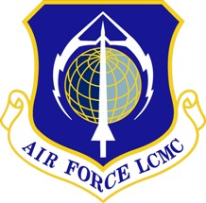

Process Guide
S105

Air Force Life Cycle Management Center (AFLCMC)
Process Guide
for
Congressional Inquiry

Process Owners: AFLCMC/CA and AFLCMC/CCX
Date: 12 February 2014
Version: 5.1

Record of Changes
Version | Effective Date | Summary
1.0 | June 2010 | Basic document
2.0 | June 2012 | AFLCMC Update
3.0 | 27 December 2012 | Final Document
4.0 | May 2013 | Updated to include new CCX Legislative Liaison
5.0 | 24 October 2013 | Updated to include new CCX Legislative Liaison and CCX duties, and added new reference pages.
5.1 | 12 February 2014 | Updated with minor edits

CONGRESSIONAL INQUIRY PROCESS

- Process Definition:

1.1 This particular guide explains the AFLCMC Congressional process and summarizes how the organizations support the process. It is important that all AFLCMC organizations are aware of, and complies with, procedures for timely and accurate responses to Congress. AFLCMC will communicate clearly and openly with Congress, and responses will be consistent with AF and Air Force Materiel Command’s (AFMC) positions. Appendix 1 included highlights the Secretary of Defense’s (SECDEF)guidance on Congressional Delegation (CODEL) taskings for your use. Note: All SECDEF’s responses should be submitted within 14 calendar days of receipt.

The following guidance applies:

1.2 AFLCMC/CA will be the Office of Primary Responsibility (OPR) for management oversight of all responses to non-Inspector General (IG) Congressional inquiries, and all inquiries received by any AFLCMC unit, regardless of source, will be immediately reported to AFLCMC/CA. This includes all general Congressional inquiries, reports to AFMC/CC and HQ AF senior staff on Congressional inquiries/contacts/visits, as well as advising Commanders, Program Executive Officers, and Center Directors on any legislative matters.

1.3 Installation IG offices (i.e., 88 ABW or 66 ABG) will be the OPR for IG-related Congressional inquiries to include inquiries defined as “specially handling” categories (i.e., Health Insurance Portability and Accountability [HIPAA] related/medical documents or IG personnel matters) IAW AFI 90-301, IG Complaints Resolution, and AFI 90-401, AF Relations with Congress, and related AFMC supplements. The “specially handled” inquiries require no info copy to AFLCMC on either the tasker or the response (reference AFI 90-401, AFMC Supplement). All files will be archived in the Secretary of the AF IG Automated Case Tracking System.

1.4 AFLCMC/CCX (Commander’s Action Group [CAG]) will be the primary office for tracking incoming inquiries/visits and determine if an inquiry is routine--informal contact that can be responded to directly, and if formal--coordinated response is required. AFLCMC/CCX will determine the appropriate office, individual, or unit to construct the response. Each AFLCMC organization will have an office responsible for tracking and monitoring all Congressional inquiries through the AFLCMC/CCX’s official automated tracking system (SOCCER). All inquiries, except for the “specially handled” inquiries, cited above will be reported to AFLCMC/CC in a Congressional update as part of a weekly report by AFLCMC/CCX.

1.5 The office tasked to formulate the response is responsible for ensuring it is packaged with a properly coordinated Staff Summary Sheet (hard copy), ready for approval/signature less than 5 working days and brought to the CAG to SOCCER in for LCMC Command approval. In the event that a complete response is not possible within the suspense timeline, an interim response acknowledging the inquiry will be sent and an extension requested by AFLCMC/CCX or CA. All responses should be complete, accurate, and directly addresses the issues or concerns. This applies to Congressional inquiries prepared for AFLCMC, as well as those that will be signed out by higher headquarters. The 88 ABW/JA (legal) will need to review and coordinate on the responses, as appropriate. All files will be archived in the AFLCMC SOCCER data base and unit official files except for the “specially handled” inquiries cited above.

1.6 All inquiries will be measured for timeliness through the SOCCER tracking system. The goal for AFLCMC is 94% and AFLCMC/CCX will report this metric monthly in the AFLCMC Commander’s staff meeting, as requested.

1.7 A Congressional Contact Report will be required after an LCMC employee meets with Congressional delegations and reports back on any actions and/or feedback of the visit. This report will be forwarded 5 days after the visit to AFLCMC/CCX/CA’s Legislative Liaisons for the Commander’s daily read file and shared with AFMC/CCX-LL. (Template shown at Attachment 1)

- Purpose and Scope:

2.1 It is imperative that the AF present a consistent and coordinated message whenever engaging with Congress. Per AF 90-401, Air Force Relations with Congress, SAF/LL and SAF/FML handles all relations, including inquiries from Congress, the Executive Office of the President and Vice President, the Office of Secretary of Defense and other governmental agencies.

2.2 HQ AFMC/CCX-LL is responsible for all responses to Congressional inquiries, except those sanctioned by AFI 90-301, IG complaints. AFMC will coordinate directly with SAF/LL or HQ AFMC/IG to ensure higher headquarters is notified, as appropriate, of new Congressional inquiries.

2.3 Congressional matters can be identified as one of two types: Legislative issues or Congressional inquiries involving personnel-related concerns. Congressional inquiries could involve Congressional visits to discuss both programmatic and/or base issues. The AFI 90-401 and related AFMC supplement, identify roles and responsibilities associated with Congress. These responsibilities are primarily related to programmatic legislative issues or issues that have broad application to the mission of AFMC. Program issues are the responsibility of AFMC/CCX-LL and those organizations designated as the Legislative Liaison at the installations.

- Process Description: (Figures 1, 2, and 3)

3.1 Indirect Taskings: Congress to SAF/LL to Air Staff to HQ AFMC to AFLCMC/CA:

3.1.1 Single Inquiry (Air Force Program Executive Officers/Directorates)
If a single inquiry is tasked to an Air Force Program Executive Officer (AFPEO) through SAF/AQ channels, the AFPEO will approve the response, respond to the originator, and provide an appropriate copy to the AFLCMC Commander through AFLCMC/CCX Workflow and CA. A copy of the response will be provided in AFLCMC/CC’s daily read file and in SOCCER. Note: Any AFPEOs who have separate oversight with different organizations (i.e., the Strategic Systems AFPEO with the Nuclear Enterprise), will review/coordinate inquiry, as required. (Figure 1)
If single or multiple inquiries are tasked to a Center PEO/Directorate(s), requiring AFMC Command approval--the CAG will task in SOCCER and response will be approved at the LCMC Command level. AFMC 2-ltr approvals can be approved at the PEO-level and copy forwarded to AFLCMC/CCX. For those offices geographically separated, scanned Electronic Staff Summary Sheets are required showing the appropriate coordination/response, and sent to the CAG (and AFLCMC/CA) for AFLCMC/CC approval.

3.1.2 Multiple AFPEO Inquiries: If an inquiry comes in requiring multiple PEOs to respond: the appropriate AFPEO will be the approving authority back to SAF/AQ, and provide a copy to both AFLCMC/CCX Workflow and AFLCMC/CA. AFLCMC CAG will consolidate a package of the AFPEOs’ responses and provide information copy in AFLCMC/CC’s daily read file. The Geographically Separated Units will provide scanned Electronic Staff Summary Sheets showing the appropriate coordination and response.

3.1.3 Multiple PEO/Directorate Inquiries: If a multiple PEO/Functional inquiry comes in, AFLCMC/CCX will track in SOCCER through their workflow box. AFLCMC CAG will assign an OPR, with the assistance from AFLCMC/CA’s office, receive the final response with an appropriate Staff Summary Sheet package, acquire AFLCMC/CA/CV/DS coordination and to AFLCMC/CC for approval. Note: Stakeholders will continue to share data and be involved in answering inquiries across platforms if needing one single answer approved by the AFLCMC/CC/CA or CV. (Figure 2)

3.2 Direct Tasking: All direct inquiries from outside units and customers will be reported to AFLCMC/CCX and AFLCMC CA. Outside agencies include, but are not limited to: Congress, the White House, and other AF Major Commands and Air Staff

3.2.1 AFPEOs: Inquiries going directly to the AFPEOs pertaining to acquisition chain authority and execution do not have to be coordinated through HQ AFMC and will be approved at their level. However, AFPEO chain inquiries from the SECAF, CSAF, VCSAF and AVCSAF should be answered directly and a copy provided to AFLCMC/CC through AFLCMC/CCX/CA. AFLCMC/CCX/CA will notify HQ AFMC, as appropriate. System Program Managers will notify/ coordinate with their appropriate external organizations, as required. Note: Inquiries to AFPEOs from AFMC pertaining to organize, train, and equip topics need to be coordinated and approved through AFLCMC/CC.

3.2.2 Center Directorates: Inquiries coming directly to the directorates from outside units will be reported directly to AFLCMC/CCX/CA. AFLCMC CAG will task into SOCCER workflow boxes, assign, and track. Inquiries will require AFLCMC/CC approval, or in CC’s absence, the appropriate AFLCMC Command representative.

Figure 1. AFLCMC Congressional Inquiry Process
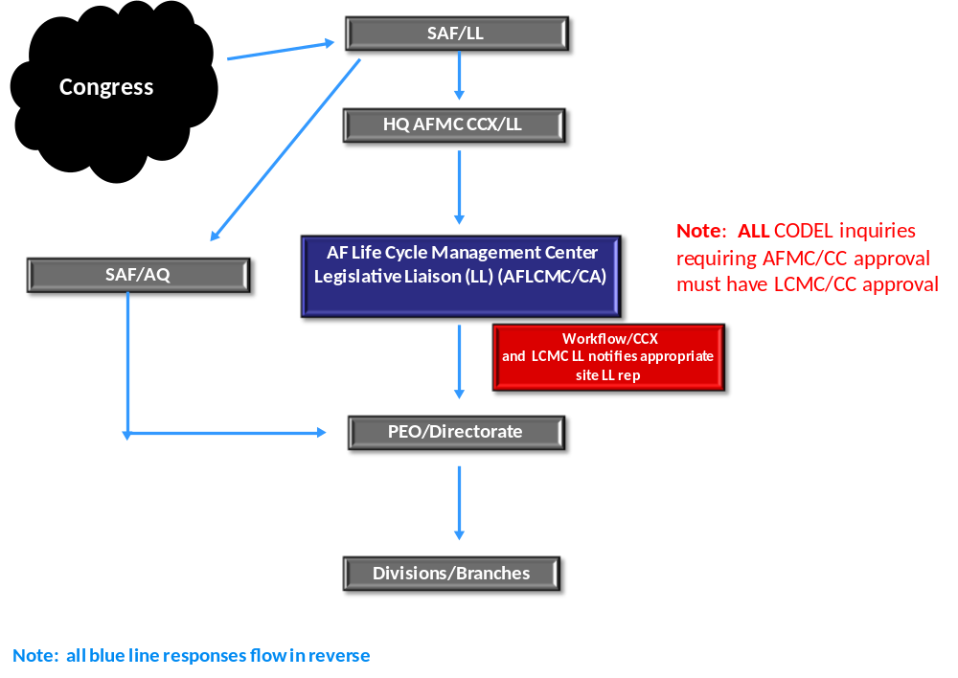
Figure 2. Multiple Organizations’ Congressional Inquiry Process
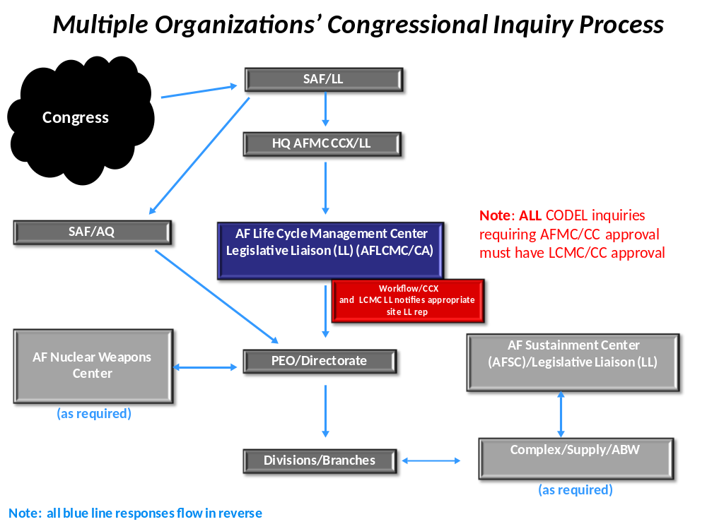

Figure 3. AFLCMC Congressional Inquiry Flowchart – Future State
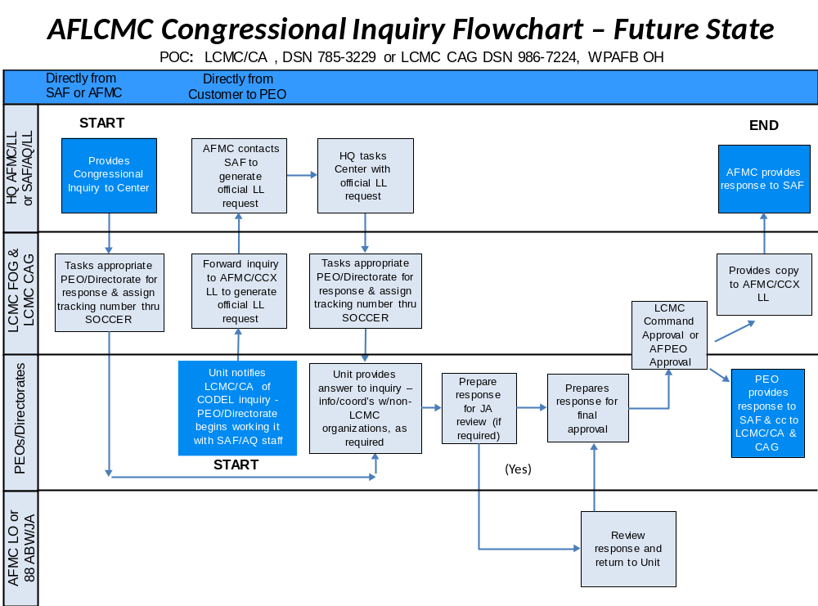

3.2.3 88th Air Base Wing (88 ABW/CC), WPAFB OH: As WPAFB host Installation Commander, the 88 ABW/CC is responsible for complying with the provisions of
AFI-90-401 as supplemented by AFMC. The 88 ABW/CC has designated 88 ABW/IG as the OPR for Congressional activities whether it be direct or indirect taskings. All inquiries coming into the ABW will be reported directly to AFLCMC/CA. The 88 ABW/CC will approve all installation inquiries, to include Civilian Personnel inquiries, with a copy to AFLCMC/CC through AFLCMC/CA. The 88 ABW/CCX receives all Congressional visits/inquiries to Wright-Patterson installation and informs AFLCMC/CC through AFLCMC/CCX/CA. The appropriate tenants are tasked and worked accordingly. Air Force officials must protect personal information about all base employees according to the guidelines of the Privacy Act. (Figure 4/5)

Figure 4. 88 ABW Congressional Inquiry Process from AFPC
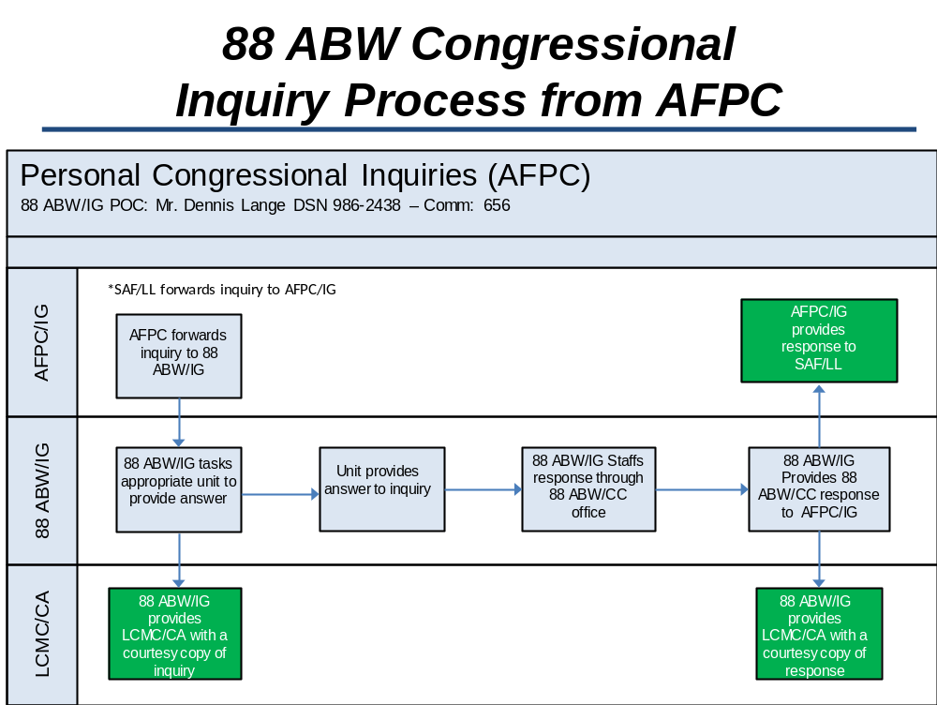

Figure 5. 88 ABW Congressional Inquiry Process from Congress
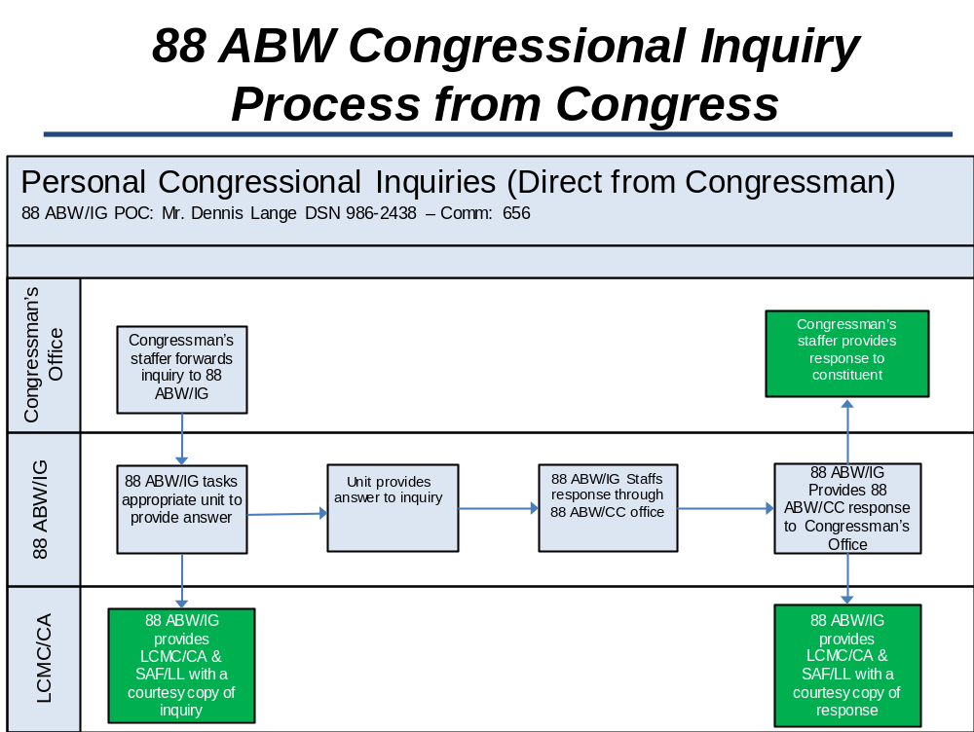

3.2.4 The 66th Air Base Group (66 ABG) Commander, Hanscom AFB (HAFB) MA: The 66 ABG Installation Commander is responsible for complying with the provisions of AFI 90-301, AFI 90-401, and AFMC supplements. The 66 ABG/CC has designated 66 ABG/IG as the OPR for Congressional activities whether it be direct or indirect taskings. All inquiries except for the “specially handling” inquiries coming into the 66 ABG will be reported directly to AFLCMC/CA. The 66th ABG/CC will approve all installation inquiries, and the Director of Civilian Personnel (66 FSS/FSM) will approve all personnel inquiries with a copy to AFLCMC/CC through AFLCMC/CA. The 66 ABG’s CAG receives all Congressional visits to Hanscom installation and informs AFLCMC/CC through AFLCMC/CA. The appropriate tenants are tasked and worked accordingly. Air Force officials must protect personal information about all military and civilian employees according to the guidelines of the Privacy Act. (Figure 6).

Figure 6. 66 ABG Congressional Inquiry Process
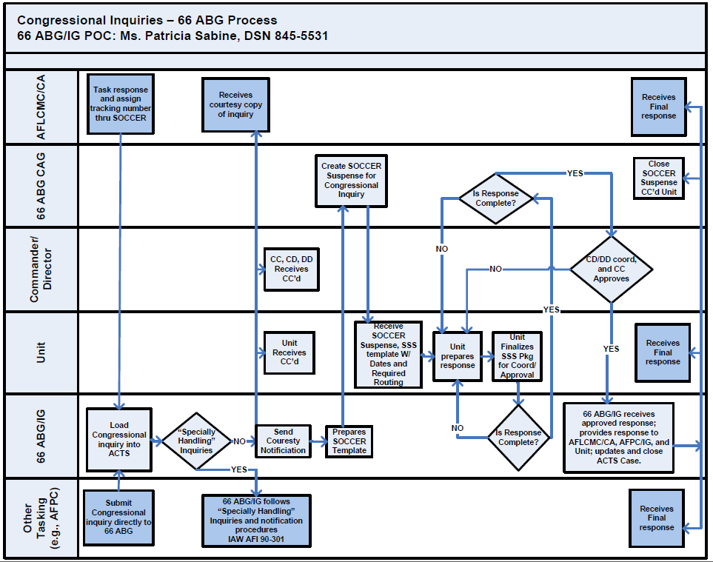

3.2.5 88 Air Base Wing Public Affairs (88 ABW/PA) or 66 ABG/PA: All units will inform the Installation PA office of actions on Congressional requests for information that have potential public relations implications. The Secretary of the AF has designated the Office of Security Review (SAF/PAS) as the approval authority for release of classified information to Congress. Refer Congressional requests for classified information to SAF/PAS through SAF/LL or SAF/FML. Air Force officials must not disclose classified information to Congress for release to a Congressional constituent. Refer to AFI-37-131 for exception. When the AF takes photographs during a Congressional visit, the host-field organization must send copies of 5x7 inch glossy prints, with captions, to SAF/LL or SAF/FML, within 72 hours after they are developed.

4.0 Process Audit:

4.1 All Congressional records are open for audit by the Inspector General’s office at any time. Each office of record will maintain their files using the Table 90-04 R 02.00 for Congressional inquiries. The official records kept below the HQ USAF level consists of non-routine inquiries and replies relating to or involving AF policy, procedures, plans, classified information and other matters of importance. This also includes changes in status or location of AF organizations, activities or installations, production facilities, major procurement or allied matters. Each office of record files a disposition to destroy inquiries and replies after 5 years. For electronic systems that replace temporary hard copy records, destroy on expiration of the retention period previously approved for the corresponding hard copy records.

Attachments:

Attachment 1. Congressional Interaction Feedback Template  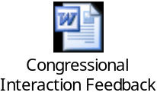 | Attachment 2. Congressional Post Visit Contact Report Template & Instructions   | Appendix 1 – SECDEF’s guidance below (pg 11)

Appendix 1
SECRETARY OF DEFENSE GUIDANCE ON CODEL TASKINGS


